
W
Newsletter - Week Beginning 4/6/2018
Dates, times and events are correct at the time of publication of this newsletter (though may be subject to some alterations or additions).
St. Patrick's
Catholic Primary School


Star of the week –
Week beginning 21.5.2018

Nursery | Wiktor Kolnierowicz  Penelope Glaze  Zuzanna Waluk | Reception | Ethan Wilde-Causey  Caitlyn Thompson
Y1M | Jacob Brown | Y4C | Lewis Reeves
Y1D | Joel Fishwick | Y4HW | Georgia Nicholson
Y2S | Cassidy Cain | Y5TL | Harry Meadows
Y2M | Teghan Smith | Y5HL | Chloe McCoy
Y3H | Reece Hill | Y6AP | Leland Taylor
Y3B | Mark Bamber | Y6JP | Willow Hart

Top attended classes for the previous week 21.5.2018 | Class | Attendance %
1st | Y6JP & Y1D | 96.8%
2nd | Y4HW | 94.3%
3rd | Y2M | 93.6%
Whole school current academic year


95.3%

Dear Parents,
Just a little update to let you know that we have now started a new working partnership with our PTA members; Mrs Brown and Mrs Tshunza. So far, we have worked together to put in place a new Parent Noticeboard on the Junior playground. Both parents have also offered support with our current Parent Workshop ‘STEPS,’ run by Mrs McLeod. If you are interested in joining our Parent/Teacher partnership, please contact Mrs A Brown (Y3 class teacher) at your earliest convenience. It is a very ‘flexible’ venture so you don’t need to worry about ‘time commitments’.
Many thanks,
Mrs A Brown (Y3 class teacher)

In class this week
On Wednesday 6th June, children across school experienced the ‘Welsh Birds of Prey’. This was a fabulous opportunity for children to witness the beauty and might of these wonderful creatures.
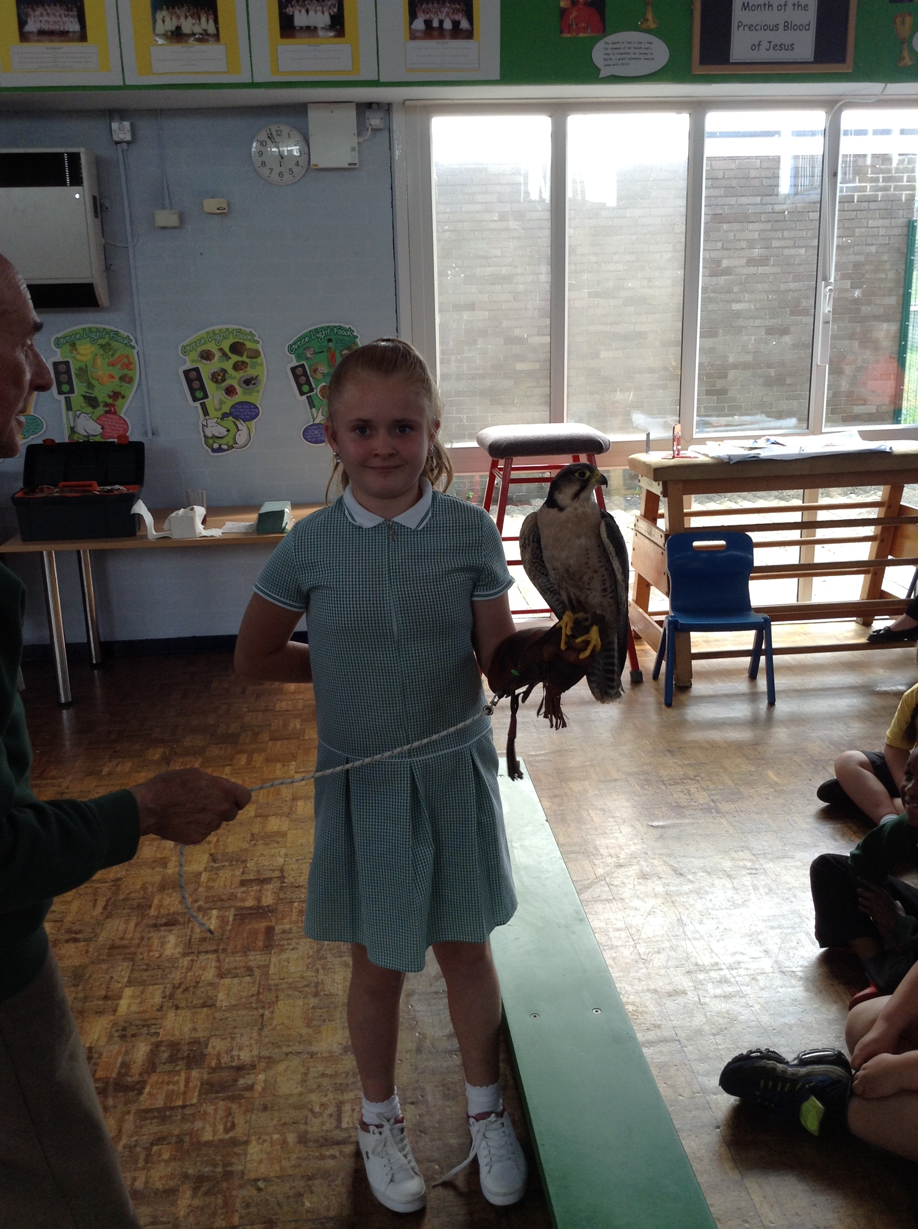
Saturday 16th June 2018
Y4 Children who have taken part in this year’s Sacramental Preparation Programme will make their First Holy Communion in a special Mass next Saturday. The Mass starts at 10am in St Patrick’s Church.
This will be a wonderful celebration for school and parish.

YY

Events
We will b Saturday 16th June 2018

Y4 Children who have taken part in this year’s Sacramental Preparation Programme will make their First Holy Communion in a special Mass. The Mass starts at 10am in St Patrick’s Church.
This will be a wonderful celebration for school and parish.
e processing into church from school at 1:45. Mass will start at 2pm. We his being a great parish and school celebration of our patron saint’s day.

Community
Good luck to our Y6 girls Cricket Team for Tuesday 12th June and for our Mixed Cricket Team of Y4/5 children for Wednesday 13th June.

