
W
Newsletter - Week Beginning 9.4.2018
Dates, times and events are correct at the time of publication of this newsletter (though may be subject to some alterations or additions).
St. Patrick's
Catholic Primary School

Top attended classes for the previous week 26.3.2018 | Class | Attendance %
1st | Y1D | 99.43%
2nd | Y3H | 97.83%
3rd | Y6JP | 97.73%
Whole school current academic year


95.34%


Star of the week –
Week beginning 26.3.2018

Nursery | Isabelle Rolle  Lacey-Rae White  Emily Eatock | Reception | Dominika Ruseva  Henry Rumsey  Mahir Bassowa
Y1M | Bethany Henriksen | Y4C | Jake Rodgers
Y1D | Max Davies | Y4HW | Megan Haugh
Y2S | Isabelle O’Neill | Y5TL | Scarlett Holcroft
Y2M | Eva Taylor | Y5HL | Megan Posteraro
Y3H | Esha Justin | Y6AP | Sam Farrell
Y3B | Leon Hodor | Y6JP | Callum Ogden

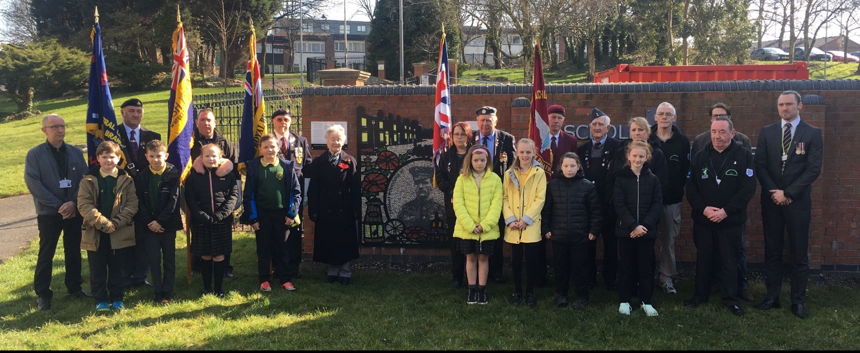
Thomas Woodcock VC 100th Anniversary
On Monday 26th March 2018, some children from Year 5 attended a short ceremony to mark the 100th Anniversary of the death of Thomas Woodcock VC (a former pupil of St Patrick’s School who won the Victoria Cross for an act of gallantry in the Great War).

Community
Events
In class this week
Polite reminder…
Could parents and carers please remember to direct your children to select their school meals on line at home (if you have the facility) so you are aware of their choices.
Although children are able to do this in school this can impact upon their learning time.
Thank you your
co-operation.

The Y1 children went on a nature walk for the start of their new topic ‘Growing.’

Y4 Sacramental Preparation
For children who are taking part in Sacramental Preparation, can we please remind you that the next meeting is Tuesday 17th April at 14:30.

Tuesday 17th April (pm)
Vision screening for all Reception children.

