
W
Newsletter - Week Beginning 30.4.2018
Dates, times and events are correct at the time of publication of this newsletter (though may be subject to some alterations or additions).
St. Patrick's
Catholic Primary School


Star of the week –
Week beginning 23.4.2018

Nursery | Cain Collier  Lacey-Rae White  Emma Mafimisebi | Reception | Henry Rumsey  Jessica Bushell  Nina Duda
Y1M | Charlie Armstrong | Y4C | Whole Class!
Y1D | Paige Brennan | Y4HW | Keite Krasaukyte
Y2S | Isabelle O’Neill | Y5TL | Liam Sixsmith
Y2M | Matilda Hart | Y5HL | McKenzie Coulton
Y3H | Benjamin Rumsey | Y6AP | Thomas Robinson
Y3B | Abbie Morris | Y6JP | Hannah-Rose Hesketh

Top attended classes for the previous week 23.4.2018 | Class | Attendance %
1st | Y6JP | 100%
2nd | Y2S | 99.13%
3rd | Y3B & Y4HW | 98.57%
Whole school current academic year


95.4%

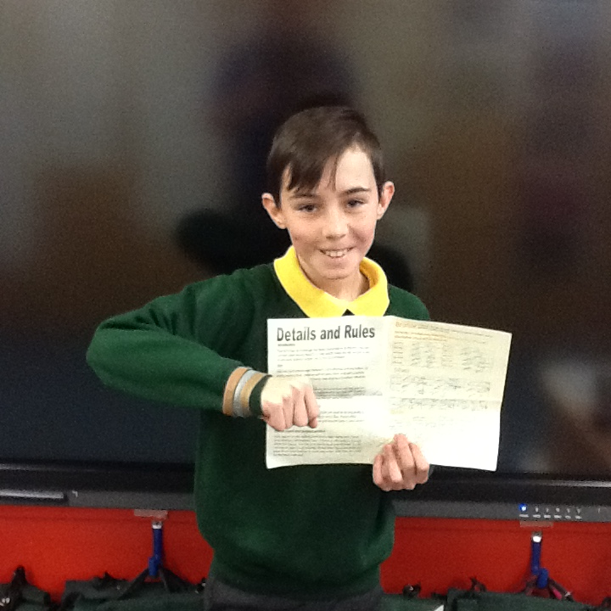 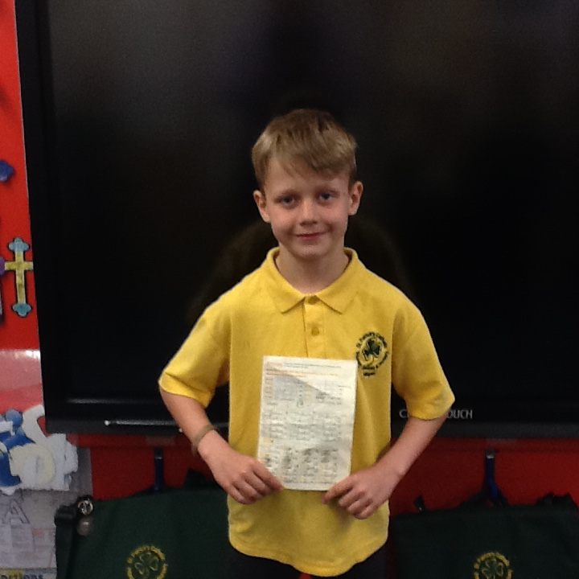 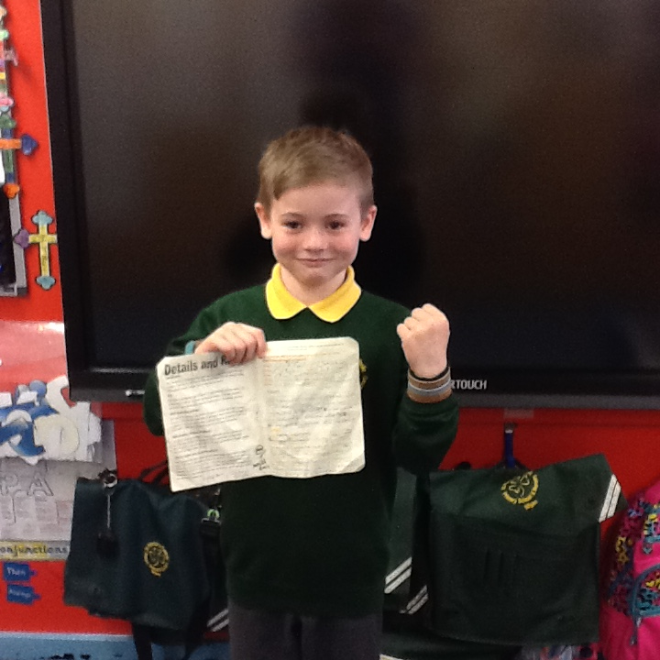 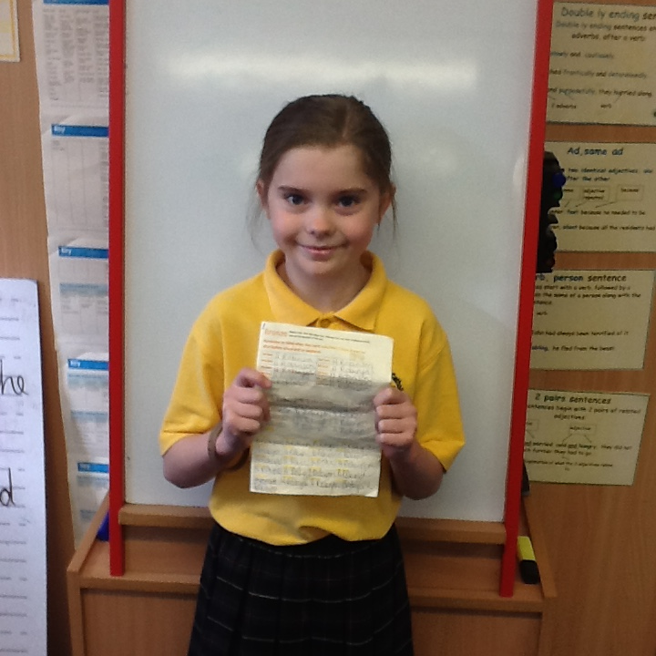 30 Fast Wristband Challenge
Well done all the children who have already achieved their Bronze, Silver and Gold wristbands!
This week ‘s Gold Winners are – Lilyanna Robinson (Y4) Ethan Irving (Y6), Harry Meadows (Y5), Kyle Collier (Y3).

Community
We will be processing into church from school at 1:45. Mass will start at 2pm. We anticipate this being a great parish and school celebration of our patron saint’s day.

Events
In class this week
Friday 18th May
May Crowning Procession in church.
All children taking part in Sacramental Preparation will have a role in the crowning group. Lauren Simm and Benjamin Morgowski will have the privilege of crowning the statue of Our Blessed Lady. (Their names were drawn, at random, during Sacramental Preparation on 1st May)

Well done to the Y5 boys who attended the Y5 inter schools football challenge at DW stadium on Monday (30th April 2018). The competition was organised by Wigan Athletic and the boys had the honour of playing on the stadiums pitch against 15 other school teams.

Sacramental Preparation

For children who are taking part in Sacramental Preparation, can we please remind you that the final meeting is Tuesday 8th May at 14:30.

