
W
Newsletter - Week Beginning 23.4.2018
Dates, times and events are correct at the time of publication of this newsletter (though may be subject to some alterations or additions).
St. Patrick's
Catholic Primary School

Top attended classes for the previous week 16.4.2018 | Class | Attendance %
1st | Y1D | 100%
2nd | Y3H | 99.13%
3rd | Y5HL | 98.64%
Whole school current academic year


95.4%


Star of the week –
Week beginning 16.4.2018

Nursery | Isabelle Rolle  Isaac Mather  Hanna Cegielska | Reception | Charlie Sharrock  Daniel Shaw Wilkinson  Maggie Gaskell
Y1M | Zuzanna Kapturowska | Y4C | Archie Porter
Y1D | Shaun Wallis | Y4HW | Lucie-Anne Finch
Y2S | Cassidy Cain | Y5TL | Lily Schofield
Y2M | Laura Mendelska | Y5HL | Kaden Ganderton
Y3H | Sophia Speed | Y6AP | Leland Taylor
Y3B | Agnieska Zalisz | Y6JP | Cameron McSorley

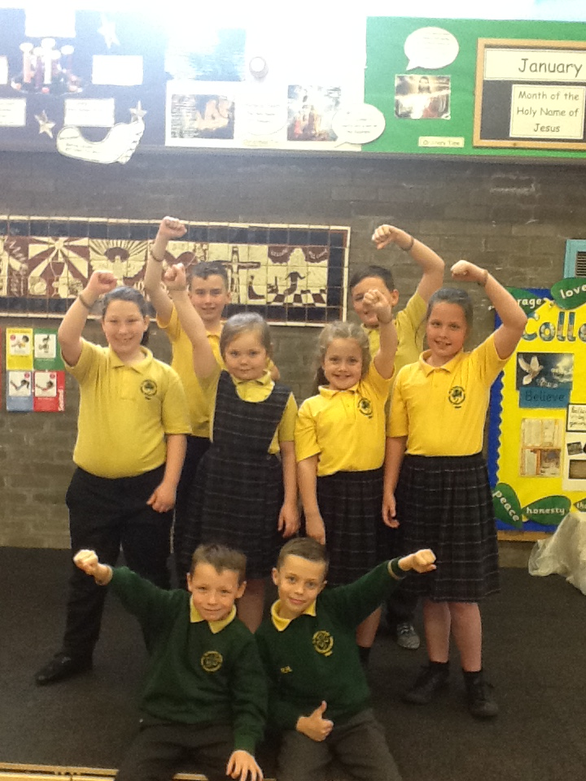
30 Fast Wristband Challenge
Well done all the children who have already achieved their Bronze, Silver and Gold
wristbands!
This week ‘s Gold Winners are – Teghan Smith (Y2), Reece Hill (Y3),
Tegan Almond (Y5) and Saul Colclough (Y6).

Community
Events
We will be processing into church from school at 1:45. Mass will start at 2pm. We anticipate this being a great parish and school celebration of our patron saint’s day.

In class this week

Friday 18th May
May Crowning Procession in church.
We will be processing into church from school at 1:45. The celebration of Our Lady will start at 2pm. We anticipate this being a great parish and school celebration.

Afterwards, refreshments will be available in school.

Sacramental Preparation

For children who are taking part in Sacramental Preparation, can we please remind you that the next meeting is Tuesday 3rd May at 14:30.

During this session we will be organising the May Procession crowning group roles for the children taking part in Sacramental Preparation.
This week, Year 2 had a very special visit from firefighters who work in our local community. We had the opportunity to learn more about fire safety equipment and how to keep ourselves safe every day.

