
W
Newsletter - Week Beginning 16.4.2018
Dates, times and events are correct at the time of publication of this newsletter (though may be subject to some alterations or additions).
St. Patrick's
Catholic Primary School

Top attended classes for the previous week 9.4.2018 | Class | Attendance %
1st | Y2S | 99.13%
2nd | Y3B/Y6JP | 98.18%
3rd | Reception | 96.59%
Whole school current academic year


95.32%


Star of the week –
Week beginning 9.4.2018

Nursery | Henry Haugh  Lewie Rennox  Patrick Unsworth | Reception | Grace Fitzpatrick  Macie-May Simm  Malika Houghton
Y1M | Amelia Breheny | Y4C | Ravyar Ali
Y1D | Caitlyn Horrigan | Y4HW | Brooklyn Banks Layton Robinson
Y2S | Oliver Henshaw | Y5TL | Jake Ward
Y2M | Jayden Jones | Y5HL | Chloe McCoy
Y3H | Oliver Irving | Y6AP | Ethan Irving
Y3B | Courtney Sharrock | Y6JP | Viktoras Kubilius

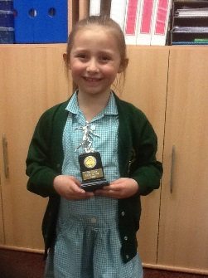

Well done Lola Close (Y1D) – Pro Kicks ‘Player of the Week!

We will be processing into church from school at 1:45. Mass will start at 2pm. We anticipate this being a great parish and school celebration of our patron saint’s day.

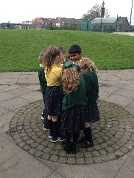
Community
Events

Friday 18th May
May Procession in church.
We will be processing into church from school at 1:45. The celebration Our Lady will start at 2pm. We anticipate this being a great parish and school celebration.

In class this week
Through role play, the Y4 children have been developing their knowledge and understanding of the particles in solids, liquids and gases.

Children from Y2 to Y6 are currently taking part in the ’30 Fast Wristband Challenge,’ which encourages the children to be more active. Children are awarded Bronze, Silver and Gold wristbands for taking part in physical activity outside school.

Romey Richardson (Y5TL), Nathan Ramsdale (Y5HL), Ellis Ramsdale (Y3B) and Ebony Hallsworth (Y5L) have already achieved the Gold wristband.
Well done!

