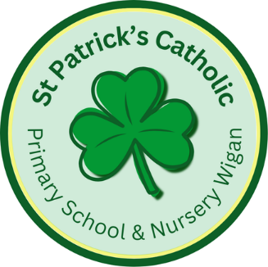

tises
Newsletter - Week Beginning 23.6.2025
Dates, times and events are correct at the time of publication of this newsletter
(though may be subject to some alterations or additions).
‘We arise today to learn, love and grow through Jesus.’

Top attended classes for the previous week 16.6.2025 |   Class | Attendance %
Gold | Y5 | 93.91
Silver | Y6 | 93.81
Bronze | Y1 | 91.46

Whole school current academic year
93.8%

Star of the Week
Week Beginning
16.6.2025
Nursery | Florence Clarke | Reception | Theodora McElchar
Nursery | Callie Wright | Reception | Rorey Leyland
Year 1 | Ada Azad | Year 4 | Evie Morris
Year 1 | Lilia Winstanley | Year 4 | Ivy Perry
Year 2 | Owen Rigby | Year 5 | Mia Fishwick
Year 2 | Ieva Prialgauskaite | Year 5 | Elza Mathews
Year 3 | Lucie Ellison | Year 6 | All of our Writing Superstars!
Year 3 | Maria Ondo Belloso | Year 6 | All of our Writing Superstars!

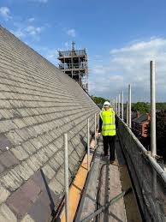
St Patrick’s Church
There are just two more weeks to sponsor a slate. Sponsor Forms are available from the Office, with each slate costing £20. Please return to the Office, Mr. Marshall or post through the presbytery letterbox.
Competition Time!
This week, children from Key Stage 2 have proudly represented our school at the Town Sports competition, showcasing their talents and determination. Throughout the event, they have demonstrated St. Patrick’s values and virtues, including respect, perseverance, and teamwork. Good luck in the finals!

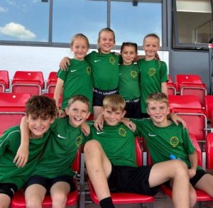
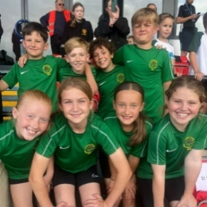

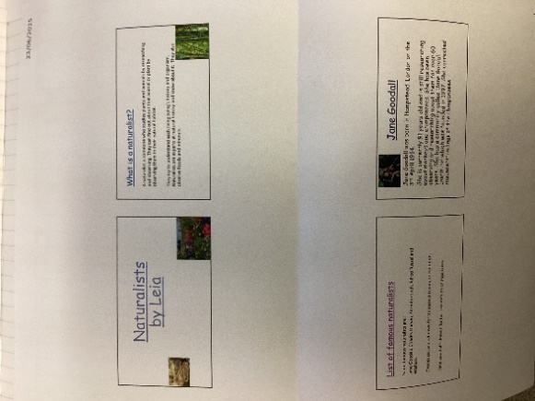
In Class This Week: Year 5

Events
30/6/2025 – Y5 Jubilee Year Retreat at Animate Youth.
8/7/2025 – Y5 attending SongShare at Robin Park.
9/7/2025 – Y2 attending SongShare at Robin Park.
10/7/2025 – Turn Wigan Purple.

This School Year finishes on Friday 18th July.

T
Wigan Borough Community First are inviting children from Wigan to redesign ‘Scholes-Henge’.
The main prize is a £100 Amazon Voucher.
Competition entry posters and further details can be obtained from school’s main office.
The closing Date for the competition is Friday 18th July 2025. Good luck to all entries!
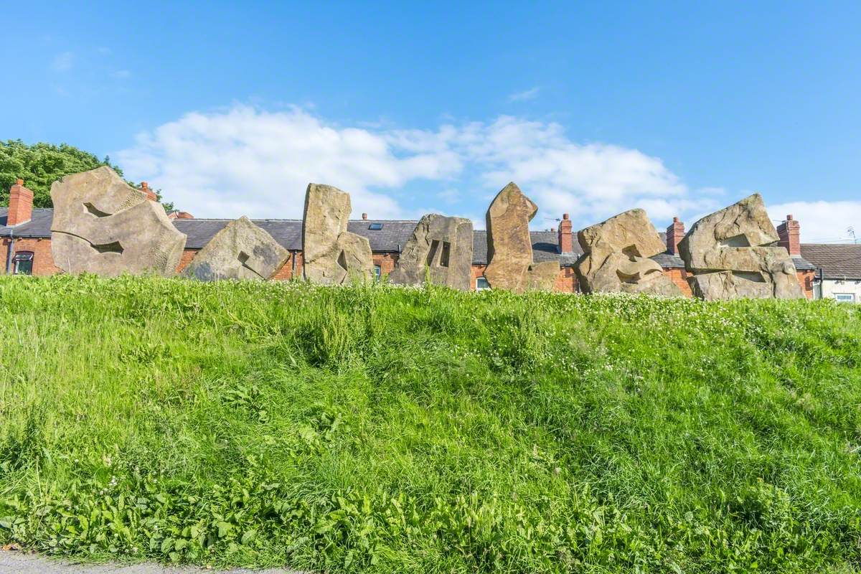

Competition

This week, in Science, Year 5 have been learning about Life Cycles. We enjoyed creating PowerPoints about naturalists such as Sir David Attenborough and Jane Goodall.

