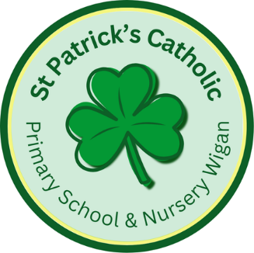

tises
Newsletter - Week Beginning 16.6.2025
Dates, times and events are correct at the time of publication of this newsletter
(though may be subject to some alterations or additions).
‘We arise today to learn, love and grow through Jesus.’

Top attended classes for the previous week 9.6.2025 |   Class | Attendance %
Gold | Y6 | 97.38%
Silver | Y4 | 94.89%
Bronze | Y5 | 93.91%
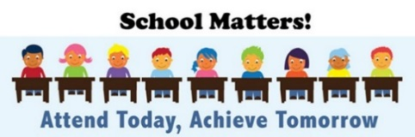
Whole school current academic year
93.93%

Star of the Week
Week Beginning
9.6.2025
Nursery | Oliver Ellison | Reception | Kian Jai-Cale
Nursery | Jayden Idam Aluu | Reception | Aroush Khurram
Year 1 | Thrilokh Anoop | Year 4 | Jaison Jacob
Year 1 | Reggie Kane | Year 4 | Kenny Ike
Year 2 | Ollie Sherman | Year 5 | Rehab Eissa
Year 2 | Esmae Starkie | Year 5 | Freddie Bannister
Year 3 | Phoebe Harker | Year 6 | Wiktor kolnierowicz
Year 3 | Alex O’Reilly | Year 6 | Lucas Sanders

Going for Gold!

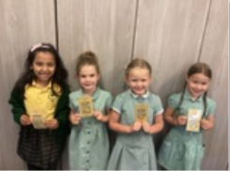
Holiday club - Summer 2025
Safe & Sound Holiday club will be available from Monday 4th August 2025 for 4 weeks. If you would like to book your child a place or you require more information, please contact Mrs. Glaze or Mr. Worthington.
 01942 244361 option 3 ggg safeandsound@saintpatricks.wigan.sch.uk
Instagram – stpsafeandsound £20 full day, £11 half day

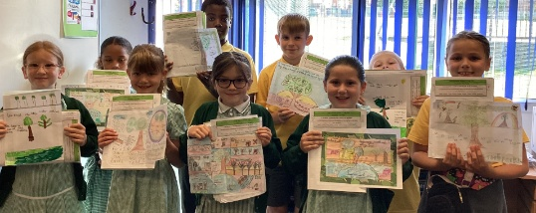
Wigan Borough Community First are inviting children from Wigan to redesign ‘Scholes-Henge’.
The main prize is a £100 Amazon Voucher.
Competition entry posters and further details can be obtained from school’s main office.
The closing Date for the competition is Friday 18th July 2025. Good luck to all entries!
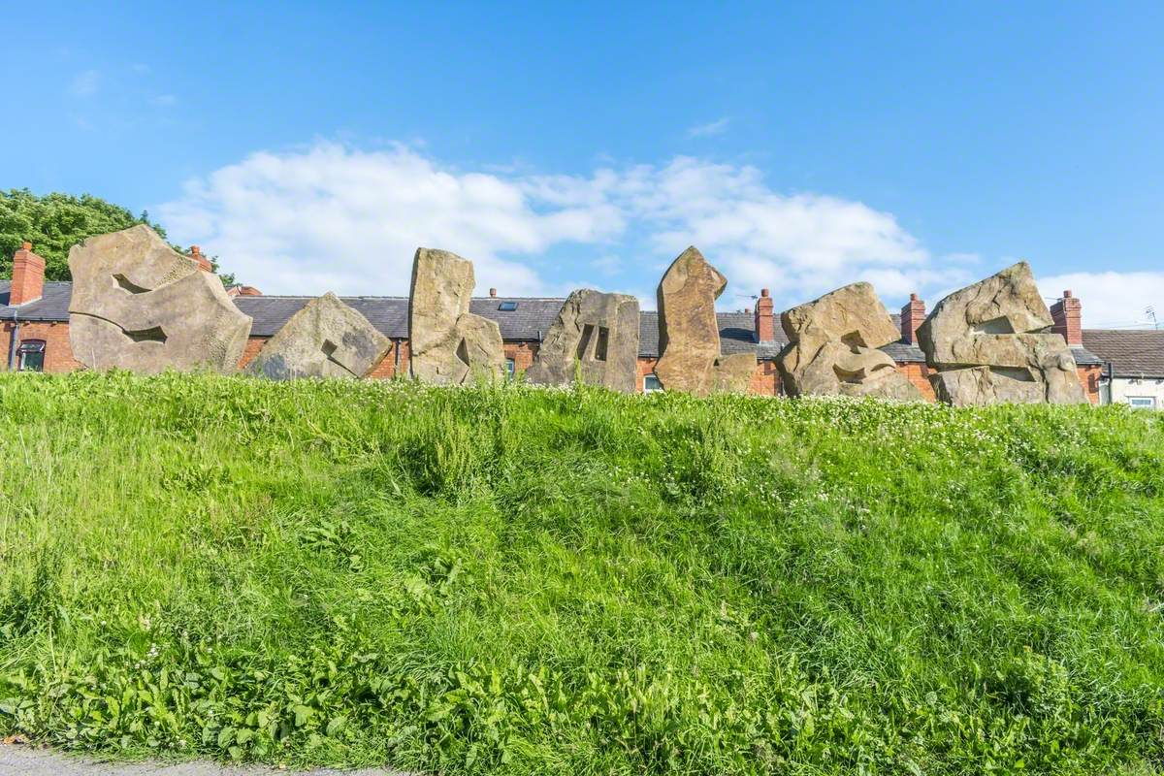

In Class This Week: Year 4

Competition

This week, Year 4 have celebrated their work on the geography topic ‘Rainforests’. Mrs. Browne held a competition for their ‘Save the Rainforest’ poster and these were her winners! I’m sure you can see why. We were so impressed with all of Y4’s efforts! They produced amazing posters with a clear purpose.

Events
23/6/2025 to 25/6/2025 - Y6 Residential.
30/6/2025 – Y5 Jubilee Year Retreat at Animate Youth.
8/7/2025 – Y5 attending SongShare at Robin Park.
9/7/2025 – Y2 attending SongShare at Robin Park.
10/7/2025 – Turn Wigan Purple.

This School Year finishes on Friday 18th July.

T

