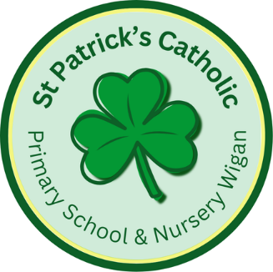

Newsletter - Week Beginning 9.6.2025
Dates, times and events are correct at the time of publication of this newsletter
(though may be subject to some alterations or additions).
‘We arise today to learn, love and grow through Jesus.’

Top attended classes for the previous week 2.6.2025 |   Class | Attendance %
Gold | Y4 | 96%
Silver | Y5 | 94.35%
Bronze | Y6 | 92.14%
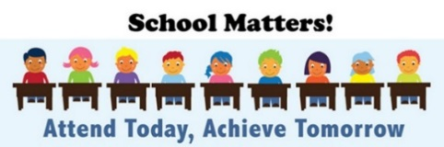
Whole school current academic year
93.97%

Star of the Week
Week Beginning
2.6.2025
Nursery | Kamsi Omokwe | Reception | Rory Davies
Nursery | Leo Aspinall | Reception | Elsie Lucas
Year 1 | Neriah Idam Aluu | Year 4 | Poppy Burton-Steele
Year 1 | Maya Hamed | Year 4 | Adriel Maseya
Year 2 | Louisa Spinola | Year 5 | Harvey Hockey
Year 2 | Kamil Handke | Year 5 | Layla Jamieson
Year 3 | Freya Hindley | Year 6 | Ieesha Ward
Year 3 | Theo Howe | Year 6 | Sami Baraka

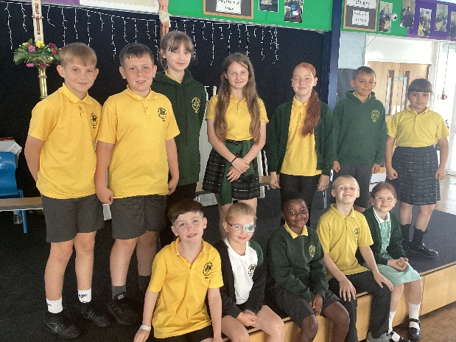
Going for Gold!

Last week, we worked with Cafod, to learn more about the Catholic Church’s Jubilee Year. The Theme this year is ‘Pilgrims of Hope’. Thank you to Doreen and Jim, our local Cafod volunteers, for coming in to school to lead assemblies and workshops.
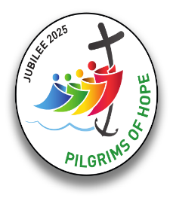

T
Wigan Borough Community First are inviting children from Wigan to redesign ‘Scholes-Henge’.
The main prize is a £100 Amazon Voucher.
Competition entry posters and further details can be obtained from school’s main office.
The closing Date for the competition is Friday 18th July 2025. Good luck to all entries!
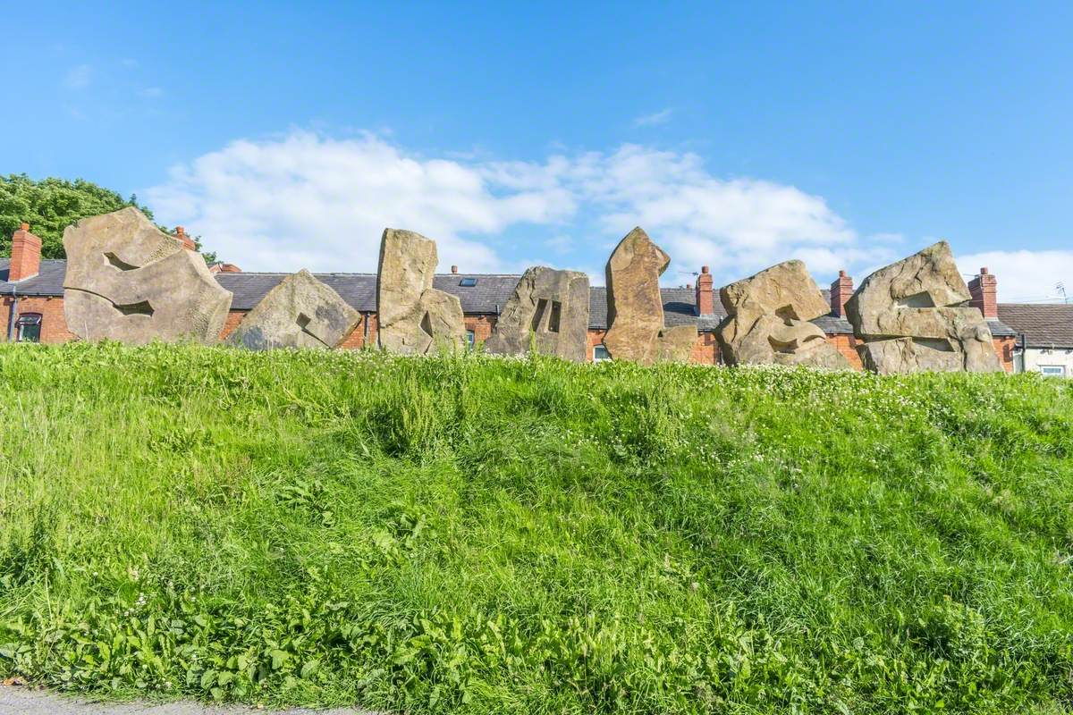

Events
23/6/2025 to 25/6/2025 - Y6 Residential.
30/6/2025 – Y5 Jubilee Year Retreat at Animate Youth.
8/7/2025 – Y5 attending SongShare at Robin Park.
9/7/2025 – Y2 attending SongShare at Robin Park.
10/7/2025 – Turn Wigan Purple.

This School Year finishes on Friday 18th July.

In Class This Week: Year 3

Competition

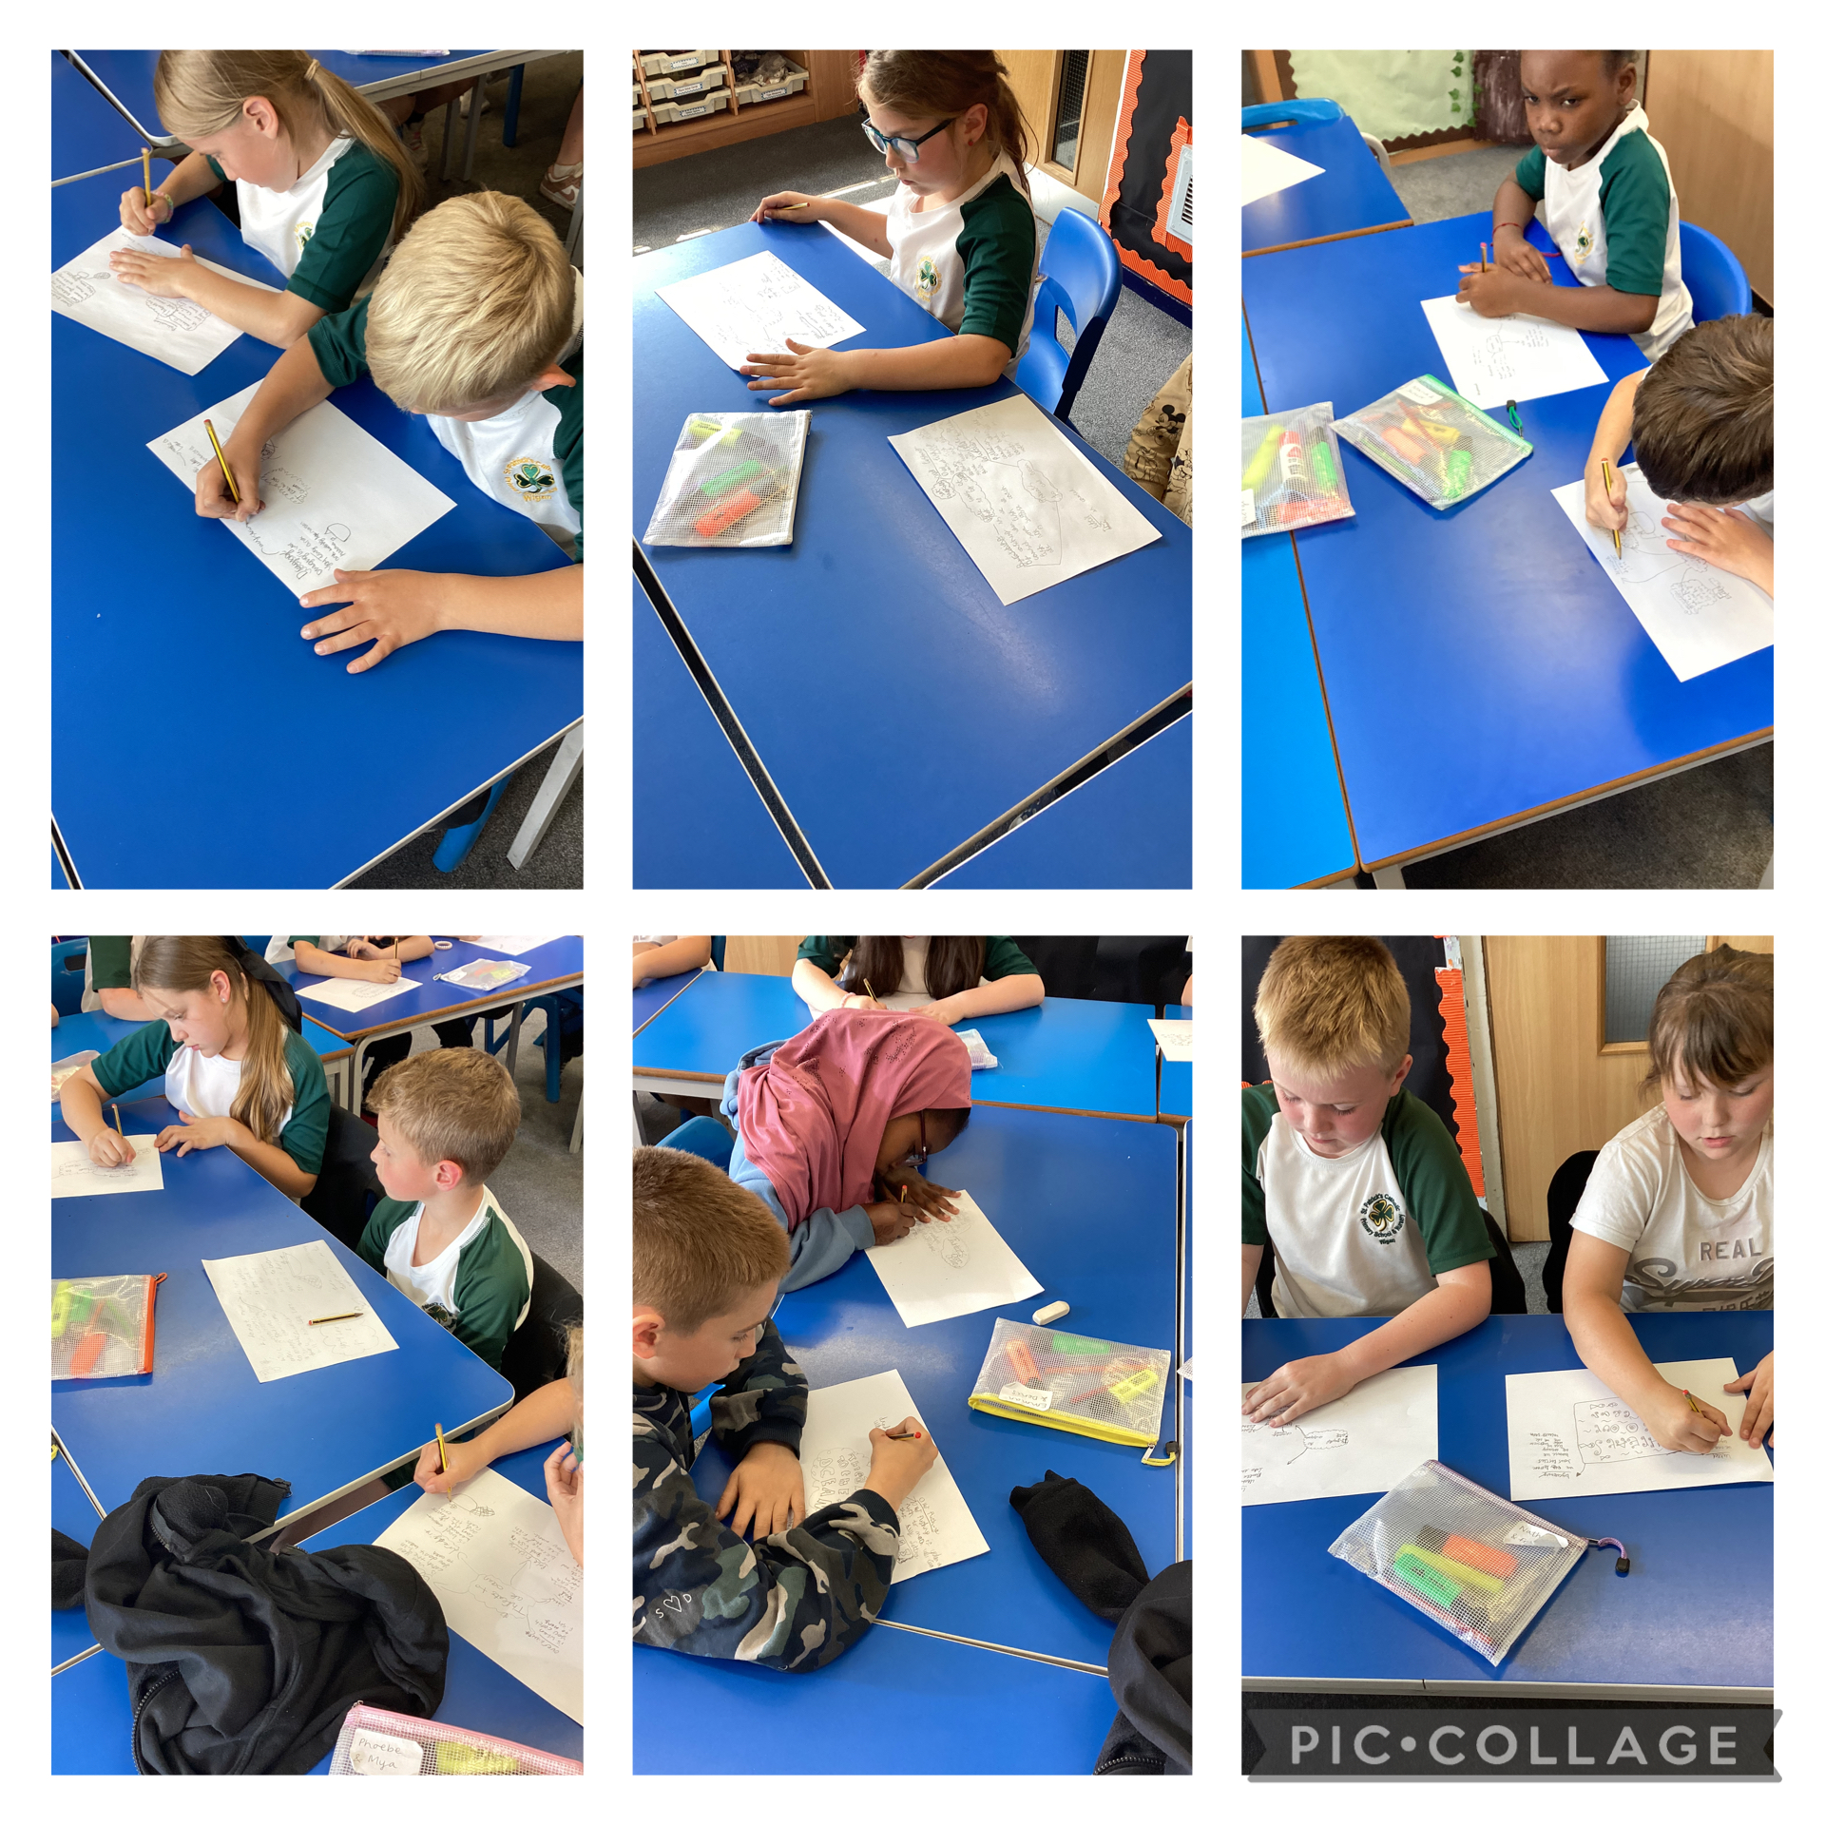
This week, Year 3 have been learning all about our seas. We created mind maps to showcase our knowledge on the threats to our oceans.

