

Newsletter - Week Beginning 2.6.2025
Dates, times and events are correct at the time of publication of this newsletter
(though may be subject to some alterations or additions).
‘We arise today to learn, love and grow through Jesus.’

Top attended classes for the previous week 19.5.2025 |   Class | Attendance %
Gold | Y4 | 99.33%
Silver | Y5 | 96.09%
Bronze | Y6 | 93.54%

Whole school current academic year
94.05%

Star of the Week
Week Beginning
19.5.2025
Nursery | Casey King | Reception | Lola Wilkieson
Nursery | Olive Atkins | Reception | Amelia Holding
Year 1 | Montano Ondo Belloso | Year 4 | Louie Robinson
Year 1 | Jacob Cockle | Year 4 | Abdurahman Rooby
Year 2 | Charlotte Ready | Year 5 | Reece Ashurst
Year 2 | Alice Nicorici | Year 5 | Aaliyah Yousef
Year 3 | Harry Abbott | Year 6 | Aurimas Abend
Year 3 | Millie Sherman | Year 6 | Noah Ashworth
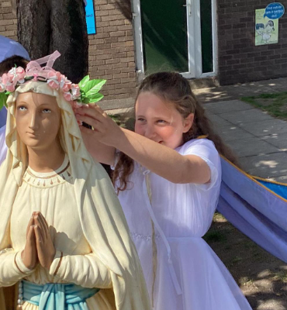
A huge well done to all of this year’s Sacramental Preparation Group, who took part in our annual May Crowning Celebrations on Friday 23rd May. This year, Evelyn in Year 4 had the honour of Crowning Our Lady as Queen of Heaven and of Earth. Ave, Maria!
Holiday club - Summer 2025
Safe & Sound Holiday club will be available from Monday 4th August 2025 for 4 weeks. If you would like to book your child a place or you require more information, please contact Mrs. Glaze or Mr. Worthington.
 01942 244361 option 3 ggg safeandsound@saintpatricks.wigan.sch.uk
Instagram - stpsafeandsound

Instagram - stpsafeandsound

Prices
£20 full day
£11 Half day


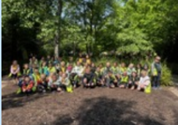


Events
11/6/2025 – Y6 Girls HH Kids Talk.
12/6/2025 – Y6 Boys HH Kids Talk.
23/6/2025 to 25/6/2025 - Y6 Residential.
30/6/2025 – Y5 Jubilee Year Retreat at Animate Youth.
8/7/2025 – Y5 attending SongShare at Robin Park.
9/7/2025 – Y2 attending SongShare at Robin Park.
10/7/2025 – Turn Wigan Purple.

This School Year finishes on Friday 19th July.

This week, Year 2 visited Blackpool Zoo. We had a fantastic time looking at all the different animals! All the children were very well behaved and were a credit to the school.

In Class This Week: Year 2

SPONSOR A SLATE 2025

If you would like the name(s) of a loved one to be inscribed on a slate before it is fitted to the new roof, please collect and return a sheet from Mr Marshall. Each slate is £20 to sponsor, and all names will be recorded in a special Commemorative Book in Church.
St Patrick’s Church

T

