


St. Patrick's
Catholic Primary School

‘We arise today to learn, love and grow through Jesus.’
Newsletter - Week Beginning 15.7.2024
Dates, times and events are correct at the time of publication of this newsletter
(though may be subject to some alterations or additions).
Top attended classes for the previous week 8.07.2024 |   Class | Attendance %
Gold | Y3G | 99.09%
Silver | Y4B | 97.39%
Bronze | Y3R | 97.24%
Whole school current academic year

9 92.15%

Star of the Week
Week Beginning
8.07.2024
Nursery | Connie Perkins | Reception | Sarah Ali
Nursery | Janan Bahrami | Reception | Joseph Livesley
Year 1 | Joe Corrigan | Year 4 | Mia Fishwick
Year 1 | Elliot Jones | Year 4 | Juliana Alnusairi
Year 2 | Mia Cooper | Year 5 | James France
Year 2 | Migle Maciulaityte | Year 5 | Jason Unah
Year 3 | All of Year 3! | Year 6 | Natan Hodor
Year 3 | All of Year 3! | Year 6 | Mia Aaron

I ask you to support us by checking your child(ren) on a regular basis. Thank you for your continuing support.
EMENTS

Achievements

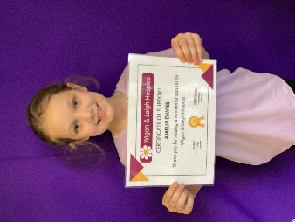
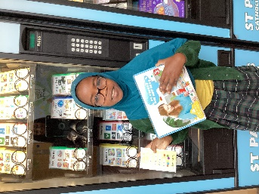
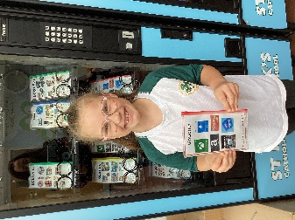

Emman for filling her achievement card
Amelia has raised £85 for Wigan and Leigh Hospice by making bracelets and selling them for charity.

Aubree for filling her achievement card

St Patrick’s Church

We 16th June 2018

Y4 Children who have taken part in this year’s Sacramental Preparation Programme will make their First Holy Communion in a special Mass. The Mass starts at 10am in St Patrick’s Church.
This will be a wonderful celebration for school and parish.
e processing into church from school at 1:45. Mass will start at 2pm. We his being a great parish and school celebration of our patron saint’s day.

Important Reminder:

School closes on Friday 19th July, at 3:15pm, for the Summer Holidays.

School reopens, at 8:45am, on Monday 2nd September for the start of the 2024/2025 Academic Year.

and can also A huge

Thank you

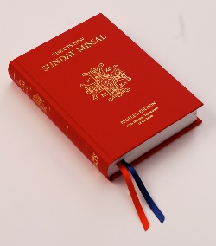

A huge thank you to Miss Roberts and Mr Baxter who leave us today.
We wish you all the best in your new roles in your new schools. They will be lucky to have you.

We are purchasing new Mass Books for the back of the Church. If you would like to sponsor a Mass Book in memory of a loved one, please place £20 (the cost of one individual book) in an envelope – alongside the person’s name – and hand to Mr Marshall or at Church directly. Names will be scribed on the inside front cover.

