


St. Patrick's
Catholic Primary School

‘We arise today to learn, love and grow through Jesus.’
Newsletter - Week Beginning 8.7.2024
Dates, times and events are correct at the time of publication of this newsletter
(though may be subject to some alterations or additions).
Top attended classes for the previous week 01.07.2024 |   Class | Attendance %
Gold | Y3R | 97.73%
Silver | Y4B | 96.96%
Bronze | Y2R | 96.36%
Whole school current academic year

9 92.10%

Star of the Week
Week Beginning
01.07.2024
Nursery | Amelia Holding | Reception | William Hart
Nursery | Emily Newton | Reception | Lucas Tarbuck
Year 1 | Rayan Matthew | Year 4 | Finlay Horrigan
Year 1 | Kamil Handke | Year 4 | Harry Burton-Steele
Year 2 | Aubree Clayton | Year 5 | Henry Haugh
Year 2 | Oliver Clarke | Year 5 | Carrick O’Donnell
Year 3 | Amelia Jazdzewska | Year 6 | Charlie Sharrock
Year 3 | Zahran Ahmed | Year 6 | Isla-Rose Perry

Children ar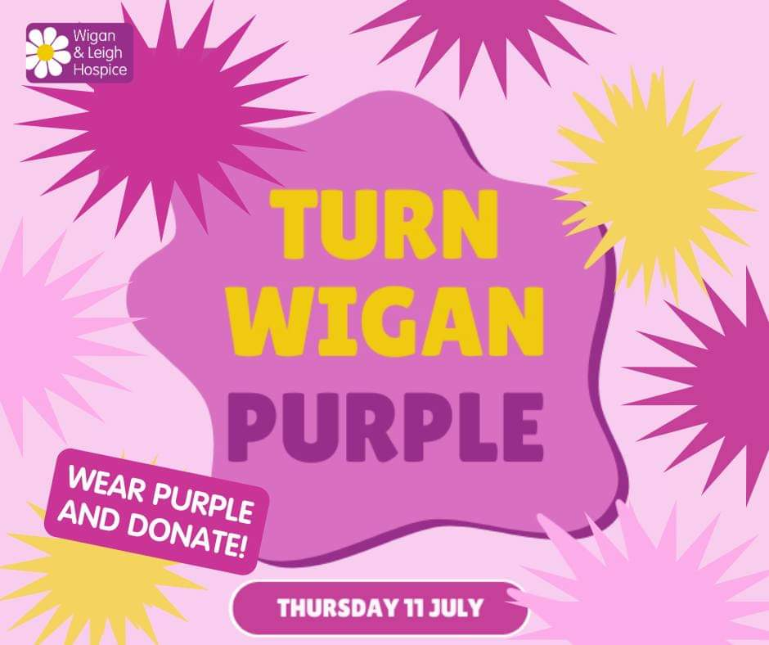

u
Thursday 11th July 2024
Please donate £1

I ask you to support us by checking your child(ren) on a regular basis. Thank you for your continuing support.
EMENTS

Gates open from 2:30 races to start at 2:45

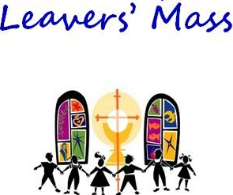

I ask you to support us by checking your child(ren) on a regular basis. Thank you for your continuing support.
EMENTS

Sports Day 2024

End of Academic Year and Year 6 Leavers’ Celebration Mass

9:30am on Thursday 18th July in
St. Patrick’s Church. All welcome.

St Patrick’s Church

We 16th June 2018

Y4 Children who have taken part in this year’s Sacramental Preparation Programme will make their First Holy Communion in a special Mass. The Mass starts at 10am in St Patrick’s Church.
This will be a wonderful celebration for school and parish.
e processing into church from school at 1:45. Mass will start at 2pm. We his being a great parish and school celebration of our patron saint’s day.

Important Reminder:

School closes on Friday 19th July, at 3:15pm, for the Summer Holidays.

School reopens, at 8:45am, on Monday 2nd September for the start of the 2024/2025 Academic Year.

and can also

In Class This Week – Year 6

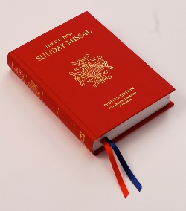


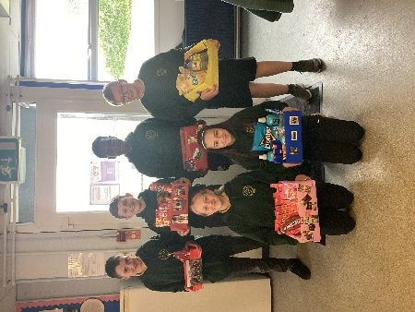

We are purchasing new Mass Books for the back of the Church. If you would like to sponsor a Mass Book in memory of a loved one, please place £20 (the cost of one individual book) in an envelope – alongside the person’s name – and hand to Mr Marshall or at Church directly. Names will be scribed on the inside front cover.

In D&T this week we have been exploring market research and designing our ‘bring a box’ reading for Pat’s Fest.

