


St. Patrick's
Catholic Primary School

‘We arise today to learn, love and grow through Jesus.’
Newsletter - Week Beginning 1.7.2024
Dates, times and events are correct at the time of publication of this newsletter
(though may be subject to some alterations or additions).
Top attended classes for the previous week 24.6.2024 |   Class | Attendance %
Gold | Y3SR | 98.64
Silver | Y2LR | 95.91
Bronze | YRDM | 95.24
Whole school current academic year

9 92.11%

Star of the Week
Week Beginning
24.6.2024
Nursery | Jayden Idam Aluu | Reception | Evie Caie-Birch
Nursery | Lola Wilkieson | Reception | Montano Ono Belloso
Year 1 | Mason Stokes | Year 4 | Andreea Mocanu
Year 1 | Alice Nicorici | Year 4 | Isaac Sharratt
Year 2 | Leona Jones | Year 5 | Harley Starkie
Year 2 | Erika Cochintoiu | Year 5 | Wiktor Kolnierowicz
Year 3 | Evelyn Prescott | Year 6 | Kofi Antwi
Year 3 | Rory Whyte | Year 6 | Bethany Rigby

Children ar

Thursday 11th July 2024
Please donate £1

I ask you to support us by checking your child(ren) on a regular basis. Thank you for your continuing support.
EMENTS

Gates open from 2:30 races to start at 2:45

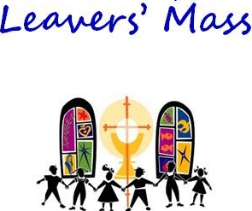

I ask you to support us by checking your child(ren) on a regular basis. Thank you for your continuing support.
EMENTS

Sports Day 2024

End of Academic Year and Year 6 Leavers’ Celebration Mass

9:30am on Thursday 18th July in
St. Patrick’s Church. All welcome.

St Patrick’s Church

Events

Upcoming Class Masses:
Thursday 11th July - Year 4
(Please note: These may be cancelled if a Funeral Mass is being celebrated that day)

Upcoming Stay and Prays:
Friday 12th July – Year 4

We 16th June 2018

Y4 Children who have taken part in this year’s Sacramental Preparation Programme will make their First Holy Communion in a special Mass. The Mass starts at 10am in St Patrick’s Church.
This will be a wonderful celebration for school and parish.
e processing into church from school at 1:45. Mass will start at 2pm. We his being a great parish and school celebration of our patron saint’s day.

and can also reproduc e.

In Class This Week – Year 5

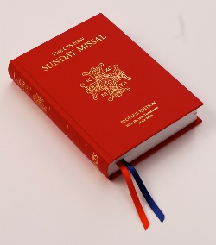
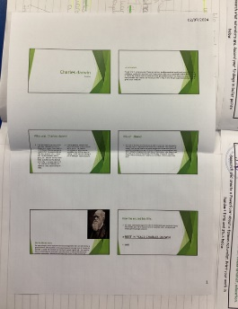

We are purchasing new Mass Books for the back of the Church. If you would like to sponsor a Mass Book in memory of a loved one, please place £20 (the cost of one individual book) in an envelope – alongside the person’s name – and hand to Mr Marshall or at Church directly. Names will be scribed on the inside front cover.
This week, we have been learning about the work of naturalists. We researched a famous naturalist, such as Sir David Attenborough, and created a PowerPoint about their work. We enjoyed sharing this with the rest of the class.

