


St. Patrick's
Catholic Primary School

‘We arise today to learn, love and grow through Jesus.’
Newsletter - Week Beginning 24.6.2024
Dates, times and events are correct at the time of publication of this newsletter
(though may be subject to some alterations or additions).
Top attended classes for the previous week 17.6.2024 |   Class | Attendance %
Gold | Y2LR | 97.27%
Silver | Y6P | 95.45%
Bronze | Y6DE | 93.48%
Whole school current academic year

9 92.16%

Star of the Week
Week Beginning
17.6.2024
Nursery | Rory Davies | Reception | Ruby Bullough
Nursery | Arnas Abend | Reception | Lukas Uzga
Year 1 | Sienna Simm | Year 4 | Daren Abdullah
Year 1 | Esme Ruddy | Year 4 | Reece Ashurst
Year 2 | Callie Eastham | Year 5 | Erin Hopper
Year 2 | Jace Manley | Year 5 | Owen Jones
Year 3 | Adriel Maseya | Year 6 | Macie-May Simm
Year 3 | Jamie Eastham | Year 6 | Kofi Antwi

Congratulations…

A

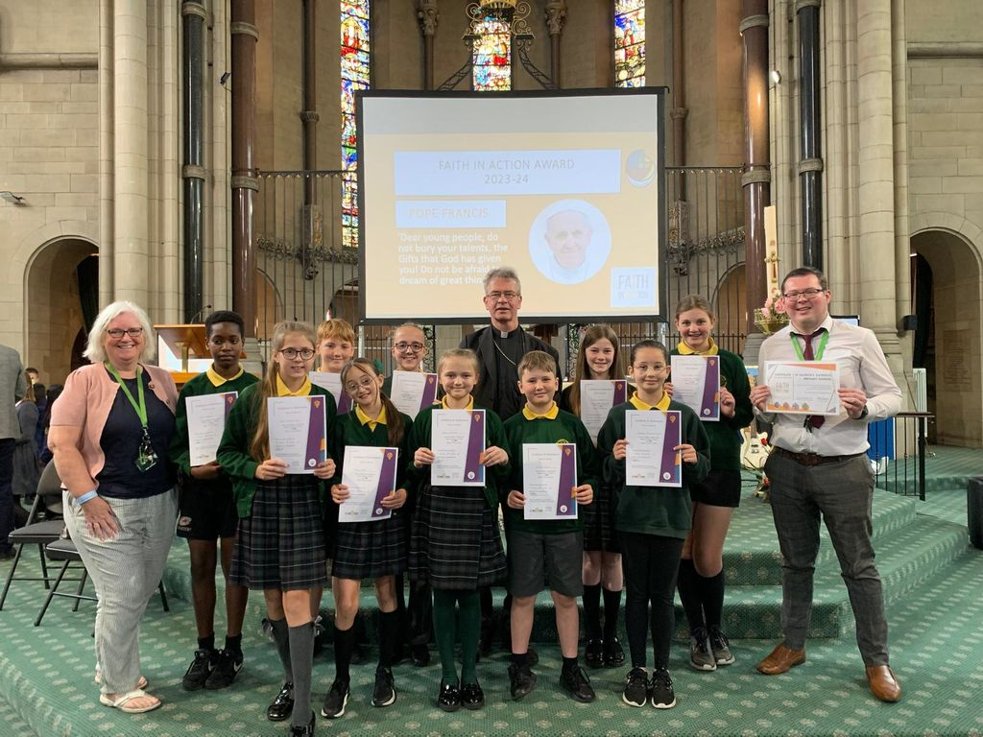

I ask you to support us by checking your child(ren) on a regular basis. Thank you for your continuing support.
EMENTS

Interested in becoming a teacher?
Sports Day 2024

I ask you to support us by checking your child(ren) on a regular basis. Thank you for your continuing support.
EMENTS

Gates open from 2:30 races to start at 2:45

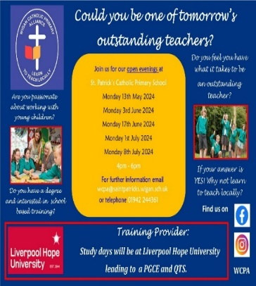
To our Year 6 Children, who received their Faith in Action Awards last week from Bishop Tom Neylon. Well done, children, we are so very proud of you!

St Patrick’s Church

We 16th June 2018

Y4 Children who have taken part in this year’s Sacramental Preparation Programme will make their First Holy Communion in a special Mass. The Mass starts at 10am in St Patrick’s Church.
This will be a wonderful celebration for school and parish.
e processing into church from school at 1:45. Mass will start at 2pm. We his being a great parish and school celebration of our patron saint’s day.

and can also reproduce.

Events

Upcoming Class Masses:
Thursday 4th July – Year 5
Thursday 11th July = Year 4
(Please note: These may be cancelled if a Funeral Mass is being celebrated that day).

Upcoming Stay and Prays:
Friday 5th July – Year 5
Friday 12th July – Year 4

In Class This Week – Year 4

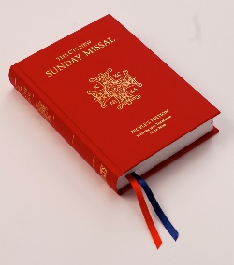
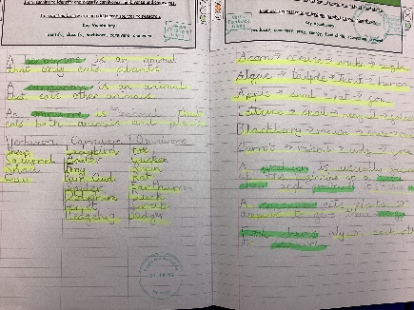

We are purchasing new Mass Books for the back of the Church. If you would like to sponsor a Mass Book in memory of a loved one, please place £20 (the cost of one individual book) in an envelope – alongside the person’s name – and hand to Mr Marshall or at Church directly. Names will be scribed on the inside front cover.
This week, in Year 4, the children are learning about eating and digestion. This started with animals and if they are a herbivore, carnivore or omnivore. They also explored food chains.

