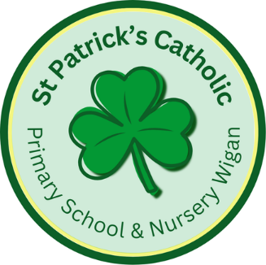

Newsletter - Week Beginning 19.5.2025
Dates, times and events are correct at the time of publication of this newsletter
(though may be subject to some alterations or additions).
‘We arise today to learn, love and grow through Jesus.’

Top attended classes for the previous week 12.5.2025 |   Class | Attendance %
Gold | Y4 | 99.11%
Silver | Y1 | 96.83%
Bronze | Y3 | 94.44%
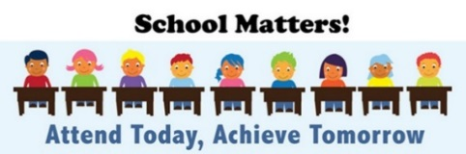
Whole school current academic year
94.09%

Star of the Week
Week Beginning
12.5.2025
Nursery | Nilah Nidhin | Reception | Kye Malone
Nursery | Scarlett McMullen | Reception | Milana Mitickina
Year 1 | Enijie Boasiako | Year 4 | Poppy Burton-Steele
Year 1 | Kaira Omokwe | Year 4 | Jessica Lee
Year 2 | Sienna-Rose Simm | Year 5 | Nevaeh Reeves
Year 2 | Taylan Uzsoy | Year 5 | Lewie Rennox
Year 3 | Nathan Barry | Year 6 | All of our SATs Superstars!
Year 3 | Emilie Hirst | Year 6 | All of our SATs Superstars!

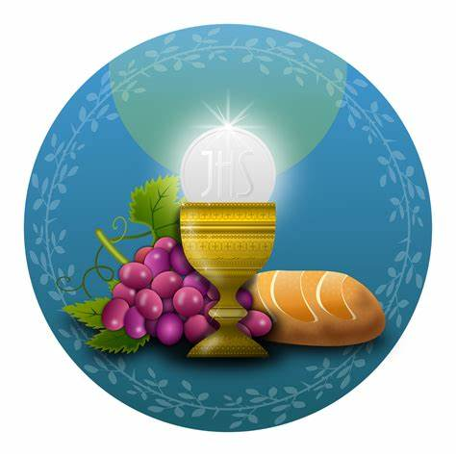

A huge well done to all of this year’s Sacramental Preparation Group, who made their First Holy Communion on Saturday 17th May. Thank you to all those involved in preparing and helping the children.
A Half Term Prayer
We thank you, Lord, for this Half Term. For our challenges, our successes and the mistakes from which we have learnt. Be with us as we spend our time with family and friends. Keep us safe in our activities; grant us a good rest and good fun. Bring us back refreshed and ready for a new Half Term. Amen

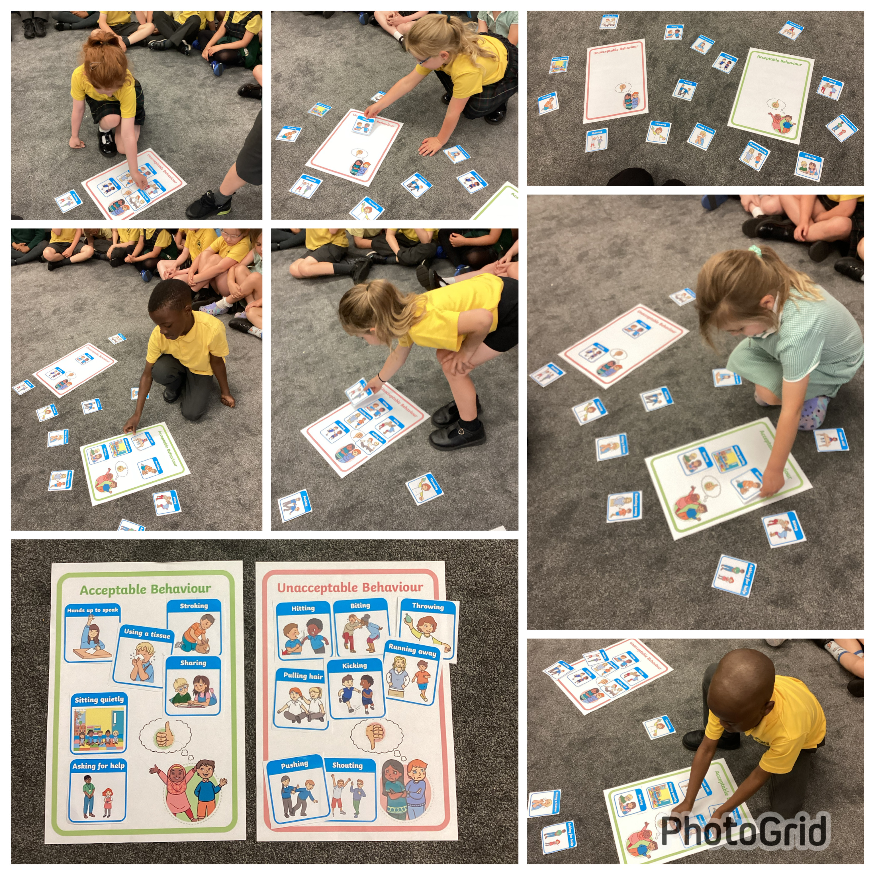

T

Going for Gold!
Events
Monday 26th May to Friday 30th May 2025 – Half Term.
3/6/2025 – CAFOD in School delivering assemblies and workshops.
4/6/2025 – Year 4 visiting the Catholic Cathedral.
4/6/2025 – Year 2 visiting Blackpool Zoo.
5/6/2025 – Year 5 and 6 Hate Crime Workshops in School.
11/6/2025 – Y6 Girls HH Kids Talk.
12/6/2025 – Y6 Boys HH Kids Talk.

In Class This Week: Year 1

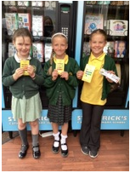
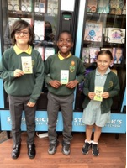
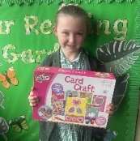
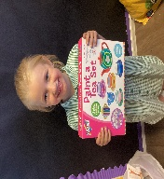
Freya H, Eden and Freya B also filled their Going for Gold sticker charts and they used the vending machine to choose a craft set, Smyths voucher and a dart board as their prizes. Freya B also filled her reading bookmark and chose a book from the vending machine as her prize.
Jackson, Kenny and Amelia filled their Going for Gold sticker charts and they used the vending machine to choose a football, lego set and rugby ball as their prizes.
Elsie filled her Going for Gold sticker chart and used the vending machine to choose her pottery painting set!

Hallie also filled her Going for Gold sticker chart and used the vending machine to choose her card craft set!

This week the children in Year 1 have discussed acceptable and unacceptable behaviours. The children sorted different scenarios into the different categories.

