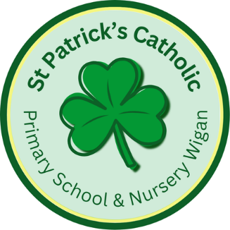

Newsletter - Week Beginning 12.5.2025
Dates, times and events are correct at the time of publication of this newsletter
(though may be subject to some alterations or additions).
‘We arise today to learn, love and grow through Jesus.’

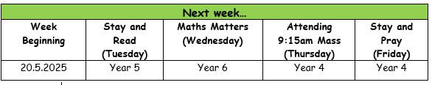

Top attended classes for the previous week 6.5.2025 |   Class | Attendance %
Gold | Y1 | 96.04%
Silver | Y4 | 95.28%
Bronze | Y6 | 94.94%

Whole school current academic year
94.09%

Star of the Week
Week Beginning
6.5.2025
Nursery | Khamilah Olayiwola | Reception | Lochlan Barry
Nursery | Simon Ward | Reception | Khalid Olayiwola
Year 1 | Faustas Barcaitis | Year 4 | Evelyn Prescott
Year 1 | Georgie O’Neill | Year 4 | Matas Maciulaitis
Year 2 | Evie Price | Year 5 | Aaliyah Youssef
Year 2 | Dollie Eccles | Year 5 | Freddie Bannister
Year 3 | Amelia Unsworth | Year 6 | Henry Haugh
Year 3 | Mya Clark | Year 6 | Isaac Mather
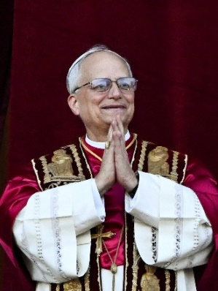
Well done, Year 6!
Year 6 have this week completed their SATs Tests (in Maths, Reading and SPaG) with great maturity and focus this week. They enjoyed a visit to Mesnes Park, on Friday, to celebrate the end of SAT Week.
We join Catholics, around the world, in uniting in joy and prayer at the election of Pope Leo XIV.
We pray the new Holy Father will be strengthened in his ministry and that he will continue building bridges that connect us to one another.


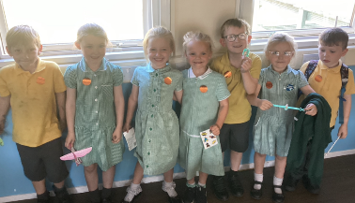
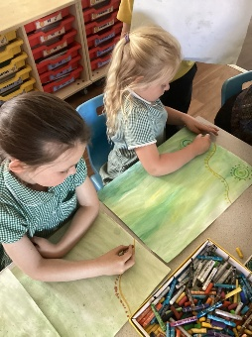
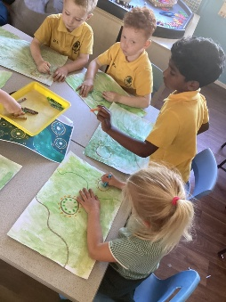

Danson, Hallie, Elsie, Lucy, Liam, Amelia and Max were also awarded a Headteachers Award this week for their fantastic writing!
This week, Reception have been creating aboriginal inspired artwork for our Monkey Puzzle jungle display.
In Class This Week: Reception

SPONSOR A SLATE 2025

If you would like the name(s) of a loved one to be inscribed on a slate before it is fitted to the new roof, please collect and return a sheet from Mr Marshall. Each slate is £20 to sponsor, and all names will be recorded in a special Commemorative Book in Church.

T
St Patrick’s Church
Events
12/5/2025 – Y6 SATs Week in School.
17/5/2025 (Saturday) – First Holy Communion Mass (10am) at St John’s Church
19/5/2025 – Y3 visiting the Heritage Centre.
23/5/2025 – Celebrations in Honour of Our Lady (Private Celebration this year – Sacramental Programme can wear their First Holy Communion outfits again).

Monday 26th May to Friday 30th May 2025 – Half Term.

