

Newsletter - Week Beginning 5.5.2025
Dates, times and events are correct at the time of publication of this newsletter
(though may be subject to some alterations or additions).
‘We arise today to learn, love and grow through Jesus.’

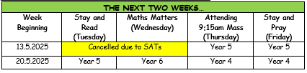

Top attended classes for the previous week 28.4.2025 |   Class | Attendance %
Gold | Rec | 95.91%
Silver | Y5 | 95.43%
Bronze | Y4 | 95.11%

Whole school current academic year
94.11%

Star of the Week
Week Beginning
28.4.2025
Nursery | Lilith Edwards | Reception | Danson McMullen
Nursery | Maeve Edwardson | Reception | Thomas Lee
Year 1 | Jayden Ward | Year 4 | Riyan Praveen John
Year 1 | Torin Edwards | Year 4 | Kevinas Barcaitis
Year 2 | Elliott Jones | Year 5 | Layla Unsworth
Year 2 | Lexi Stroud | Year 5 | Joe Disley-Shaw
Year 3 | Lucas Hockey | Year 6 | All children, for working incredibly hard
Year 3 | Aubree Clayton | Year 6 | All children, for working incredibly hard
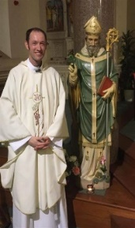
Sunday 11th May is Good Shepherd Sunday, in which we celebrate Vocations to the Priesthood. Two of our former pupils are currently serving Priests in the Archdiocese: Fr Andrew Unsworth & Fr Anthony Kelly. Please pray for them.
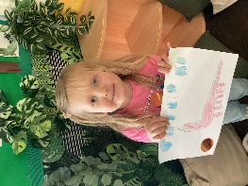
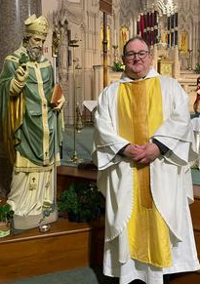
ACHIEVEMENTS
Lilith has achieved a Head Teachers Award for her excellent drawing of a dinosaur.
Well done Lilith!


T
Events
12/5/2025 – Y6 SATs Week in School.
17/5/2025 (Saturday) – First Holy Communion Mass (10am) at St John’s Church
19/5/2025 – Y3 visiting the Heritage Centre.
23/5/2025 – Celebrations in Honour of Our Lady (Private Celebration this year).

Monday 26th May to Friday 30th May 2025 – Half Term.

In Class This Week: Nursery

This week in Nursery we have taken part in a volcano science experiment. We mixed the ingredients together and watched the volcano erupt.

St Patrick’s Church
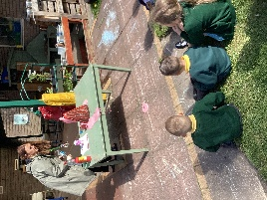
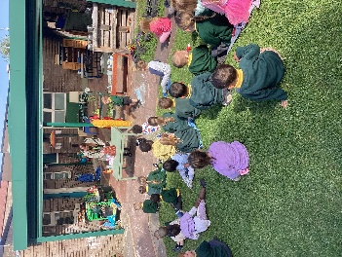
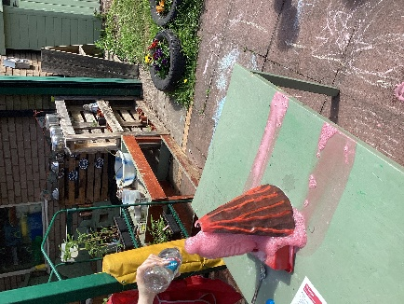
SPONSOR A SLATE 2025

If you would like the name(s) of a loved one to be inscribed on a slate before it is fitted to the new roof, please collect and return a sheet from Mr Marshall. Each slate is £20 to sponsor, and all names will be recorded in a special Commemorative Book in Church.

