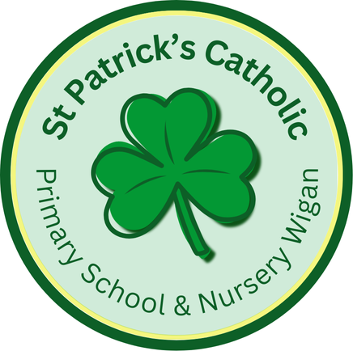

Newsletter - Week Beginning 28.4.2025
Dates, times and events are correct at the time of publication of this newsletter
(though may be subject to some alterations or additions).
‘We arise today to learn, love and grow through Jesus.’

Top attended classes for the previous week 7.4.2025 |   Class | Attendance %
Gold | Y5 | 98.48
Silver | Y4 | 97.56
Bronze | Y3 | 95.33

Whole school current academic year
94.26%

Star of the Week
Week Beginning
7.4.2025
Nursery | Violet McMullen | Reception | Alex Reyes-Laithwaite
Nursery | Fred Abbott | Reception | Rorey Leyland
Year 1 | Aoife-Jean Miller | Year 4 | Archie Bullough
Year 1 | Lukas Uzga | Year 4 | Amelia Jazdzewska
Year 2 | Finn Welsby | Year 5 | Finlay Horrigan
Year 2 | Mason Stokes Jarosz | Year 5 | Jake Gaskell
Year 3 | Isabelle Oczerklewicz | Year 6 | Annabella Edwardson
Year 3 | Aria Carrington | Year 6 | Busra Ucar

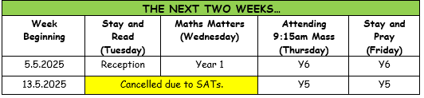

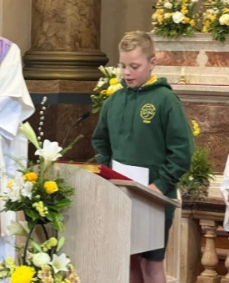
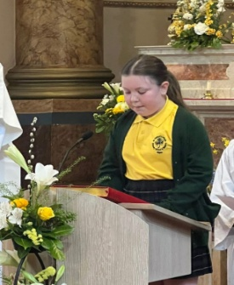
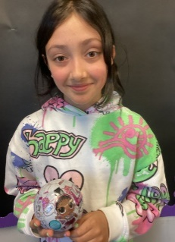
Well done to Jessica, Y4 for completing her ‘Going for Gold’ chart. Here she is with her prize.
ACHIEVEMENTS
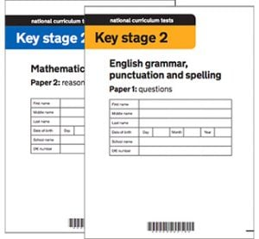
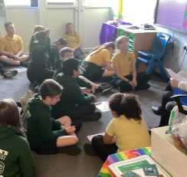

In Class This Week: Year 6

Well done to Patrick, Y6, and Layla. Y5, who represented our school by doing the Bidding Prayers at Fr Paul’s Induction Mass last Wednesday evening.
SPONSOR A SLATE 2025

If you would like the name(s) of a loved one to be inscribed on a slate before it is fitted to the new roof, please collect and return a sheet from Mr Marshall. Each slate is £20 to sponsor, and all names will be recorded in a special Commemorative Book in Church.

T
St Patrick’s Church
Events
7/5/2025 – Y5 working with HH Kids.
8/5/2025 – 80th Anniversary of the end of the Second World War in Europe.
12/5/2025 – Y6 SATs Week in School.
17/5/2025 (Saturday) – First Holy Communion Mass (10am)
19/5/2025 – Y3 visiting the Heritage Centre.
23/5/2025 – Celebrations in Honour of Our Lady (Tbc).
Monday 26th May to Friday 30th May 2025 – Half Term.

This week, we have been practising for our upcoming SATs Tests. This has included revising different question types in Reading. We have loved using mini-whiteboards to record and share our answers and methods. Please remember us in your prayers over the next few weeks!

