


St. Patrick's
Catholic Primary School

‘We arise today to learn, love and grow through Jesus.’
Newsletter - Week Beginning 20.5.2024
Dates, times and events are correct at the time of publication of this newsletter
(though may be subject to some alterations or additions).
Top attended classes for the previous week 13.5.2024 |   Class | Attendance %
Gold | Y6P | 100%
Silver | Y6DE | 96.52%
Bronze | Y4CB | 94.78%
Whole school current academic year

9 92.25%


Star of the Week
Week Beginning
13.5.2024
Nursery | Moustapha Mbacke | Reception | Torin Edwards
Nursery | Alex Reyes-Laithwaite | Reception | Parizay Ahmed
Year 1 | Carmen Wills | Year 4 | Harvey Hockey
Year 1 | Arthur Hindley | Year 4 | Devadutt Abhilash
Year 2 | Harry Abbott | Year 5 | Isaac Mather
Year 2 | Dawid Swidrak | Year 5 | Nashe Guta
Year 3 | Mikey Brogan | Year 6 | All of our SATs Superstars!
Year 3 | Ella Knowles | Year 6 | All of our SATs Superstars!

A

Interested in becoming a teacher?
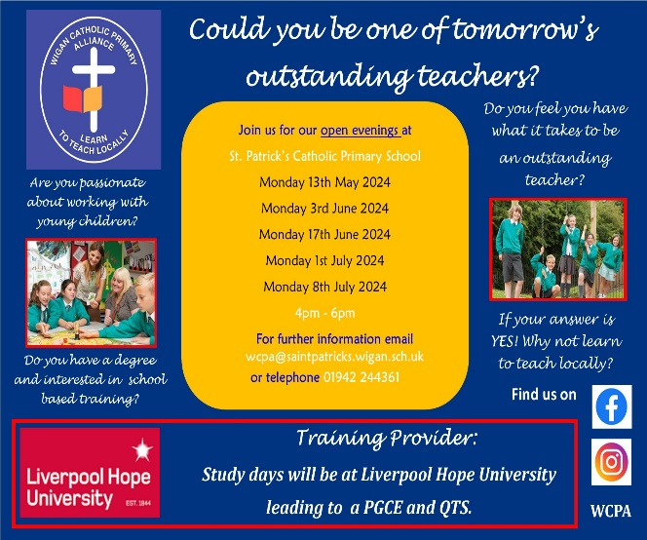
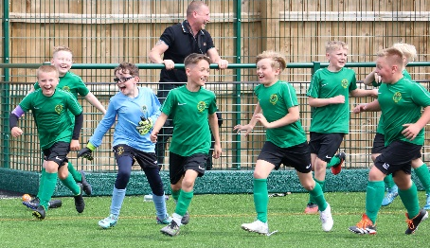

I ask you to support us by checking your child(ren) on a regular basis. Thank you for your continuing support.
EMENTS

Upcoming Stay and Reads (In the Infant Hall):

Tuesday 4th June – Year 4
Tuesday 11th June – Year 3
Tuesday 18th June – Year 2
Tuesday 25th June – Year 1

I ask you to Upcoming Class Masses
Thursday 23rd May – Year 5
Thursday 6th June – Year 4
Thursday 13th June – Year 3
Thursday 20th June – Year 2
Thursday 27th June – Year 6
support us by checking your child(ren) on a regular basis. Thank you for your continuing support.
EMENTS

Congratulations to our Years 4 and 5 children who played in a 38 Team Football Tournament at Laithwaite Park last week. They were excellent St Patrick’s Ambassadors and made it to the Semi Finals. Well done, boys, we are so proud of you!



We 16th June 2018

Y4 Children who have taken part in this year’s Sacramental Preparation Programme will make their First Holy Communion in a special Mass. The Mass starts at 10am in St Patrick’s Church.
This will be a wonderful celebration for school and parish.
e processing into church from school at 1:45. Mass will start at 2pm. We his being a great parish and school celebration of our patron saint’s day.

and can also reproduce.

In Class This Week – Nursery

St Patrick’s Church


Events
Upcoming Class Masses:
Thursday 6th June – Year 4
Thursday 13th June – Year 3
Thursday 20th June – Year 2
Thursday 27th June – Year 6
(Please note: These may be cancelled if a Funeral Mass is being celebrated that day).

Upcoming Stay and Prays:
Friday 7th June – Year 3;
Friday 14th June – Year 2
Friday 21st June – Year 1
Friday 28th June – Reception.

May Half Term: Monday 27th May – Friday 31st May
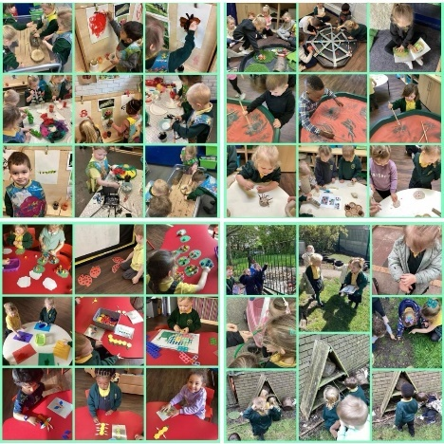

After the 9:15am Mass this Sunday, 26th May, in the Lappin Room.

All proceeds to Restoration Funds. Everyone welcome.

The Nursery children have been learning about minibeasts.

