


St. Patrick's
Catholic Primary School

‘We arise today to learn, love and grow through Jesus.’
Newsletter - Week Beginning 13.5.2024
Dates, times and events are correct at the time of publication of this newsletter
(though may be subject to some alterations or additions).
Top attended classes for the previous week 6.5.2024 |   Class | Attendance %
Gold | Y3R | 96.74%
Silver | Y6E | 94.02%
Bronze | Y4B | 93.48%
Whole school current academic year

9 92.26%


Star of the Week
Week Beginning
6.5.2024
Nursery | Kye Malone | Reception | Ivy Lucas
Nursery | Liam Hockey | Reception | Sarah Ali
Year 1 | Jack Aaron | Year 4 | Isaac Sharratt
Year 1 | Rayan Mathew | Year 4 | Evie Wilde-Causey
Year 2 | Erika Cochintoiu | Year 5 | Emma Mafimisebi
Year 2 | Freya Dickenson | Year 5 | Denise Nweke
Year 3 | Evie Morris | Year 6 | Aya Ali
Year 3 | Amber-Rose Samuel | Year 6 | Cataleya Fernandes Clara

A

Interested in becoming a teacher?
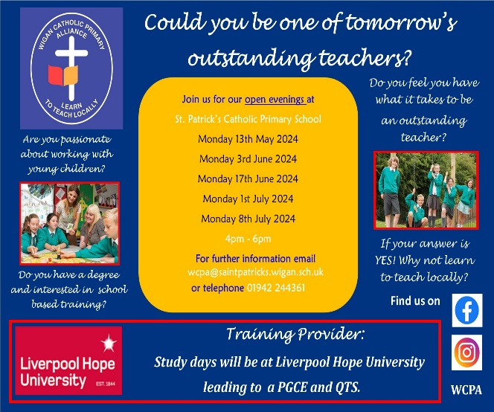

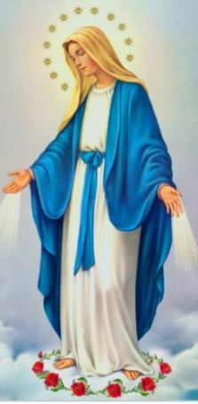
Upcoming Stay and Reads (In the Infant Hall):

Tuesday 21st May – Year 5
Tuesday 4th June – Year 4
Tuesday 11th June – Year 3
Tuesday 18th June – Year 2
Tuesday 25th June – Year 1

I ask you to Upcoming Class Masses
Thursday 23rd May – Year 5
Thursday 6th June – Year 4
Thursday 13th June – Year 3
Thursday 20th June – Year 2
Thursday 27th June – Year 6
support us by checking your child(ren) on a regular basis. Thank you for your continuing support.
EMENTS

I ask you to support us by checking your child(ren) on a regular basis. Thank you for your continuing support.
EMENTS

May – The Month of Mary
Timetable of Events
During the month of May, we honour Our Lady in our Parish in following ways:
- Praying the Holy Rosary in Church on Wednesdays at 4:15pm;
- Friday 26th May - 1:45pm Procession and 2pm School Crowning Service.



Events
Upcoming Class Masses:
Thursday 23rd May – Year 5
Thursday 6th June – Year 4
Thursday 13th June – Year 3
Thursday 20th June – Year 2
Thursday 27th June – Year 6
(Please note: These may be cancelled if a Funeral Mass is being celebrated that day).

Upcoming Stay and Prays:
Friday 24th May – Year 4
Friday 7th June – Year 3;
Friday 14th June – Year 2
Friday 21st June – Year 1
Friday 28th June – Reception.

Friday 24th May: May Crowning Celebrations
1:45pm Procession and 2pm Service.

May Half Term: Monday 27th May – Friday 31st May
and can also reproduce.

In Class This Week – Year 6

We 16th June 2018

Y4 Children who have taken part in this year’s Sacramental Preparation Programme will make their First Holy Communion in a special Mass. The Mass starts at 10am in St Patrick’s Church.
This will be a wonderful celebration for school and parish.
e processing into church from school at 1:45. Mass will start at 2pm. We his being a great parish and school celebration of our patron saint’s day.

St Patrick’s Church

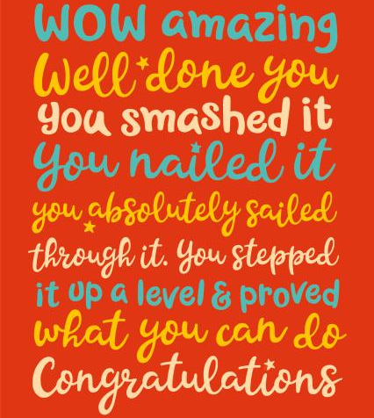
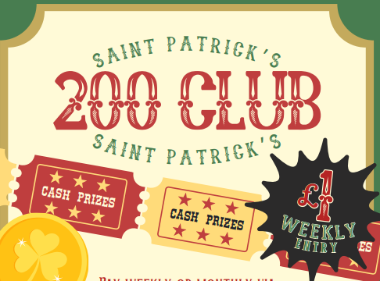

This week, the children have completed their national SATs Tests in Reading, Maths and SPaG (Spelling, Punctuation and Grammar). Thank you to everybody who remembered the children in prayer. Well done, Year 6!

If any parents, carers or family members would like to join Church’s 200 Club via Standing Order, please speak to Mr Marshall.
£1 a week to play with a £50 winner each week. You have to be in it to win it!

