


St. Patrick's
Catholic Primary School

‘We arise today to learn, love and grow through Jesus.’
Newsletter - Week Beginning 29.4.2024
Dates, times and events are correct at the time of publication of this newsletter
(though may be subject to some alterations or additions).
Top attended classes for the previous week 22.4.2024 |   Class | Attendance %
Gold | Y4H | 100%
Silver | Y3G | 98.2%
Bronze | Y5G | 97.4%
Whole school current academic year

9 92.38%


Star of the Week
Week Beginning
22.4.2024
Nursery | Hallie Larsen | Reception | Ruby Bullough
Nursery | Mauricio Quijada | Reception | Thrilokh Anoop
Year 1 | Freddie Haynes | Year 4 | Lewie Rennox
Year 1 | Excel Ofoha | Year 4 | Layla Jamieson
Year 2 | Brody Whyte | Year 5 | Victory Aihimegbe
Year 2 | Nathan Barry | Year 5 | Sophina Ashton
Year 3 | Mason Cain | Year 6 | Emile Prialgauskiate
Year 3 | Henry Sawers | Year 6 | Isla-Rose Perry

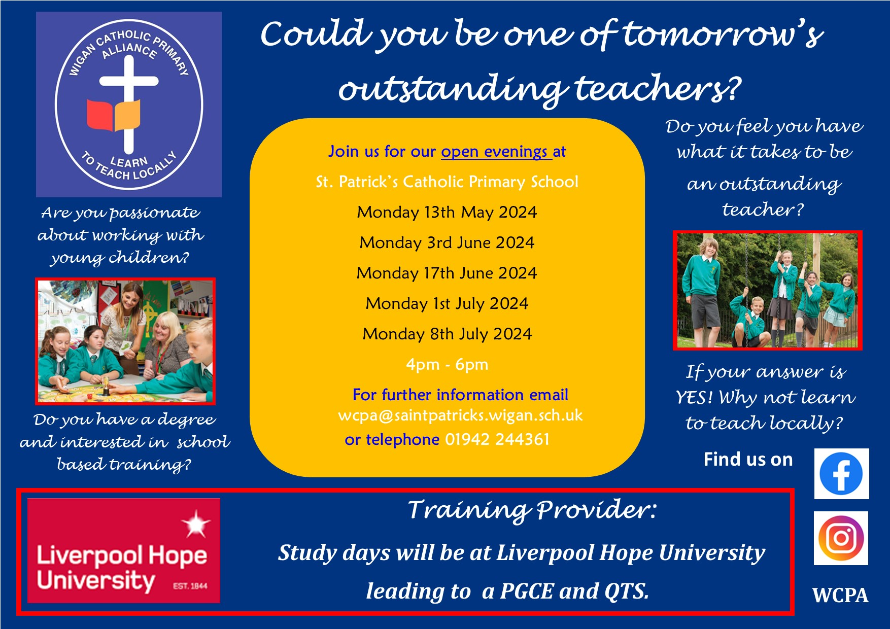

A

Interested in becoming a teacher?

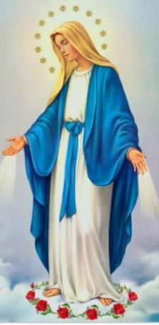

I ask you to support us by checking your child(ren) on a regular basis. Thank you for your continuing support.
EMENTS

May – The Month of Mary
Timetable of Events
During the month of May, we honour Our Lady in our Parish in following ways:
- Praying the Holy Rosary in Church on Wednesdays at 4:15pm;
- Friday 24th May - 1:45pm Procession and 2pm School Crowning Service.

In Class This Week – Year 4

and can also reproduce.

Events
Thursday KS2 Class Masses - Summer 1:
9th May – Year 2;
16th May – Year 6;
23rd May – Year 5.
(Please note: These may be cancelled if a Funeral Mass is being celebrated that day).

Stay and Pray - Summer 1:
Friday 10th May – Year 6;
Friday 17th May – Year 5;
Friday 24th May – Year 4.

Saturday 18th May: 10am First Holy Communion Mass.

Friday 24th May: May Crowning Celebrations
1:45pm Procession and 2pm Service.

May Half Term: Monday 27th May – Friday 31st May
We 16th June 2018

Y4 Children who have taken part in this year’s Sacramental Preparation Programme will make their First Holy Communion in a special Mass. The Mass starts at 10am in St Patrick’s Church.
This will be a wonderful celebration for school and parish.
e processing into church from school at 1:45. Mass will start at 2pm. We his being a great parish and school celebration of our patron saint’s day.

St Patrick’s Church

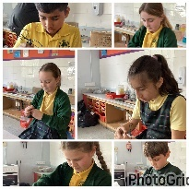
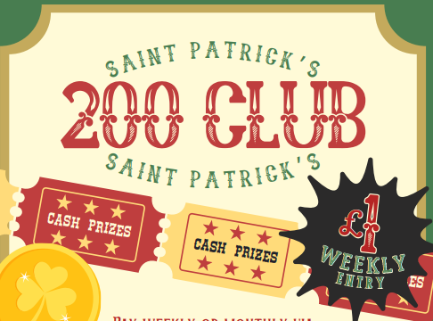
This week, Year 4 explored wire work to create a sculpture in the style of Henry Moore.

and can also reproduce.

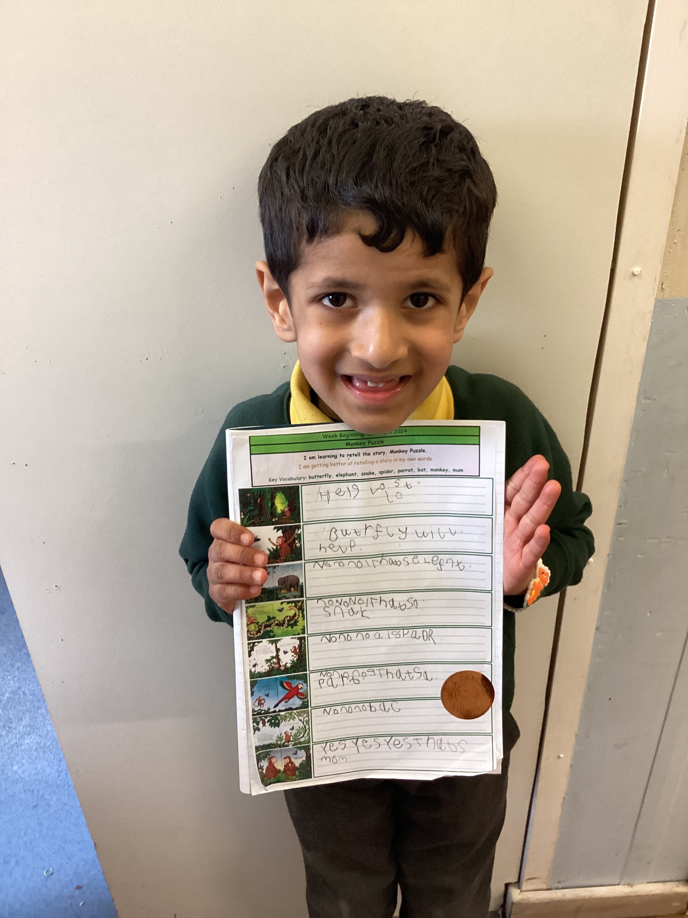
Headteacher’s Award
Arjun has received a Headteacher’s Award for his wonderful retell of ‘Monkey Puzzle.’

If any parents, carers or family members would like to join Church’s 200 Club via Standing Order, please speak to Mr Marshall.
£1 a week to play with a £50 winner each week. You have to be in it to win it!

