


St. Patrick's
Catholic Primary School

‘We arise today to learn, love and grow through Jesus.’
Newsletter - Week Beginning 22.4.2024
Dates, times and events are correct at the time of publication of this newsletter
(though may be subject to some alterations or additions).
Top attended classes for the previous week 15.4.2024 |   Class | Attendance %
Gold | Y3G | 99.5%
Silver | Y5G | 99.13%
Bronze | Y6P | 99.09%
Whole school current academic year

9 92.29%


Star of the Week
Week Beginning
15.4.2024
Nursery | Jakub Waluk | Reception | Zia Jose
Nursery | Kamsi Omokwe | Reception | Enijie Boasiako
Year 1 | Alice Nicorici | Year 4 | Layla Unsworth
Year 1 | Charlotte Ready | Year 4 | Austin Porter
Year 2 | Mya Clark | Year 5 | Jack Unsworth
Year 2 | James McNicholas | Year 5 | Eden Livesey
Year 3 | Ruby Moran | Year 6 | Riley Baggaley
Year 3 | Oliver Araujo | Year 6 | Nathan Igbinoba

A

Good Shepherd, teach us to follow You and to be faithful to the calling You gave us: to be Shepherds in Your Name. Amen.

STAY AND READ: Every Tuesday, from 9:05am-9:30am, in the Infant Hall. An opportunity for parents/carers/ a family member to read with your child, explore our online reading platforms and an opportunity to read for pleasure.

Tuesday 30th April – Year 1
Tuesday 7th May – Reception
Tuesday 14th May – Year 6
Tuesday 21st May – Year 5

.
I ask you to support us by checking your child(ren) on a regular basis. Thank you for your continuing support.
EMENTS

Sunday 21st April was Good Shepherd Sunday…
We pray for vocations to the priesthood and religious life. At St Patrick’s, we are very proud that two of our former pupils have gone on to become priests. Please remember them both in your prayers.

Fr. Anthony Kelly
Ordained July 2018
Fr. Andrew Unsworth
Ordained June 2002

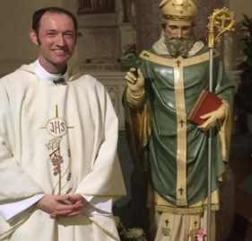
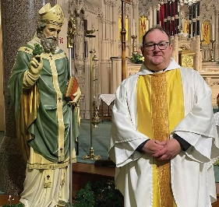


Events
Thursday KS2 Class Masses - Summer 1:
2nd May – Year 3;
9th May – Year 2;
16th May – Year 6;
23rd May – Year 5.
(Please note: These may be cancelled if a Funeral Mass is being celebrated that day).

Stay and Pray - Summer 1:
Friday 3rd May – Reception;
Friday 10th May – Year 6;
Friday 17th May – Year 5;
Friday 24th May – Year 4.

Saturday 18th May: 10am First Holy Communion Mass.

Friday 24th May: May Crowning Celebrations
1:45pm Procession and 2pm Service.

We 16th June 2018

Y4 Children who have taken part in this year’s Sacramental Preparation Programme will make their First Holy Communion in a special Mass. The Mass starts at 10am in St Patrick’s Church.
This will be a wonderful celebration for school and parish.
e processing into church from school at 1:45. Mass will start at 2pm. We his being a great parish and school celebration of our patron saint’s day.

St Patrick’s Church



and can also reproduce.

In Class This Week – Year 3

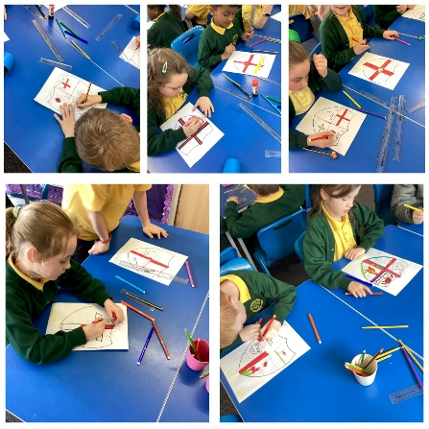

There will be a Coffee Morning this Sunday, 28th April, after the 9:15am Mass in the Lappin Room.

All proceeds to Restoration Funds – everyone welcome!

This week, Year 3 celebrated St George’s Day by learning all about St George and creating our own St George’s Day shields.

