


St. Patrick's
Catholic Primary School

‘We arise today to learn, love and grow through Jesus.’
Newsletter - Week Beginning 15.4.2024
Dates, times and events are correct at the time of publication of this newsletter
(though may be subject to some alterations or additions).
Top attended classes for the previous week 8.4.2024 |   Class | Attendance %
Gold | Y3MG | 98.18
Silver | Y3SR | 92.27
Bronze | Y2LR | 91.82
Whole school current academic year

9 92.21%


Star of the Week
Week Beginning
8.4.2024
Nursery | Finley Barnes | Reception | Valentina Elson
Nursery | Paddy Boyd | Reception | Montano Ondo Belloso
Year 1 | Elliott Jones | Year 4 | Mia Fishwick
Year 1 | Carmen Wills | Year 4 | Harley Murphy
Year 2 | Millie Banks | Year 5 | Yasminne Guerra
Year 2 | Phoebe Harker | Year 5 | Patrick Unsworth
Year 3 | Jaison Jacob | Year 6 | Tony Tran
Year 3 | Taliah Tantwala-Gregory | Year 6 | Skye Wallis

A

Here at St Patrick’s Catholic Primary School, we unite our prayers with those of the whole Catholic community in Wigan, following the sad news of Father Johnson’s death.

Father Johnson was Parish Priest of St Mary’s, Standishgate, and a great friend to our Church and School; often supporting us with First Confessions and School Events. We offer our prayers and condolences to his family, friends and former parishioners.

Eternal Rest, grant unto him, O Lord.
Father John Johnson RIP
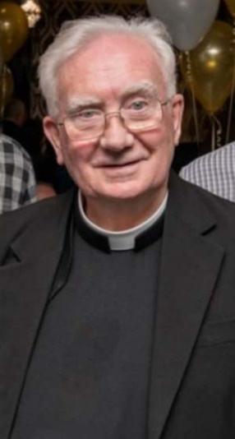
STAY AND READ: Every Tuesday, from 9:05am-9:30am, in the Infant Hall. An opportunity for parents/carers/ a family member to read with your child, explore our online reading platforms and an opportunity to read for pleasure.

Tuesday 23rd April – Year 2
Tuesday 30th April – Year 1
Tuesday 7th May – Reception
Tuesday 14th May – Year 6
Tuesday 21st May – Year 5

.
I ask you to support us by checking your child(ren) on a regular basis. Thank you for your continuing support.
EMENTS



Events
Thursday KS2 Class Masses - Summer 1:
25th April – Year 4;
2nd May – Year 3;
9th May – Year 2;
16th May – Year 6;
23rd May – Year 5.
(Please note: These may be cancelled if a Funeral Mass is being celebrated that day).

Stay and Pray - Summer 1:
Friday 26th April – Year 1;
Friday 3rd May – Reception;
Friday 10th May – Year 6;
Friday 17th May – Year 5;
Friday 24th May – Year 4.

Friday 24th May: May Crowning Celebrations
1:45pm Procession and 2pm Service.

We 16th June 2018

Y4 Children who have taken part in this year’s Sacramental Preparation Programme will make their First Holy Communion in a special Mass. The Mass starts at 10am in St Patrick’s Church.
This will be a wonderful celebration for school and parish.
e processing into church from school at 1:45. Mass will start at 2pm. We his being a great parish and school celebration of our patron saint’s day.

St Patrick’s Church



and can also reproduce.
This week in Geography, the Y2 children have been learning about seas and coasts. We have been using atlases to
This week in Geography, the Y2 children have been learning about seas and coasts. Wseas and oceans from around the world.

In Class This Week – Year 2

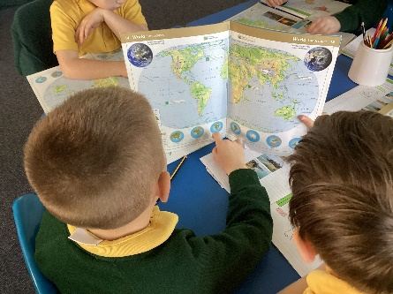

Our next Open Forum Meeting will be this Sunday, 21st April, after the 9:15am Mass. This is a chance to ask questions, listen to updates and plan events for the future. All welcome.

This week in Geography, the Y2 children have been learning about seas and coasts. We have been using atlases to locate seas and oceans from around the world.

