


St. Patrick's
Catholic Primary School

‘We arise today to learn, love and grow through Jesus.’
Newsletter - Week Beginning 8.4.2024
Dates, times and events are correct at the time of publication of this newsletter
(though may be subject to some alterations or additions).
Top attended classes for the previous week 18.3.2024 |   Class | Attendance %
Gold | Y5G | 99.57%
Silver | Y2R | 98.18%
Bronze | Y6E | 96.52%
Whole school current academic year

9 92.32%


Star of the Week

Week Beginning
18.3.2024
Nursery | Arabella Ruddy | Reception | Kiera Omokwe
Nursery | Mileja Zagurskyte | Reception | Mehreen Khan
Year 1 | Bella Livesey | Year 4 | Teresa Ward
Year 1 | Louisa Spinola | Year 4 | Leia-Maria Obada-Visiliu
Year 2 | Reyna Praveen-John | Year 5 | Noah Ashworth
Year 2 | Freya Dickenson | Year 5 | Gurudutt Abhilash
Year 3 | Abdu Rooby | Year 6 | Leland Sumner
Year 3 | Evelyn Prescott | Year 6 | Henry Rumsey

To the children in our Sacramental Programme Group, who have now received the Sacrament of Reconciliation (Confession) for the very first time. Father O’Shea and Father Hugh praised the children’s attitude towards the Sacrament and the preparation they had received. Please hold the children in prayer, as they now prepare to make their First Holy Communion on Saturday 18th May.
Congratulations

A

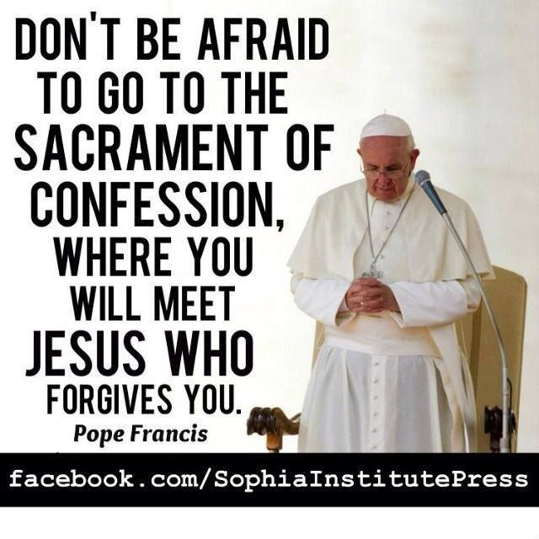
.
I ask you to support us by checking your child(ren) on a regular basis. Thank you for your continuing support.
EMENTS

STAY AND READ: Every Tuesday, from 9:05am-9:30am, in the Infant Hall. An opportunity for parents/carers/ a family member to read with your child, explore our online reading platforms and an opportunity to read for pleasure.

Tuesday 16th April – Year 3
Tuesday 23rd April – Year 2
Tuesday 30th April – Year 1
Tuesday 7th May - Reception



Events
Thursday KS2 Class Masses - Summer 1:
18th April – Year 5;
25th April – Year 4;
2nd May – Year 3;
9th May – Year 2;
16th May – Year 6;
23rd May – Year 5.
(Please note: These may be cancelled if a Funeral Mass is being celebrated that day).

Stay and Pray - Summer 1:
Friday 19th April – Year 2;
Friday 26th April – Year 1;
Friday 3rd May – Reception;
Friday 10th May – Year 6;
Friday 17th May – Year 5;
Friday 24th May – Year 4.

Friday 24th May: May Crowning Celebrations
1:45pm Procession and 2pm Service.

We 16th June 2018

Y4 Children who have taken part in this year’s Sacramental Preparation Programme will make their First Holy Communion in a special Mass. The Mass starts at 10am in St Patrick’s Church.
This will be a wonderful celebration for school and parish.
e processing into church from school at 1:45. Mass will start at 2pm. We his being a great parish and school celebration of our patron saint’s day.

St Patrick’s Church



In Year 1 this week, we have been making felt hand puppets. We have designed our own character puppets from the story Room on the Broom. We have used techniques such as measuring, cutting and gluing.
a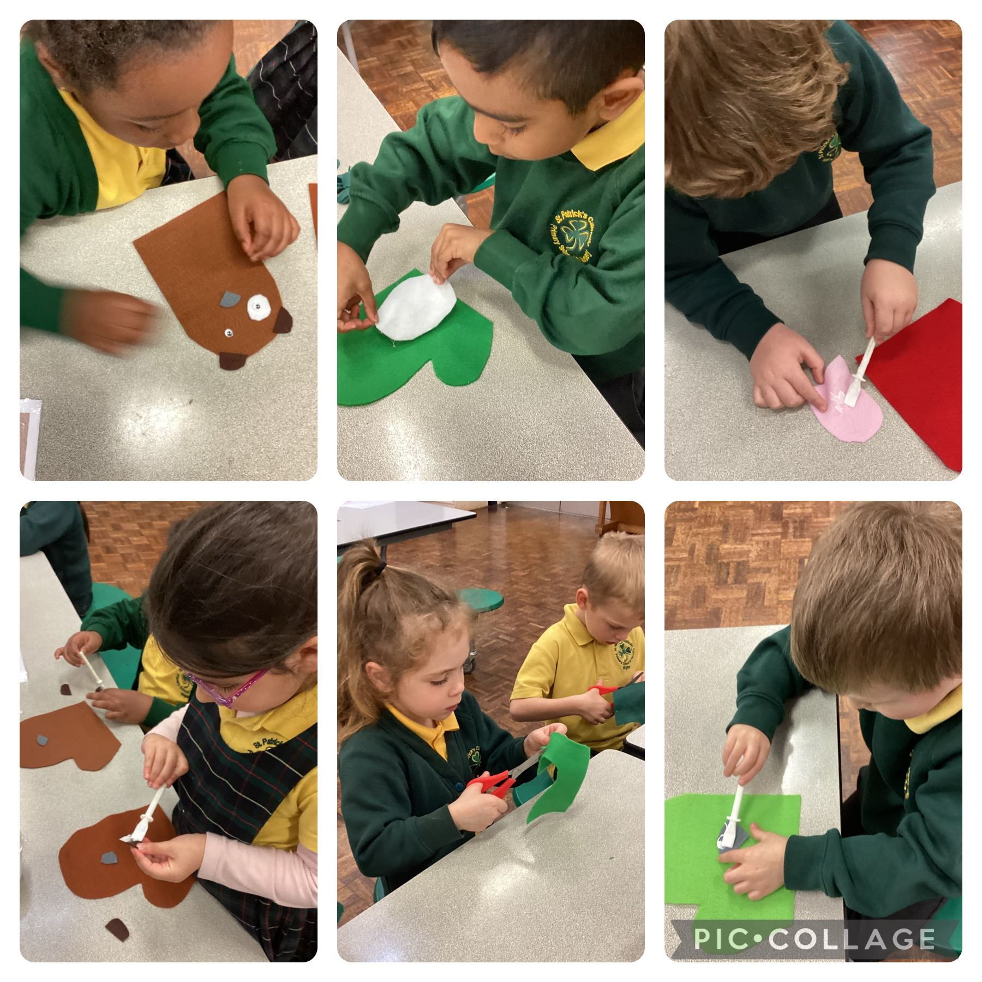

In Class This Week – Year 1

A reminder, if you aren’t already, to follow St Patrick’s Church on Facebook for updates, news and events. Search for: ‘St Patrick’s Catholic Church, Wigan’.

