
W
Newsletter - Week Beginning 26.2.2018
Dates, times and events are correct at the time of publication of this newsletter (though may be subject to some alterations or additions).
St. Patrick's
Catholic Primary School

Top attended classes for the previous week 12.2.2018 | Class | Attendance %
1st | Y3B | 98.64%
2nd | Y1D | 98.18%
3rd | Reception | 97.67%
Whole school current academic year


95.5%


Star of the week –
Week beginning 12.2.2018

Nursery | Erin Hopper  Talia Alzain  Matthew Liptrot | Reception | Ethan Wilde Causey  Jessica Bushell  Layton Pennington
Y1M | Alice McKenna | Y4C | Evie Schofield
Y1D | Max Davies | Y4HW | Keite Krasauskyte
Y2S | Oliver Henshaw | Y5TL | Rhys Collier
Y2M | Eliza Bucholska | Y5HL | Lucy Houghton
Y3H | Isla Hurst | Y6AP | Cole Culshaw
Y3B | Abbie Morris | Y6JP | Tyler Simm

Taekwondo Competition Winners
Brothers, Rhys and Kyle Collier were both placed receiving First and Second place!
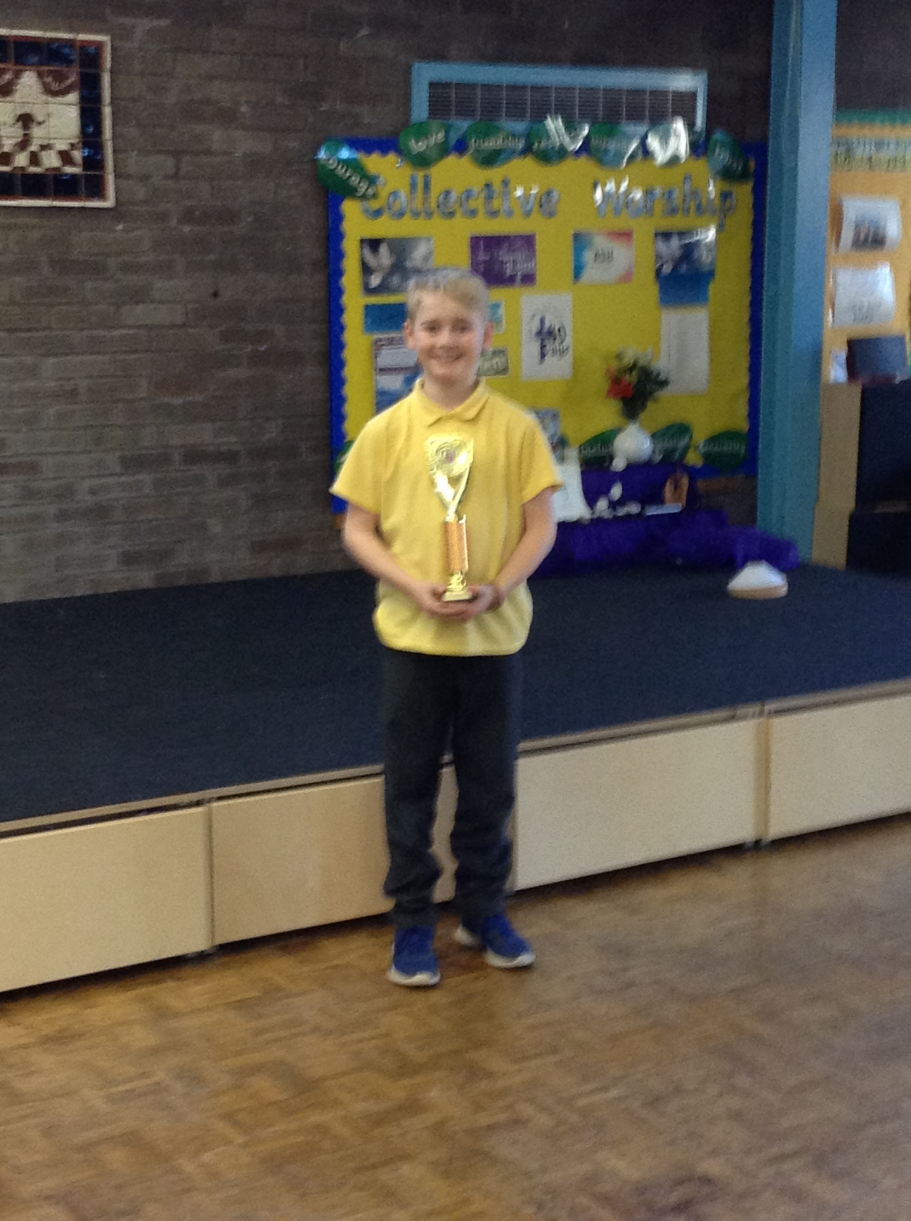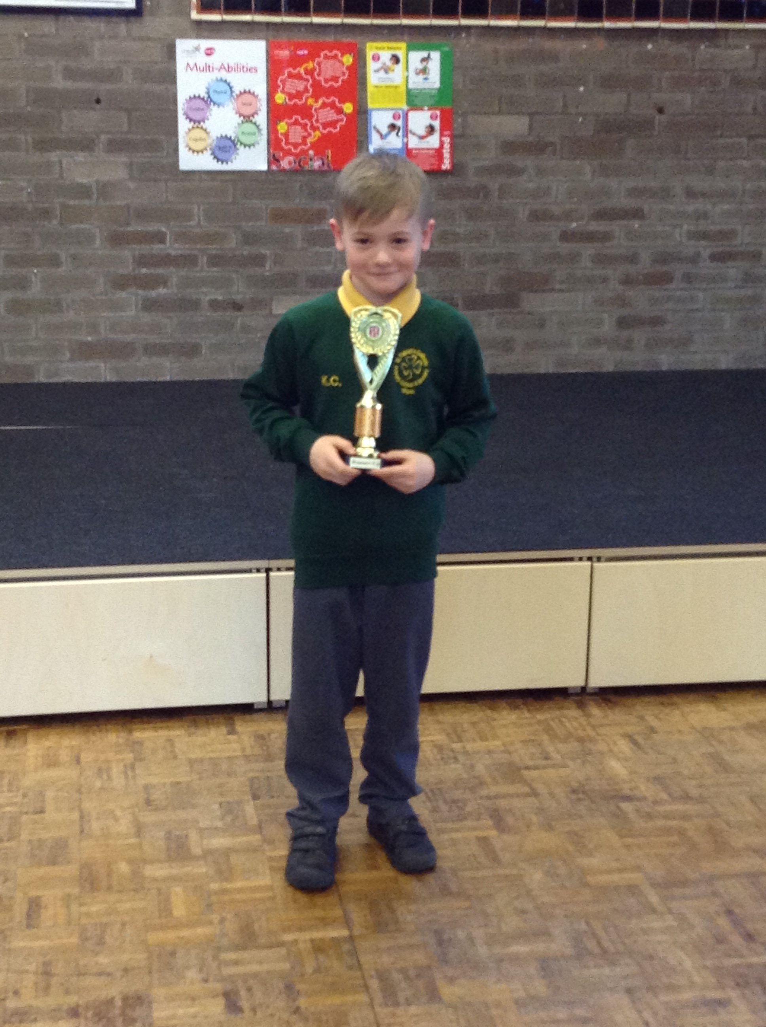

Thursday Mass
Year groups from Y2 to Y6 will be attending mass on, a rolling programme, in church on Thursday mornings at 9.15. Watch this space to find out when your child/children will be attending.
Remember…
We hold a coffee morning every Monday from 9 am to 10.30 am. It takes place in the training room.
Please come and join us!


Community
In class this week
Events
This week the Reception children have really enjoyed experiencing ‘The Theatre’. They have been dressing up as different characters and retelling their favourite stories.

Year 6 parents are invited to our first ‘Stay & Pray’ session which will take place on Thursday 8th March at 9 am in the junior hall. It will last for approximately 10-15 minutes.

