
W
Newsletter - Week Beginning 19.3.2018
Dates, times and events are correct at the time of publication of this newsletter (though may be subject to some alterations or additions).
St. Patrick's
Catholic Primary School

Top attended classes for the previous week 12.3.2018 | Class | Attendance %
1st | Y4HW | 99.5%
2nd | Y2M | 99.1%
3rd | Y1D | 98.2%
Whole school current academic year


95.43%


Star of the week –
Week beginning 12.3.2018

Nursery | Harley Starkie  Emilee Dean  Poppy Parker | Reception | Logan Baggaley  Ehleen Usman  Miley Darbyshire Ward
Y1M | Bobby Grimes | Y4C | Daria Saeed
Y1D | Lola Close | Y4HW | Jayden Dunsby
Y2S | Faye McSorley | Y5TL | Zeke Edwards
Y2M | Lowyn Gregory | Y5HL | Jessica Bradshaw
Y3H | Oliver Hesketh | Y6AP | Bradley Hamer
Y3B | Ruby Wallis | Y6JP | Patrick Sixsmith

Some Y5 children took part in a one mile run, at the weekend, to raise money for JoiningJack – helping Jack in his fight to find a cure for Duchenne Muscular Dystrophy. Well done, we are so proud!
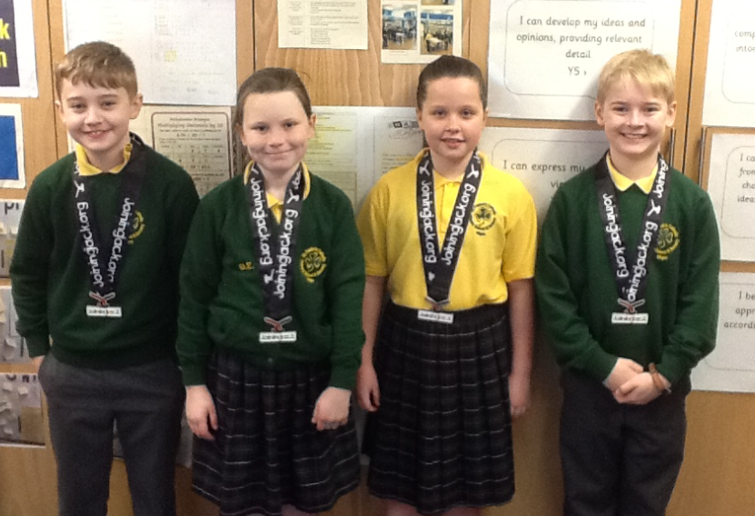

We would like to wish you all a very Happy Easter, filled with love, happiness and peace.

Community
Events
In class this week
Holy Week Masses at St Patrick’s:
Holy Thursday - 7:30pm - Mass of the Last Supper, followed by ‘watching’ and closing with night prayer at 9:45pm
Good Friday - 3pm – Passion of the Lord, followed by confessions
Holy Saturday – 12 noon – traditional blessing of Polish Easter Baskets
Holy Saturday – 7:30pm – Easter Vigil
Easter Sunday – 9am Mass
All are welcome!

This year the Easter Assembly will take place on Tuesday 27th March at 1.45pm in church.
Everyone welcome!
Remember…
Monday 26th March - Easter Ball. Tickets are available at the office.
Thursday 29th March – Non -uniform day, to raise money for the Good Shepherd and our annual ‘decorate an egg competition.’

In Maths: Year 3 have been exploring capacity this week. They have been learning to measure liquids using millilitres and litres.

