
W
Newsletter - Week Beginning 12.3.2018
Dates, times and events are correct at the time of publication of this newsletter (though may be subject to some alterations or additions).
St. Patrick's
Catholic Primary School

Top attended classes for the previous week 26.2.2018 | Class | Attendance %
1st | Y2S | 99.13%
2nd | Y4C | 98.33%
3rd | Y1D and Y2M | 98.18%
Whole school current academic year


95.5%


Star of the week –
Week beginning 5.3.2018

Nursery |  | Reception
Y1M |  | Y4C
Y1D |  | Y4HW
Y2S |  | Y5TL
Y2M |  | Y5HL
Y3H |  | Y6AP
Y3B |  | Y6JP

Taekwondo Competition Winners
Brothers, Rhys and Kyle Collier were both placed receiving First and Second place!
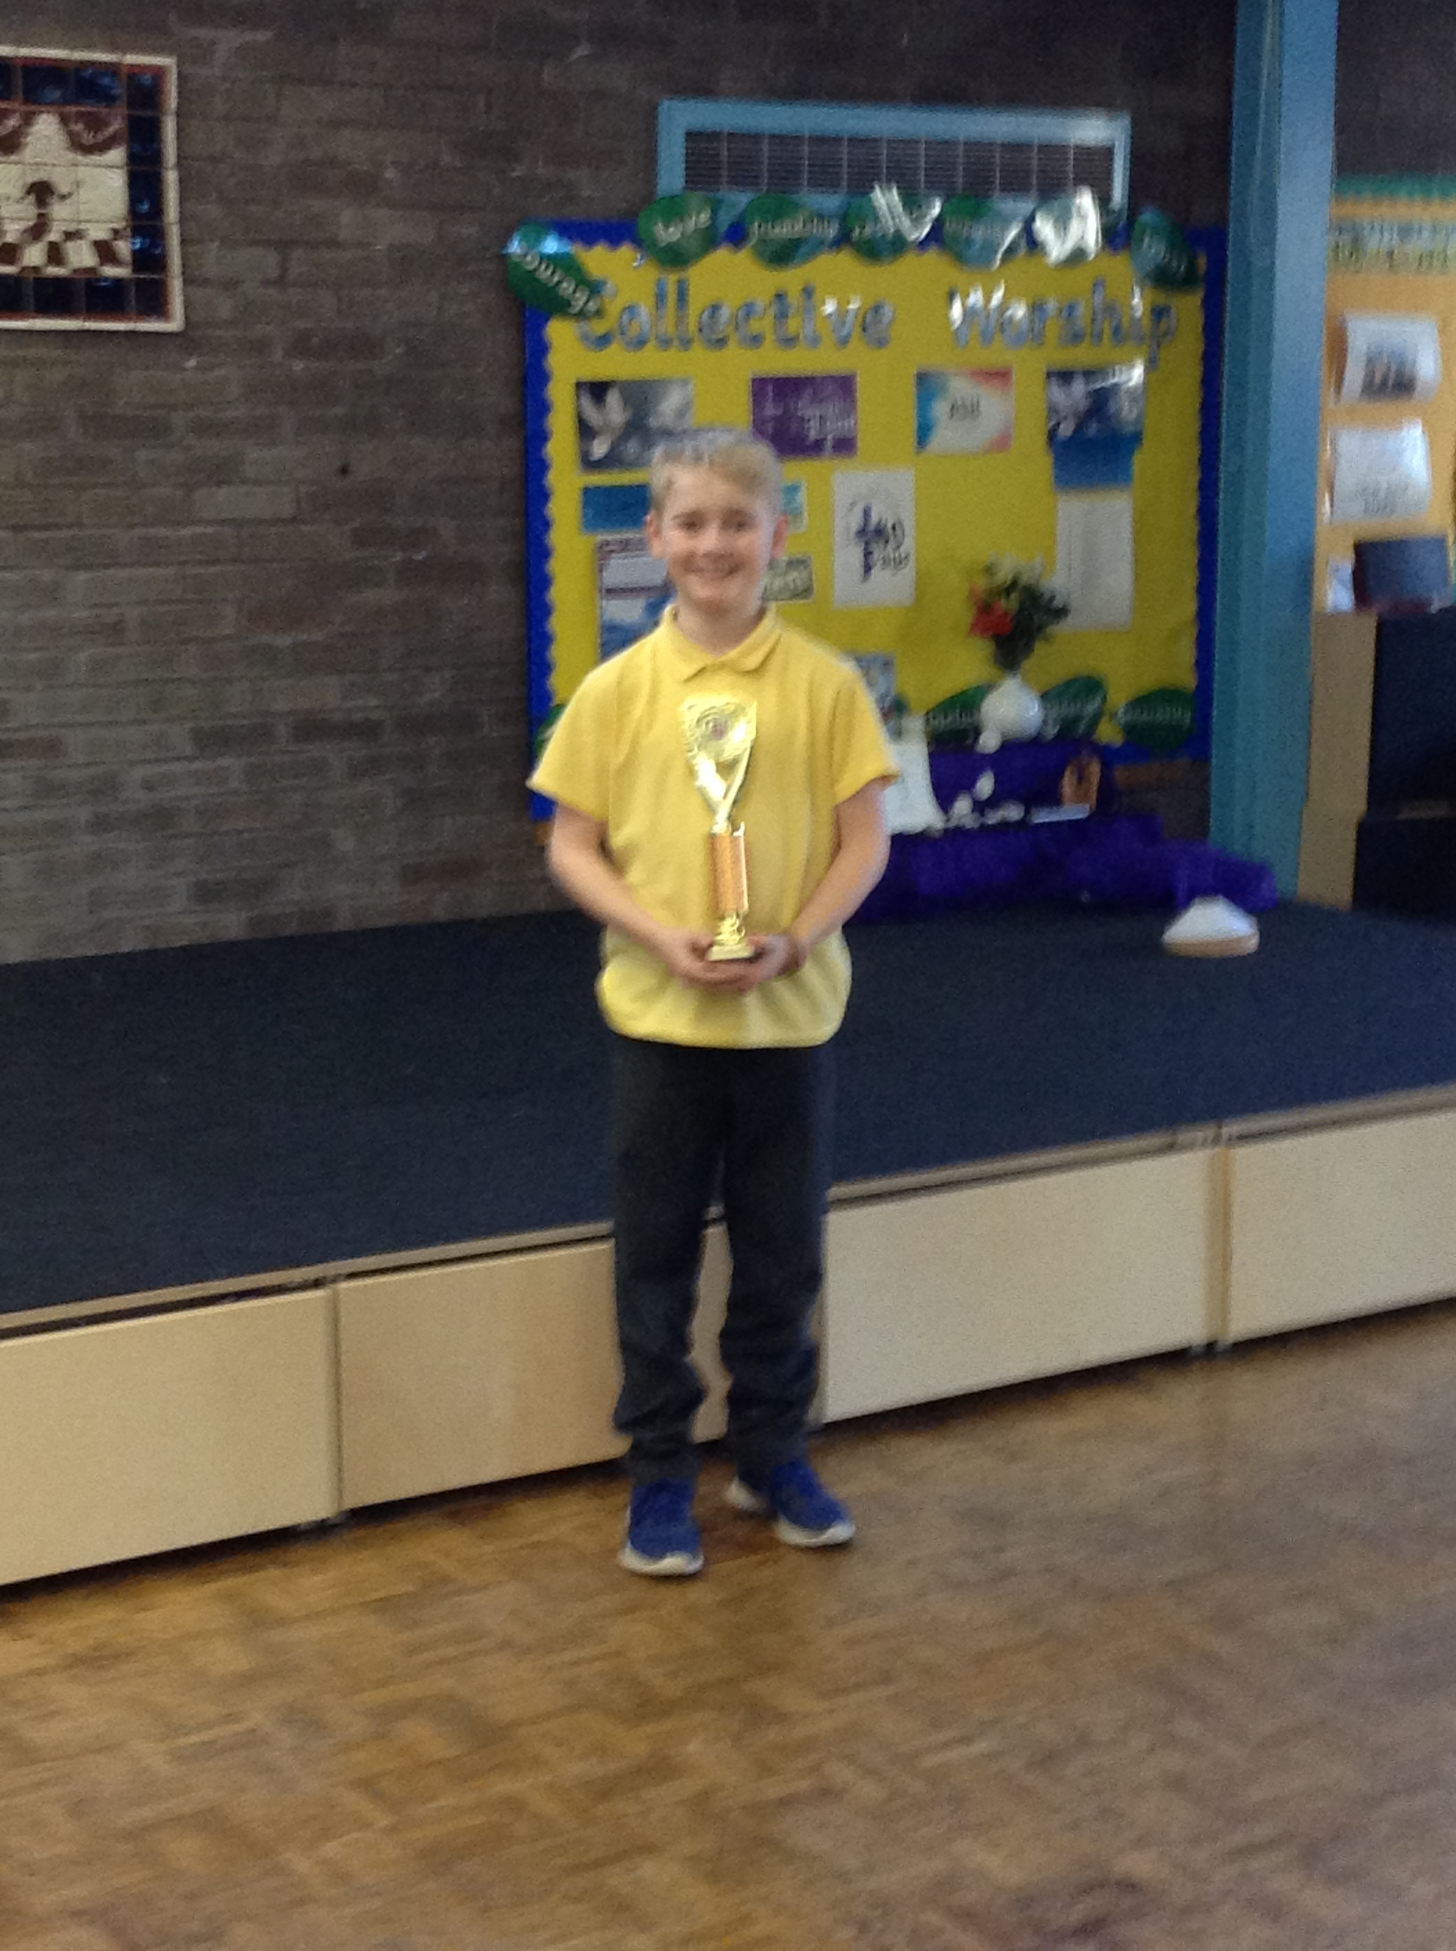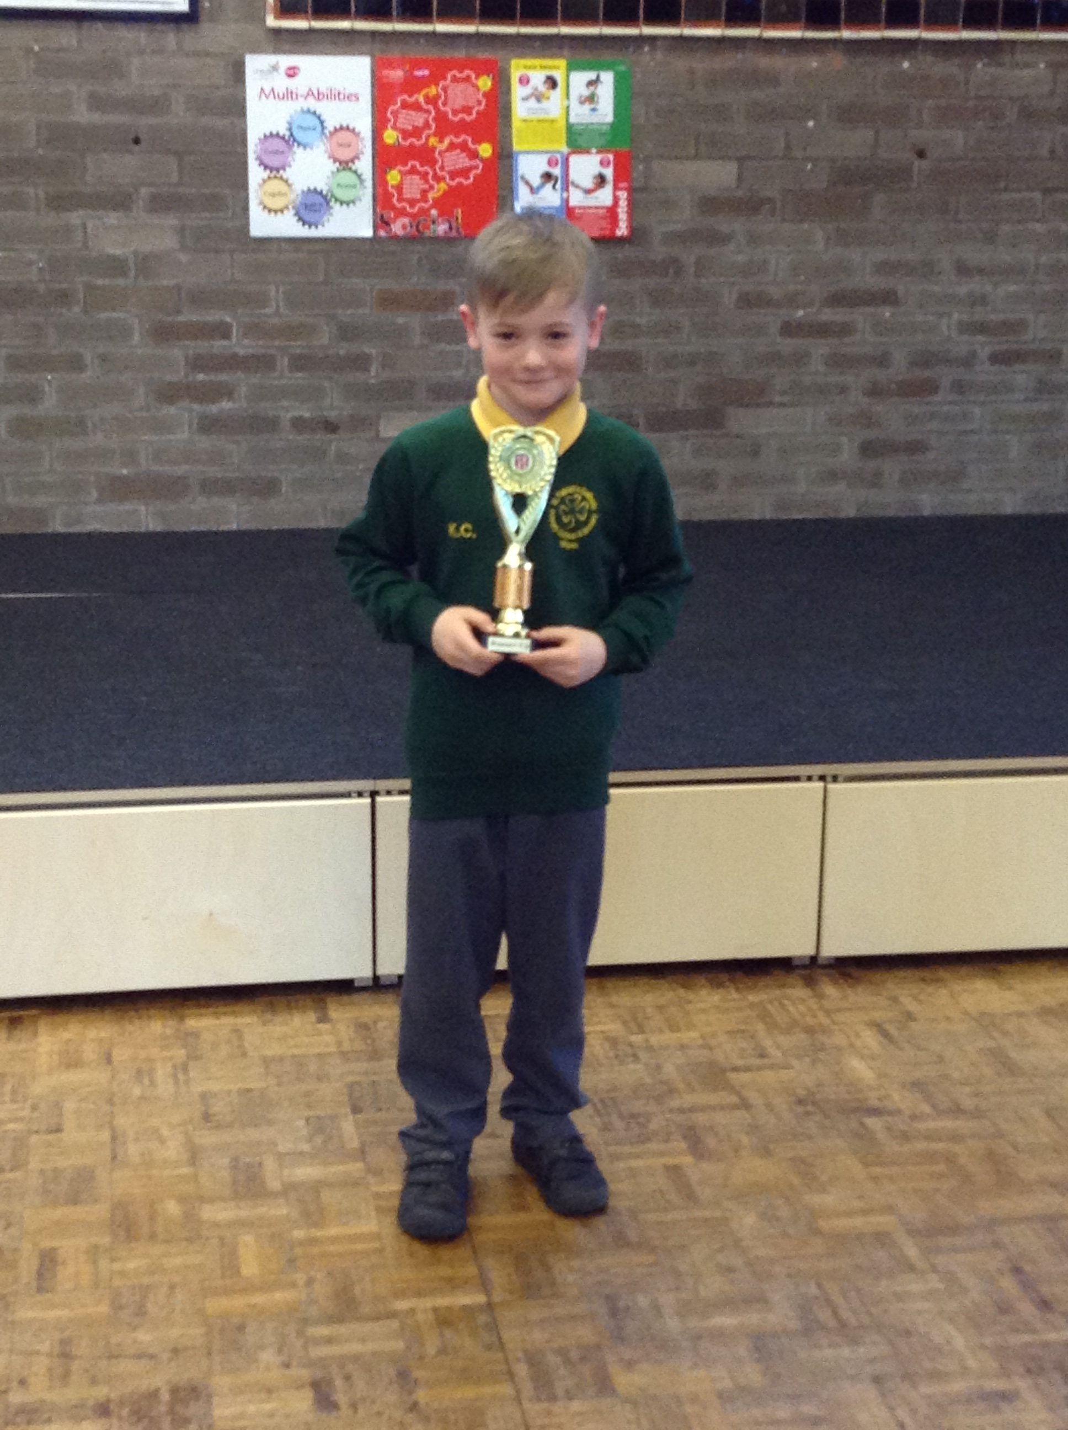

Thursday Mass
Year groups from Y2 to Y6 will be attending mass on, a rolling programme, in church on Thursday mornings at 9.15. Watch this space to find out when your child/children will be attending.
Remember…
We hold a coffee morning every Monday from 9 am to 10.30 am. It takes place in the training room.
Please come and join us!


Community
In class this week
Events
This week the Reception children have really enjoyed experiencing ‘The Theatre’. They have been dressing up as different characters and retelling their favourite stories.

Year 6 parents are invited to our first ‘Stay & Pray’ session which will take place on Thursday 8th March at 9 am in the junior hall. It will last for approximately 10-15 minutes.

