
W
Newsletter - Week Beginning 15.1.2018
Dates, times and events are correct at the time of publication of this newsletter (though may be subject to some alterations or additions).
St. Patrick's
Catholic Primary School

Top attended classes for the previous week 8.1.2018 | Class | Attendance %
1st | Y3H | 99.57%
2nd | Y5T | 99.5%
3rd | Y6JP | 97.09%
Whole school current academic year

95.44%


Star of the week –
Week beginning 8.1.2018

Nursery | Renee Lin  Zuzanna Waluk  Henry Haugh | Y3B | Quinn Anglesea
Reception | Charlie Sharrock  Jackson Davies  Bethany Rigby | Y4C | Max Edwardson
Y1M | Sophia Murphy | Y4HW | Lucie-Anne Finch
Y1D | Darcey Scully | Y5L | Zach Burchall
Y2S | Grace Abbott | Y5HL | Tegan Almond
Y2M | Laura Mendelska | Y6AP | Frankie Cassidy
Y3H | Esha Justin | Y6JP | Lexie Kennedy

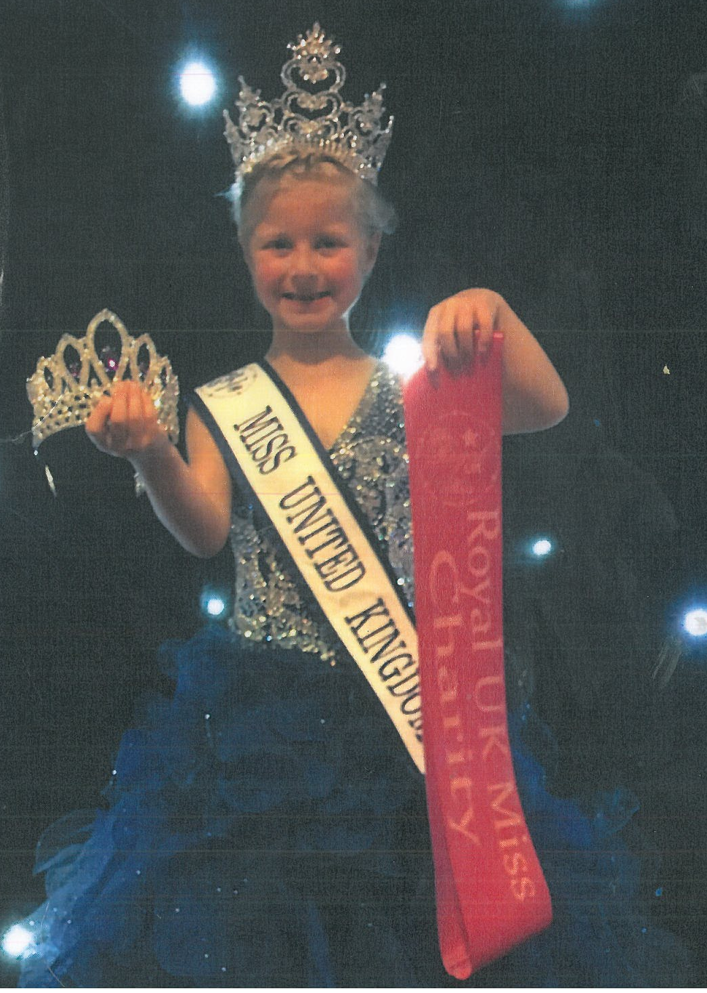

Congratulations Charlie Reeves!
Charlie took part in the Royal UK Princess competition and won the position of Miss United Kingdom
(age 6-7 years). In her role, Charlie has a daily challenge which involves helping others such as: collecting
food for The Brick, and collecting baby clothes and toys for other charities. Charlie has also raised an
amazing £7000 for charity. Well done Charlie, we are all so proud of you!

Events
In class this week
Monday 22nd January – 9.-10.30 Coffee Morning. Please join us!
Tuesday 23rd January – Choir attending Young Voices at Manchester Arena.
Tuesday 23rd January – WCPSD open evening (4-6pm) at Saint Patrick’s. Are you interested in becoming a primary school teacher? Are you due to receive a degree this year or do you already have a degree? If so, come and see what we offer at Wigan Catholic Primary Schools Direct.
Tuesday 30th January- School Photograph day.
Tuesday 6th February- Safer internet day.

Reception
In Reception we have been learning about people who help us.

Community
Father O’Shea will be taking over as our new Parish Priest on Sunday 21st January 2018.
Mass times at
St Patrick’s will be:
- Sunday 9am
- Tuesday 7:30pm
- Thursday 9am
- Saturday 9am

