


St. Patrick's
Catholic Primary School

‘We arise today to learn, love and grow through Jesus.’
Newsletter - Week Beginning 24.3.2025
Dates, times and events are correct at the time of publication of this newsletter
(though may be subject to some alterations or additions).
Top attended classes for the previous week 17.3.2025 |   Class | Attendance %
Gold | Y5 | 97.83%
Silver | Y4 | 95.76%
Bronze | Y3 | 95.35%

Whole school current academic year
94.02%

Star of the Week
Week Beginning
17.3.2025
Nursery | Freddie Martin | Reception | Theodora McElchar
Nursery | Ryan Nijith | Reception | Aroush Khurram
Year 1 | Elijah Scrivens | Year 4 | Frankie Whyte
Year 1 | Nylah Reeves | Year 4 | Isaac Hart
Year 2 | Ieva Prialgauskaite | Year 5 | Nevaeh Reeves
Year 2 | Declan O’Donnell | Year 5 | Penelope Glaze
Year 3 | Reyna Praveen | Year 6 | Jason Unah
Year 3 | James McNicholas | Year 6 | Isabelle Rolle

Please note: stay and pray, stay and read or maths matters is cancelled for the next two weeks (until Easter) due to hall availability.

T

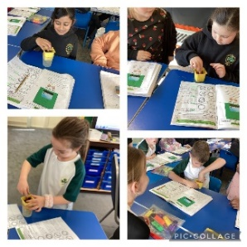
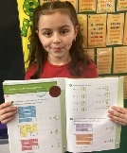


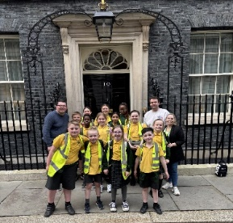

Celebrations
Well done to Amelia Clossick in Y4 for her headteacher’s award. All week, Amelia has shown perseverance and determination to achieve in maths.

During Lent… (All taking place in the Lappin Room)
Morning Prayer of the Church
8am each weekday
Evening Prayer of the Church
6:45pm each weekday
Stations of the Cross
7pm each Wednesday
Confessions
Each weekday after Mass (in the Sacristy).

T

Safe and Sound are now taking bookings for Easter Holiday club.
Week 1- 14/4/25-17/4/25
Week 2 22/4/25-25/4/25
Please be aware we are closed Good Friday & Easter Monday.
If you require a place please come and speak to Mrs Glaze or Mr Worthington.

On Wednesday 19th March, our School Council and Faith in Action Group went to London with Mrs Hobden, Mr Edwardson and Mr Marshall. We visited Number 10 Downing Street, toured the Houses of Parliament and did some sightseeing. At Number 10, the police officers on guard referred to as “invited guests of the Prime Minister!” Photographs can be found on the School Website under the ‘News’ Section. Well done, children, you were excellent St Patrick’s Ambassadors.
This week, Year 3 have set up an experiment for our comparative test. We are testing how plants grow in different conditions.

In Class This Week: Year 3

Job Vacancy
HT PA and HR Support

Closing date 31.3.2025 5pm

We are seeking to appoint a Personal Assistant (PA) to the Headteacher and HR Support with personal qualities and skills of the highest order. Ideally candidates will have significant administrative and HR experience.

Please see job description and application pack on our school website – Yellow arrow Saint Patrick’s Community – Job Vacancies. https://www.saintpatricks.wigan.sch.uk/job-vacancies/
For further details contact the school office on 01942 244361 or visit the school website https://www.saintpatricks.wigan.sch.uk/job-vacancies/

T

