


‘We arise today to learn, love and grow through Jesus.’
St. Patrick's
Catholic Primary School

Newsletter - Week Beginning 17.3.2025
Dates, times and events are correct at the time of publication of this newsletter
(though may be subject to some alterations or additions).
Top attended classes for the previous week 10.3.2025 |   Class | Attendance %
Gold | Y2 | 96.9%
Silver | Y5 | 95.87%
Bronze | Y3 | 95.56%

Whole school current academic year
Events
11.4.2025 – School Lenten Service in Church – time and more details to be confirmed.
25.3.2025- Y5 Heritage Centre visit ‘Coal Mining’.
11.4.2025- Easter Service in church 2pm start.
30.4.2025- Y1 visit to Blackpool Sea life centre.
19.5.2025- Y3 Heritage Centre visit ‘The Romans’.
4.6.2025- Y2 visiting Blackpool Zoo.

94%

Star of the Week
Week Beginning
10.3.2025
Nursery | Jayden Idam-Aluu | Reception | Isabella Kernig-Bridge
Nursery | Lottie Johnson | Reception | Sion Shelly
Year 1 | Montano Ondo Belloso | Year 4 | Maya Danska
Year 1 | Enijie Boasiako | Year 4 | Emmie-Leigh Tennant
Year 2 | Rayan Mathew | Year 5 | Edward Fitzpatrick
Year 2 | Carmen Wills | Year 5 | Joe Disley-Shaw
Year 3 | Henry Vermeulen | Year 6 | Annliya Shelly
Year 3 | Erika Cochintoiu | Year 6 | Isaac Mather

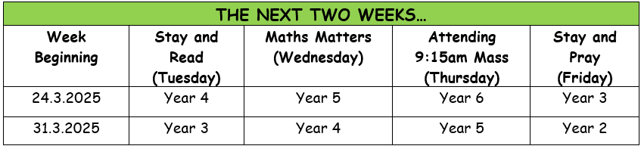
St Patrick’s Church

Achievements

Well done to our year 4 super stars who completed their ‘Going for Gold’ cards and chose a prize from the vending machines.


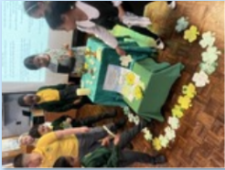

On Monday the children celebrated St Patrick’s Day. We thought about our whole school Mission Statement and what means to each of us. We listened to the Story of St Patrick and made our own shamrocks to place on the display.

Safe and Sound are now taking bookings for Easter Holiday club.

Week 1- 14/4/25-17/4/25
Week 2 22/4/25-25/4/25

Please be aware we are closed Good Friday & Easter Monday.

If you require a place please come and speak to Mrs Glaze or Mr Worthington.
In Class This Week: Year 2

T


During Lent…
Morning Prayer of the Church
8am each weekday
Evening Prayer of the Church
6:45pm each weekday
Stations of the Cross
7pm each Wednesday
Confessions
Each weekday after Mass.

