


St. Patrick's
Catholic Primary School

‘We arise today to learn, love and grow through Jesus.’
Newsletter - Week Beginning 10.3.2025
Dates, times and events are correct at the time of publication of this newsletter
(though may be subject to some alterations or additions).
Top attended classes for the previous week 3.3.2025 |   Class | Attendance %
Gold | Y5 | 97.83%
Silver | Y4 | 95.76%
Bronze | Y3 | 95.35%

Whole school current academic year
94.02%

Star of the Week
Week Beginning
3.3.2025
Nursery | Oliver Ellison | Reception | Pippa Harrison
Nursery | Mathias Dajbog | Reception | Lucy Croft
Year 1 | Mehreen Khan | Year 4 | Sienna Grindall
Year 1 | Isabelle Welsh | Year 4 | Harry Eccles
Year 2 | Lucy Price | Year 5 | Arnav Aniyan
Year 2 | Brooklyn O’Reilly | Year 5 | Andreea Mocanu
Year 3 | Harry Barlow | Year 6 | Erin Hopper
Year 3 | George Hughes | Year 6 | Eden Livesey

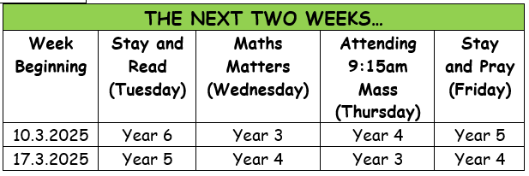




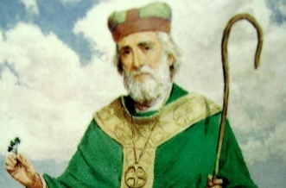
Events
During March – Y5 and Y6 Lenten Confessions and First Confessions for Y4 with Fr Paul and Fr Hugh.
17/3/25 – The Feast of Saint Patrick.
18/3/25 – Y5 visiting Heritage Centre.
19/3/25 – School Council and Faith in Action Groups visiting the Houses of Parliament.
20/3/25 – Wonderdome in School.
21/3/25 – Comic Relief.
11/4/25 – School Lenten Service in Church – time and more details to be confirmed.

During Lent…

Morning Prayer of the Church
8am each weekday

Evening Prayer of the Church
6:45pm each weekday

Stations of the Cross
7pm each Wednesday

Confessions
Each weekday after Mass.

This week, Year 1 have been exploring the art of renowned land artist and sculptor, Andy Goldsworthy. They collected twigs and used these to create patterns and shapes for their very own land art!
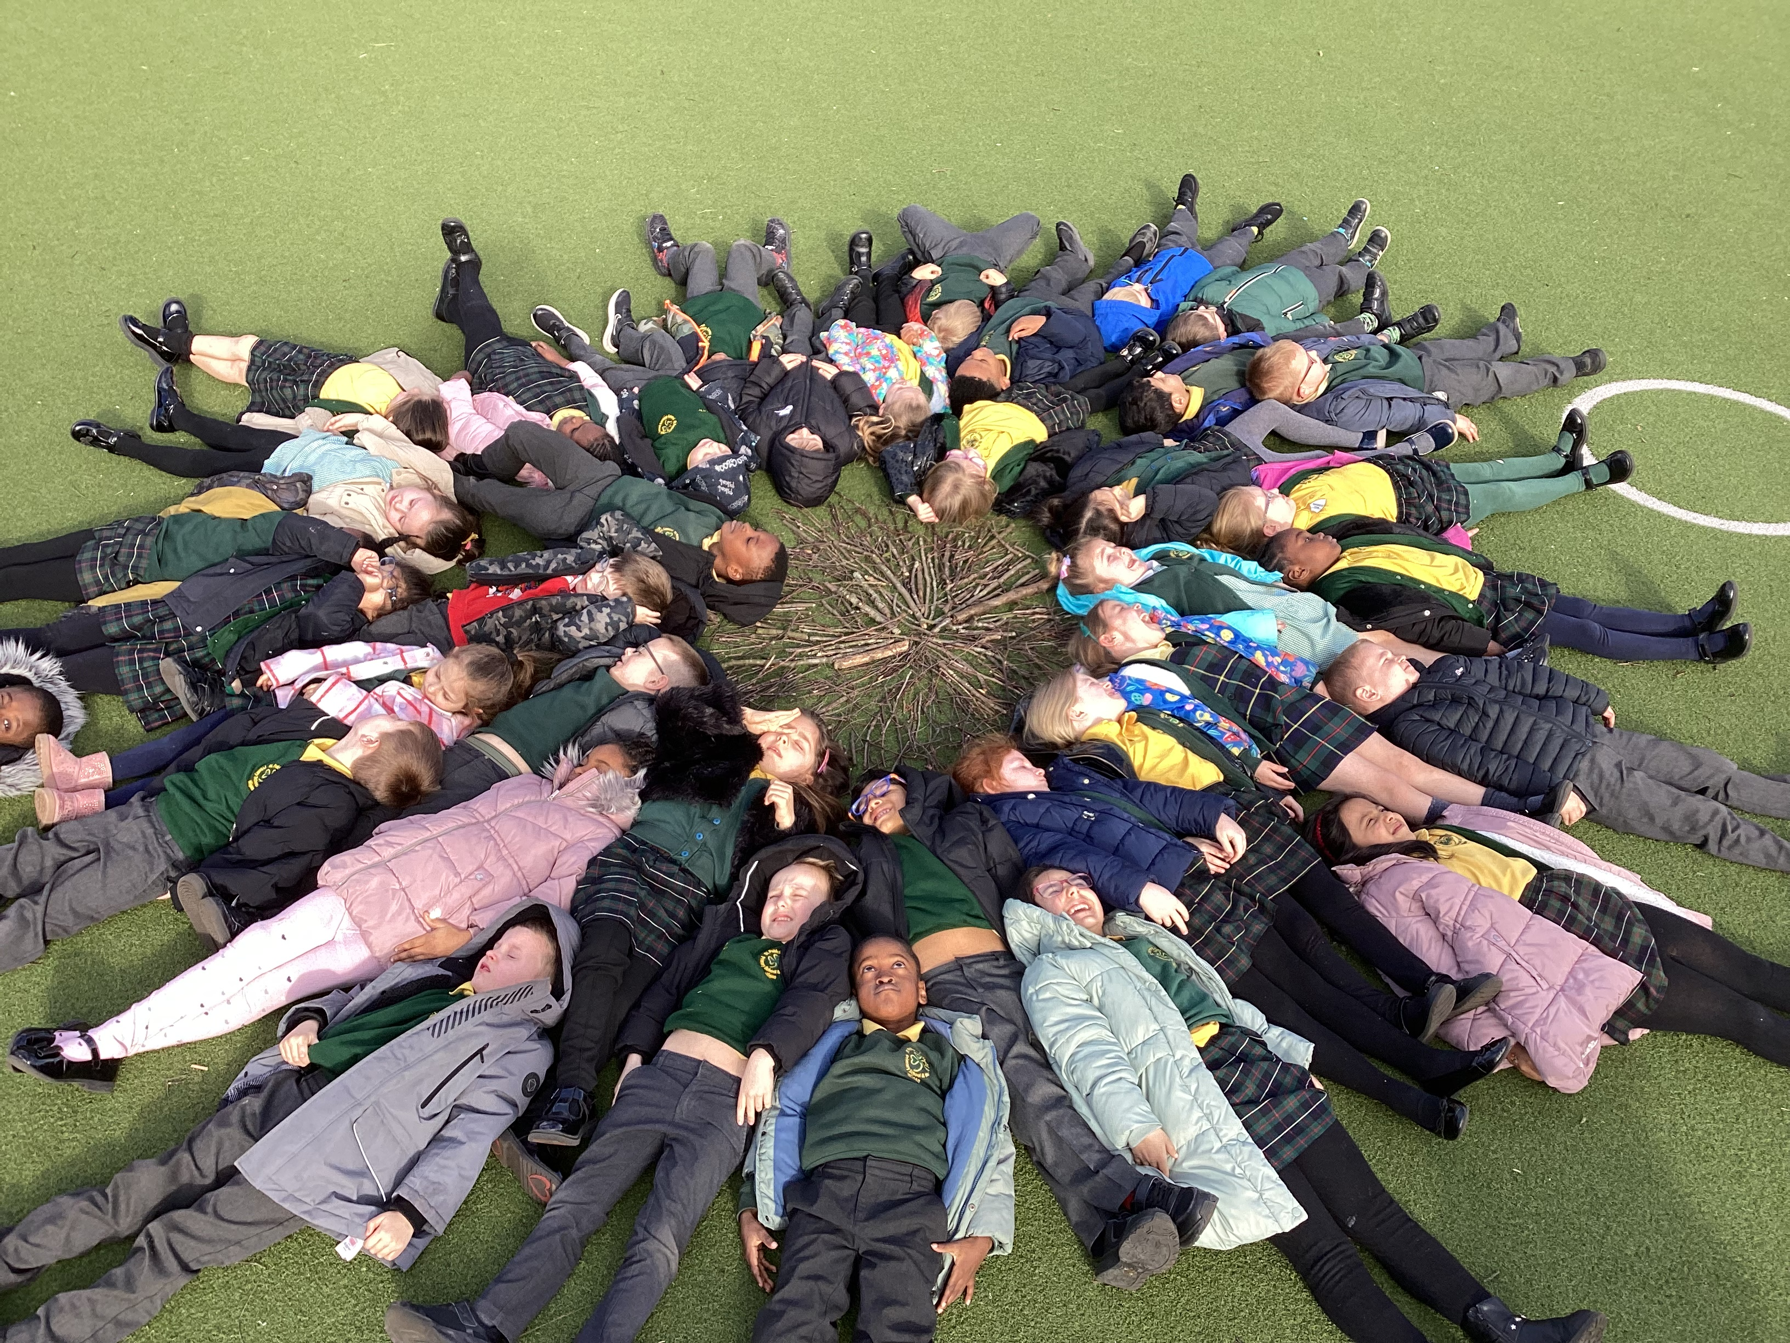

T
On Monday, 17th March, we celebrate the Feast of Saint Patrick: our Patronal Feast. From all of us here at St Patrick’s Catholic Primary School, a very happy Patronal Feast to you all!
St Patrick, Apostle of Ireland and Patron of our community, pray for us!
On St Patrick’s Day, Holy Mass will be offered at 7:30pm – all are welcome!
St Patrick’s Church
In Class This Week: Year 1

