


St. Patrick's
Catholic Primary School

‘We arise today to learn, love and grow through Jesus.’
Newsletter - Week Beginning 24.2.2025
Dates, times and events are correct at the time of publication of this newsletter
(though may be subject to some alterations or additions).
Top attended classes for the previous week 10.2.2025 |   Class | Attendance %
Gold | Rec | 96.58%
Silver | Y6 | 96.51%
Bronze | Y4 | 95.23%

Whole school current academic year
93.87%

Star of the Week
Week Beginning
10.2.2025
Nursery | Daisy Ameye | Reception | Rupert Davies
Nursery | Imoitor Nezan | Reception | Kye Malone
Year 1 | Aoife-Jean Miller | Year 4 | Isla-Mae Kenny
Year 1 | Ada Azad | Year 4 | Michael Brogan
Year 2 | Isabelle Ward | Year 5 | Penelope Glaze
Year 2 | Ieva Prialgauskaite | Year 5 | Daren Abdullah
Year 3 | Oliver Clarke | Year 6 | James France
Year 3 | Mya Clark | Year 6 | Victory Aihimegbe

Patronal Feast Celebrations
Friday 14th March
1:45pm Procession;
2pm Whole School Mass.

Monday 17th March
7:30pm Mass.

All welcome to join us as we celebrate Saint Patrick.

THE NEXT TWO WEEKS… (After Half Term)
Week Beginning | Stay and Read  (Tuesday) | Maths Matters (Wednesday) | Attending 9:15am Mass (Thursday) | Stay and Pray (Friday)
3.3.2025 | Reception | Year 1 | Year 5 | Year 6
10.3.2025 | Year 6 | Year 3 | Year 4 | Year 5

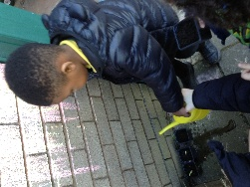
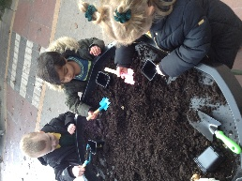
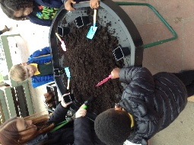


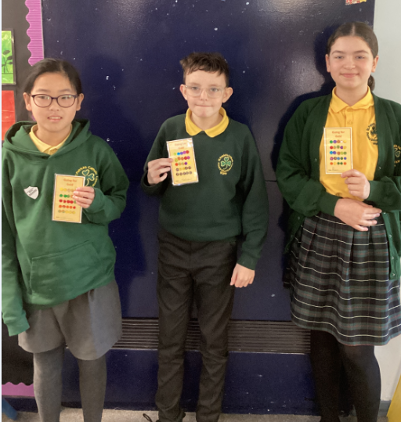

T
Congratulations to Nicole, Busra and Michael who have completed their going for gold chart! Keep up the hard work.
St Patrick’s Night 2025
Whelley Legion – Friday 14th March

With music from The Flyby Knights (Irish Band) and DJ Martyn. Traditional Irish Dancing, hot food and a raffle. Tickets now on sale, priced at £10, from Mr Marshall. All proceeds to Church Restoration Funds.

T
A New Half Term Prayer
As we enter a new Half Term, Lord, please continue to guide and help us in all that we do. Be with us as we work and play so we can continue to learn, love and grow through Jesus. Amen. St Patrick, pray for us!

St Patrick’s Church

This week we have been learning about Spring. We have planted daffodil bulbs; we are going to water them and watch them grow.

In Class This Week: Nursery

Events
3/3/25 – Sorycubs Nursery Session
4/3/25 – Y6 visiting Science and Industry Museum
5/3/25 – Ash Wednesday; the start of Lent (More details to follow)
6/3/25 – Y5 visiting Astley Colliery Museum
7/3/25 – World Book Day
10/3/25 – Y6 visiting Heritage Centre
During March – Y5 and Y6 Lenten Confessions and First Confessions for Y4 with Fr Paul and Fr Hugh.

