


St. Patrick's
Catholic Primary School

‘We arise today to learn, love and grow through Jesus.’
Newsletter - Week Beginning 26.2.2024
Dates, times and events are correct at the time of publication of this newsletter
(though may be subject to some alterations or additions).
Top attended classes for the previous week 12.2.2024 |   Class | Attendance %
Gold | Y2R | 98.18%
Silver | Y4H | 97.5%
Bronze | Y3G & Y6P | 97.27%
Whole school current academic year

92%


Star of the Week

Week Beginning
12.2.2024
Nursery | Hallie Larsen | Reception | Lucas Tarbuck
Nursery | Itanas Astrauskas | Reception | Jacob Cockle
Year 1 | Lana Alnusairi | Year 4 | Jake Gaskell
Year 1 | Johaan Nijith | Year 4 | Reece Ashurst
Year 2 | Anastasia Ward | Year 5 | Jack Unsworth
Year 2 | Henry Vermeulen | Year 5 | Cain Collier
Year 3 | Amber-Rose Samuel | Year 6 | Emilija Kubiliute
Year 3 | Ellie Wilkieson | Year 6 | Leland Sumner

As St Patrick’s Day falls on a Sunday this year (17th), we will be celebrating our Patron on Friday 15th March:

1:45pm Procession of St Patrick’s Statue, Banners and Children’s Art Work from School in to Church;

2pm Holy Mass.

All welcome.

Our Patronal Feast Celebrations:

A

.
I ask you to support us by checking your child(ren) on a regular basis. Thank you for your continuing support.
EMENTS

STAY AND READ: Every Tuesday, from 9:05am-9:30am, in the Infant Hall. An opportunity for parents/carers/ a family member to read with your child, explore our online reading platforms and an opportunity to read for pleasure.

Tuesday 27th February - Year 6
Tuesday 5th March - Reception
Tuesday 12th March - Year 6
Tuesday 19th March - Year 5

Every Year Group will have Stay and Read opportunities in the Summer Term.
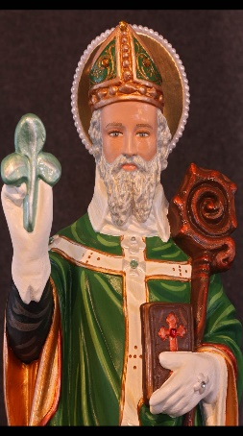



St Patrick’s Church

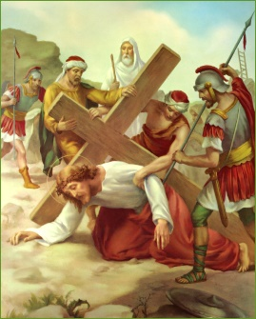
Events
We 16th June 2018

Y4 Children who have taken part in this year’s Sacramental Preparation Programme will make their First Holy Communion in a special Mass. The Mass starts at 10am in St Patrick’s Church.
This will be a wonderful celebration for school and parish.
e processing into church from school at 1:45. Mass will start at 2pm. We his being a great parish and school celebration of our patron saint’s day.

drink to stay alive a

#
d can also reproduce.

This week in Year 4, we have been to visit the Wigan Heritage Museum to find out about Ancient Egypt. We will be learning more about our topic ‘Ancient Egypt’ over the coming weeks.
In Class This Week – Y4

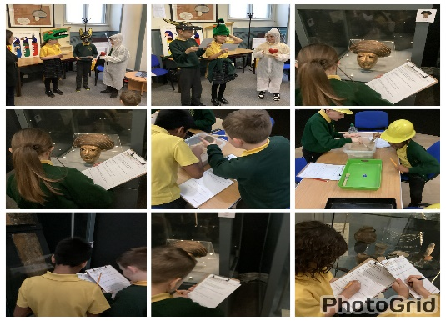
-15.3. 2024 – Patronal Feast Celebrations: 1:45pm Procession and 2pm Holy Mass. All are welcome to celebrate our Patron, St Patrick.

KS2 Class Masses this Half Term:
29/2/24 – Year 6
7/3/24 – Year 5
14/3/24 – Year 4
21/3/24 – Year 3
(Please note: These may be cancelled if a Funeral Mass is being celebrated that day).

Stay and Pray – Spring 2 (Infant Hall - 9:05am)
Friday 1st March - Reception
Friday 8th March – Year 6
Friday 15th March – Year 5
Friday 22nd March – Year 4

The Stations of the Cross will be prayed, each Wednesday during Lent, at 7pm. Holy Mass will be celebrated at 7:30pm, followed by an opportunity for Confessions.
All welcome.

