


St. Patrick's
Catholic Primary School

‘We arise today to learn, love and grow through Jesus.’
Newsletter - Week Beginning 13.1.2025
Dates, times and events are correct at the time of publication of this newsletter
(though may be subject to some alterations or additions).
Top attended classes for the previous week 6.1.2025 |   Class | Attendance %
Gold | Y3 | 89.67%
Silver | Y6 | 89.53%
Bronze | Y4 | 89.17%

Whole school current academic year
93.68%

Star of the Week
Week Beginning
6.1.2025
Nursery | Casey King | Reception | Arabella Ruddy
Nursery | Maeva Edwardson | Reception | Lucy Croft
Year 1 | Elijah Scrivens | Year 4 | Rory Whyte
Year 1 | Nylah Reeves | Year 4 | Jamie Eastham
Year 2 | Lexi Stroud | Year 5 | Hossein Moradi
Year 2 | Martha – May  Lee- Mort | Year 5 | Emily Eatock
Year 3 | Freya Bullough | Year 6 | Emily Ellison
Year 3 | Millie Sherman | Year 6 | Carrick O’Donnell

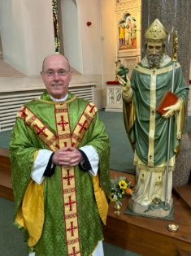

With sadness, this weekend we say ‘goodbye and good luck’ to Father O’Shea. Here at St Patrick’s Primary, we feel blessed to have had Father as our Parish Priest for the last seven years. He has been a great support to children and staff alike; with his wonderful contributions to the life of our school being recognised many times in our Catholic Schools’ Inspection Report. Thank you, Father O’Shea, for everything and please be assured of our future prayers. We wish you happiness and luck in your new Parishes – they are very lucky to have you.

THE NEXT TWO WEEKS…
Week Beginning | Stay and Read  (Tuesday) | Maths Matters (Wednesday) | Attending 9:15am Mass (Thursday) | Stay and Pray (Friday)
20.1.25 | Year 3 | Year 5 | Year 6 | Year 4
27.1.25 | Year 4 | Year 1 | Year 5 | Year 3

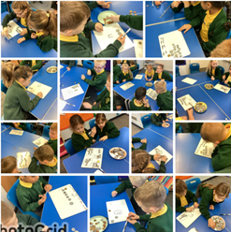

School Admission Arrangements 2026/2027 Consultation
A formal consultation of the school's admission arrangements for 2026/27 will take place between 16th December 2024 and 31st January 2025. Any comments relating to the proposed policy should be sent to the school email address enquiries@admin.saintpatricks.wigan.sch.uk

To view these documents please visit our admissions page on the school website.
https://st-patricks-catholic-primary-school.secure-primarysite.net/admission-arrangements-3/
This week, in Maths, Year 2 have been exploring, calculating and comparing different amounts of money.

Events

20/1/25 – Y4 visiting the Library
24/1/25 – Catholic Church Jubilee Year – ‘Pilgrims of Hope’ - being launched in School.
27/1/25 – Y3 visiting the library
29/1/25 – Birds of Prey visiting school.
30/1/25 – KS2 Outdoor Learning Experience in the school grounds to support Geography Fieldwork Topic.

In Class This Week: Year 2

Job Vacancy
School Cleaner
We seek an honest, reliable and well-motivated individual to join our cleaning team. For further details contact the school office on 01942 244361 or visit the school website https://www.saintpatricks.wigan.sch.uk/job-vacancies/

