


St. Patrick's
Catholic Primary School

‘We arise today to learn, love and grow through Jesus.’
Newsletter - Week Beginning 6.1.2025
Dates, times and events are correct at the time of publication of this newsletter
(though may be subject to some alterations or additions).
Top attended classes for the previous week 16.12.2024 |   Class | Attendance %
Gold
Silver
Bronze

Whole school current academic year


Star of the Week
Week Beginning
16.12.2024
Nursery | Paddy Boyd | Reception
Nursery | Autumn Aspey | Reception
Year 1 | Faustas Barcaitis | Year 4 | All of our Year 4 Autumn Superstars!
Year 1 | Jamin Jacob | Year 4 | All of our Year 4 Autumn Superstars!
Year 2 | Connie Boyd | Year 5 | All of our Year 5 Autumn Superstars!
Year 2 | Freddie Haynes | Year 5 | All of our Year 5 Autumn Superstars!
Year 3 | All of our Year 3 Autumn Superstars! | Year 6 | Olivia Lawler
Year 3 | All of our Year 3 Autumn Superstars! | Year 6 | Isaac Mather

Thank you, Father O’Shea!
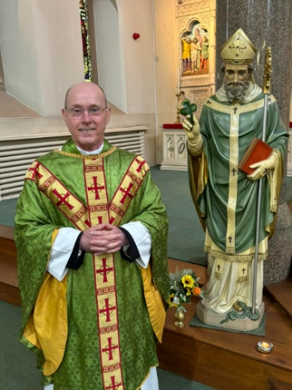

THE NEXT TWO WEEKS…
Week Beginning | Stay and Read  (Tuesday) | Maths Matters (Wednesday) | Attending 9:15am Mass (Thursday) | Stay and Pray (Friday)
13.1.25 | Year 6 | Year 4 | Year 3 | Year 5
20.1.25 | Year 3 | Year 5 | Year 6 | Year 4
School Admission Arrangements 2026/2027 Consultation
A formal consultation of the school's admission arrangements for 2026/27 will take place between 16th December 2024 and 31st January 2025. Any comments relating to the proposed policy should be sent to the school email address enquiries@admin.saintpatricks.wigan.sch.uk

To view these documents please visit our admissions page on the school website.
https://st-patricks-catholic-primary-school.secure-primarysite.net/admission-arrangements-3/

With sadness, this weekend we say ‘goodbye and good luck’ to Father O’Shea. Here at St Patrick’s Primary, we feel blessed to have had Father as our Parish Priest for the last seven years. He has been a great support to children and staff alike; with his wonderful contributions to the life of our school being recognised many times in our Catholic Schools’ Inspection Report. Thank you, Father O’Shea, for everything and please be assured of our future prayers. We wish you happiness and luck in your new Parishes – they are very lucky to have you.

Events

13/1/25 – Y5 visiting the Library
14/1/25 – Y3 visiting Science and Industry Museum
20/1/25 – Y4 visiting the Library
27/1/25 – Y3 visiting the library
29/1/25 – Birds of Prey visiting school.
30/1/25 – KS2 Outdoor Learning Experience in the school grounds to support Geography Fieldwork Topic.

In Class This Week: Year 2

