


St. Patrick's
Catholic Primary School

‘We arise today to learn, love and grow through Jesus.’
Newsletter - Week Beginning 12.2.2024
Dates, times and events are correct at the time of publication of this newsletter
(though may be subject to some alterations or additions).
Top attended classes for the previous week 22.1.2024 |   Class | Attendance %
Gold | Y6E | 98.18%
Silver | Y6P | 96.82%
Bronze | Y4B | 96.67%
Whole school current academic year

91.37%


Star of the Week

Week Beginning
5.2.2024
Nursery | Max Perkins | Reception | Elijah Scrivens
Nursery | Jayden Idam Aluu | Reception | Parizay Ahmed
Year 1 | Leva Prialgauskaite | Year 4 | Elza Mathews
Year 1 | Oceana Ward | Year 4 | Matthew Liptrot
Year 2 | Freya Bullough | Year 5 | Annabella Edwardson
Year 2 | Dawid Swidrak | Year 5 | Olivia Lawler
Year 3 | Paul Slater | Year 6 | Ethan Wilde-Causey
Year 3 | Jessica Lee | Year 6 | Maggie Gaskell

Every Tuesday, from 9:05am-9:30am, in the Infant Hall. An opportunity for parents/carers/ a family member to read with your child, explore our online reading platforms and an opportunity to read for pleasure.

SPRING 2 STAY AND READS:
Tuesday 27th February - Year 6
Tuesday 5th March - Reception
Tuesday 12th March - Year 6
Tuesday 19th March - Year 5

Every Year Group will have Stay and Read opportunities in the Summer Term.
Stay and Read Begins!

Half Term
We would like to wish everybody a safe, peaceful and relaxing Half Term break. We look forward to welcoming our children back into school, at 8:45am, on Monday 26th February.
I ask you to support us by checking your child(ren) on a regular basis. Thank you for your continuing support.
EMENTS

A





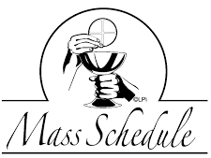

New Programme of Masses at St Patrick’s Church:
Now we have two priests, please see the additional Masses to Church’s usual schedule. All are welcome!
Please spread the word to your families and friends.

Sunday – 9:15am;
Tuesday – 7:30pm;
Wednesday – 7:30pm;
Thursday – 9:15am (Class Mass);
Friday – 7:30pm;
Saturday – 9:15am.

Events
We 16th June 2018

Y4 Children who have taken part in this year’s Sacramental Preparation Programme will make their First Holy Communion in a special Mass. The Mass starts at 10am in St Patrick’s Church.
This will be a wonderful celebration for school and parish.
e processing into church from school at 1:45. Mass will start at 2pm. We his being a great parish and school celebration of our patron saint’s day.

This week in Year 3, we had fun on our Number Day. On Number Day, we made headbands to showcase our favourite numbers and we went on a number treasure hunt.
week Year 2 g can move, grow and change, breathe, needs food and drink to stay alive and can also reproduce.

In Class This Week – Y3

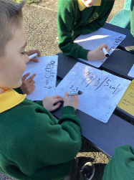
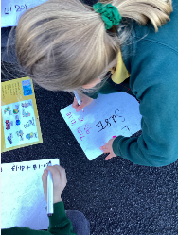
-15.3. 2024 – Patronal Feast Celebrations: 1:45pm Procession and 2pm Holy Mass. All are welcome to celebrate our Patron, St Patrick.

KS2 Class Masses in the next Half Term:
29/2/24 – Year 6
7/3/24 – Year 5
14/3/24 – Year 4
21/3/24 – Year 3
(Please note: These may be cancelled if a Funeral Mass is being celebrated that day).

Stay and Pray – Spring 2 (Infant Hall - 9:05am)
Friday 1st March - Reception
Friday 8th March – Year 6
Friday 15th March – Year 5
Friday 22nd March – Year 4

