


St. Patrick's
Catholic Primary School

‘We arise today to learn, love and grow through Jesus.’
Newsletter - Week Beginning 5.2.2024
Dates, times and events are correct at the time of publication of this newsletter
(though may be subject to some alterations or additions).
Top attended classes for the previous week 22.1.2024 |   Class | Attendance %
Gold | Y5G | 97.83%
Silver | Y4H | 97.50%
Bronze | Y2R | 97.27%
Whole school current academic year

91.4%


Star of the Week

Week Beginning
29.1.2024
Nursery | Nola Clark | Reception | Leon Jarvis
Nursery | Gabriella Asare | Reception | Bella Nicorici
Year 1 | Lucy Price | Year 4 | Arnav Aniyan
Year 1 | Joe Corrigan | Year 4 | Eddie Fitzpatrick
Year 2 | Emilie Hirst | Year 5 | Busra Ucar
Year 2 | Freya Hindley | Year 5 | Victory Aihimegbe
Year 3 | Louie Robinson | Year 6 | Emile Prialgauskaite
Year 3 | Poppy Burton-Steele | Year 6 | Henry Rumsey

A

Ash Wednesday – The Start of Lent
Ash Wednesday, the start of Lent, is on Wednesday 14th February. Lent is forty days of preparation for the events of Holy Week and the joy of Jesus’ resurrection at Easter.

Please join us for the Blessing and Distribution of Ashes at St Patrick’s Church on the 14th February

1:15pm Service in Church, with Ashes (School attending);

7:30pm Mass in Church, with Ashes.


Achievements
I ask you to support us by checking your child(ren) on a regular basis. Thank you for your continuing support.
EMENTS

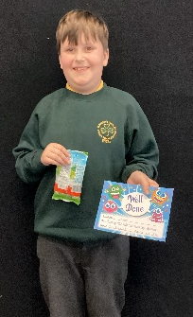

Well done Lucas!
A special award for outstanding work and effort.
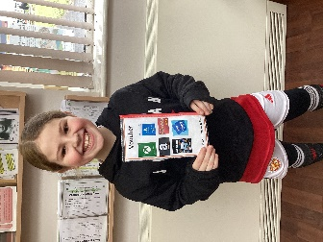

Well done Madeline!
Who completed her Going for Gold chart, this week!

St Patrick’s Church

Events
We 16th June 2018

Y4 Children who have taken part in this year’s Sacramental Preparation Programme will make their First Holy Communion in a special Mass. The Mass starts at 10am in St Patrick’s Church.
This will be a wonderful celebration for school and parish.
e processing into church from school at 1:45. Mass will start at 2pm. We his being a great parish and school celebration of our patron saint’s day.

This week during D and T week, we have been learning all about wheels and axels. We have explored how vehicles move and researched ideas to help us make our own moving trolley.

the children have been learning to group ‘living’ and ‘non-living things. They were a to recognise the difference between the two. They now know that a living thinThis week Year 2 g can move, grow and change, breathe, needs food and drink to stay alive and can also reproduce.

In Class This Week – Y2

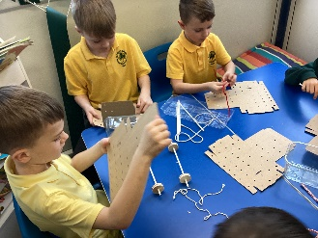
- 14.2.2024 – 1:15pm School Ash Wednesday Service in Church (the start of Lent) – all welcome.

KS2 Class Masses this Half Term:
15/2/24 – Year 3

Stay and Pray – Spring 1 (Infant Hall - 9:05am)

Stay and Pray – Spring 2 (Infant Hall - 9:05am)

Friday 1st March - Reception
Friday 8th March – Year 6
Friday 15th March – Year 5
Friday 22nd March – Year 4

St Patrick’s Night 2024
Whelley Legion – Friday 15th March

With music from Michael Coyne (Irish Singer) and DJ Martyn. Traditional Irish Dancing from The Price Family, hot food and a raffle.

Tickets now on sale, priced at £10, from Mr Marshall (Y5). All proceeds to Church Restoration Funds.

