


St. Patrick's
Catholic Primary School

‘We arise today to learn, love and grow through Jesus.’
Newsletter - Week Beginning 29.1.2024
Dates, times and events are correct at the time of publication of this newsletter
(though may be subject to some alterations or additions).
Top attended classes for the previous week 22.1.2024 |   Class | Attendance %
Gold | Y6E | 98.18%
Silver | Y4B | 96.67%
Bronze | Y5G | 94.78%
Whole school current academic year

91.2%


Star of the Week

Week Beginning
22.1.2024
Nursery | Milana Mitickina | Reception | Lucas Tarbuck
Nursery | Moustapha Mbacke | Reception | Reggie Kane
Year 1 | Joe Corrigan | Year 4 | Aaliyah Youssef
Year 1 | Lana Alnusairi | Year 4 | Devadutt Abhilash
Year 2 | Aria Carrington | Year 5 | Joey Hurst
Year 2 | James McNicholas | Year 5 | Carrick O’Donnell
Year 3 | George Elsden | Year 6 | Maysum Rooby
Year 3 | Henry Sawers | Year 6 | Jessica Bushell

A

Father Hugh’s first visit

We offered a warm St Patrick’s welcome to Father Hugh Donleavy this week. Father Hugh has recently become a Priest and is Father O’Shea’s assistant. He has been into school to meet Mrs Hobden and attend the Sacramental Preparation Parent’s Meeting. Over the next few weeks and months, all Year Groups will get the opportunity to meet Fr Hugh.
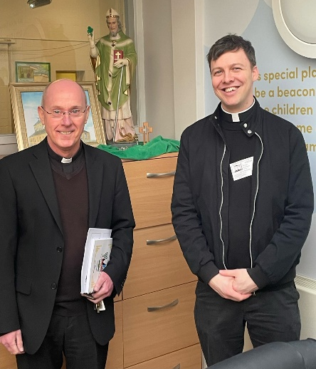
Reminder
Head lice
May I take this opportunity to ask for your support in the continuous battle against head lice. Head lice are a problem in many communities and do not reflect poor hygiene. Please could I ask you to support us by checking your child(ren) on a regular basis. Thank you for your continuing support.
I ask you to support us by checking your child(ren) on a regular basis. Thank you for your continuing support.
EMENTS

St Patrick’s Church
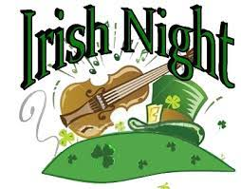
Events
We 16th June 2018

Y4 Children who have taken part in this year’s Sacramental Preparation Programme will make their First Holy Communion in a special Mass. The Mass starts at 10am in St Patrick’s Church.
This will be a wonderful celebration for school and parish.
e processing into church from school at 1:45. Mass will start at 2pm. We his being a great parish and school celebration of our patron saint’s day.

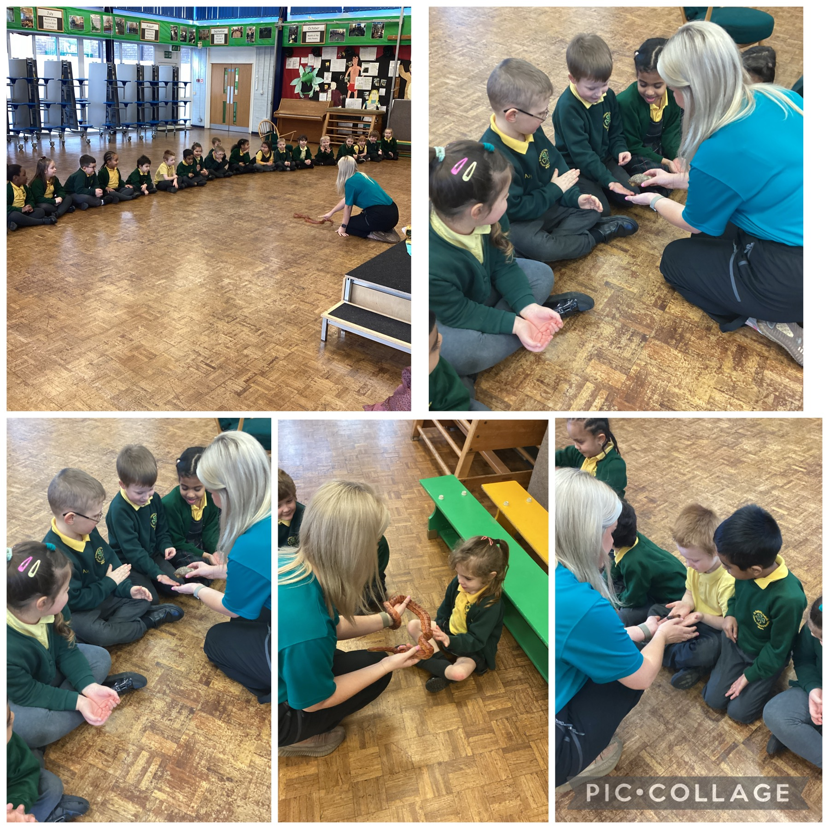
This week, we had some exciting visitors from Zoo Lab. We learned all about how different types of animals move their bodies. The children were very brave!

the children have been learning to group ‘living’ and ‘non-living things. They were able to recognise the difference between the two. They now know that a living thing can move, grow and change, breathe, needs food and drink to stay alive and can also reproduce.

In Class This Week – Y1

- 14.2.2024 – 1:15pm School Ash Wednesday Service in Church (the start of Lent) – all welcome.

KS2 Class Masses
(Thursday 9:15am in Church) – All welcome.
8/2/24 – Year 4
15/2/24 – Year 3

Stay and Pray – Spring 1 (Infant Hall - 9:05am)

St Patrick’s Night 2024
Whelley Legion – Friday 15th March

With music from Michael Coyne (Irish Singer) and DJ Martyn. Traditional Irish Dancing from The Price Family, hot food and a raffle.

Tickets on sale from this Sunday, priced at £10, from Mr Marshall (Y5). All proceeds to Church Restoration Funds.

