


.
St. Patrick's
Catholic Primary School

‘We arise today to learn, love and grow through Jesus.’
Newsletter - Week Beginning 22.1.2024
Dates, times and events are correct at the time of publication of this newsletter
(though may be subject to some alterations or additions).
Top attended classes for the previous week 15.1.2024 |   Class | Attendance %
Gold | RM | 94.00%
Silver | Y4H | 93.75%
Bronze | Y4B | 92.5%
Whole school current academic year

91.3%


Star of the Week

Week Beginning
15.1.2024
Nursery | Willow Dunn | Reception | Joseph Livesley
Nursery | Rory Davies | Reception | Benjamin Orimoloye
Year 1 | Dexter Hayes-McKay | Year 4 | George France
Year 1 | Kamil Handke | Year 4 | Madeline Brown
Year 2 | Aubree Clayton | Year 5 | Henry Haugh
Year 2 | Harry Barlow | Year 5 | Evie Minshull
Year 3 | Laurel Ofoha | Year 6 | Mia Aaron
Year 3 | Maya Danska | Year 6 | Mackenzie Holmes

A

Our Eco-School Award Journey Begins!
After achieving the LiveSimply Award in September, we have now successfully registered for the Eco-School’s Award. We look forward to beginning this next journey over the Spring and Summer Terms.

More updates to follow!
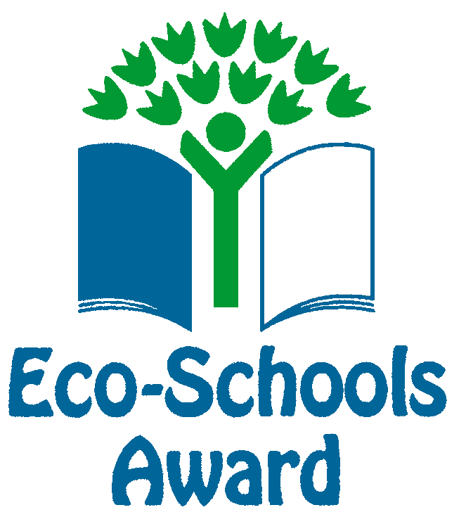
Achievements
ACHIEVEMENTS

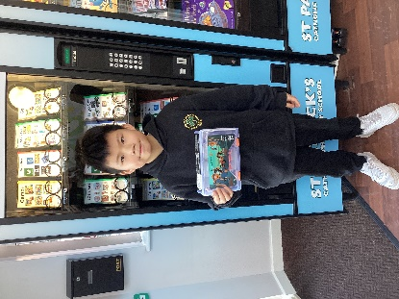
A huge well done to Justin, in Year 6, for filling his Going for Gold Reward Card and winning a prize from the vending machine.

St Patrick’s Church
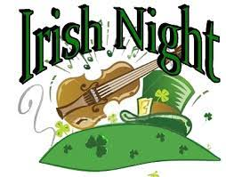
Events
We 16th June 2018

Y4 Children who have taken part in this year’s Sacramental Preparation Programme will make their First Holy Communion in a special Mass. The Mass starts at 10am in St Patrick’s Church.
This will be a wonderful celebration for school and parish.
e processing into church from school at 1:45. Mass will start at 2pm. We his being a great parish and school celebration of our patron saint’s day.

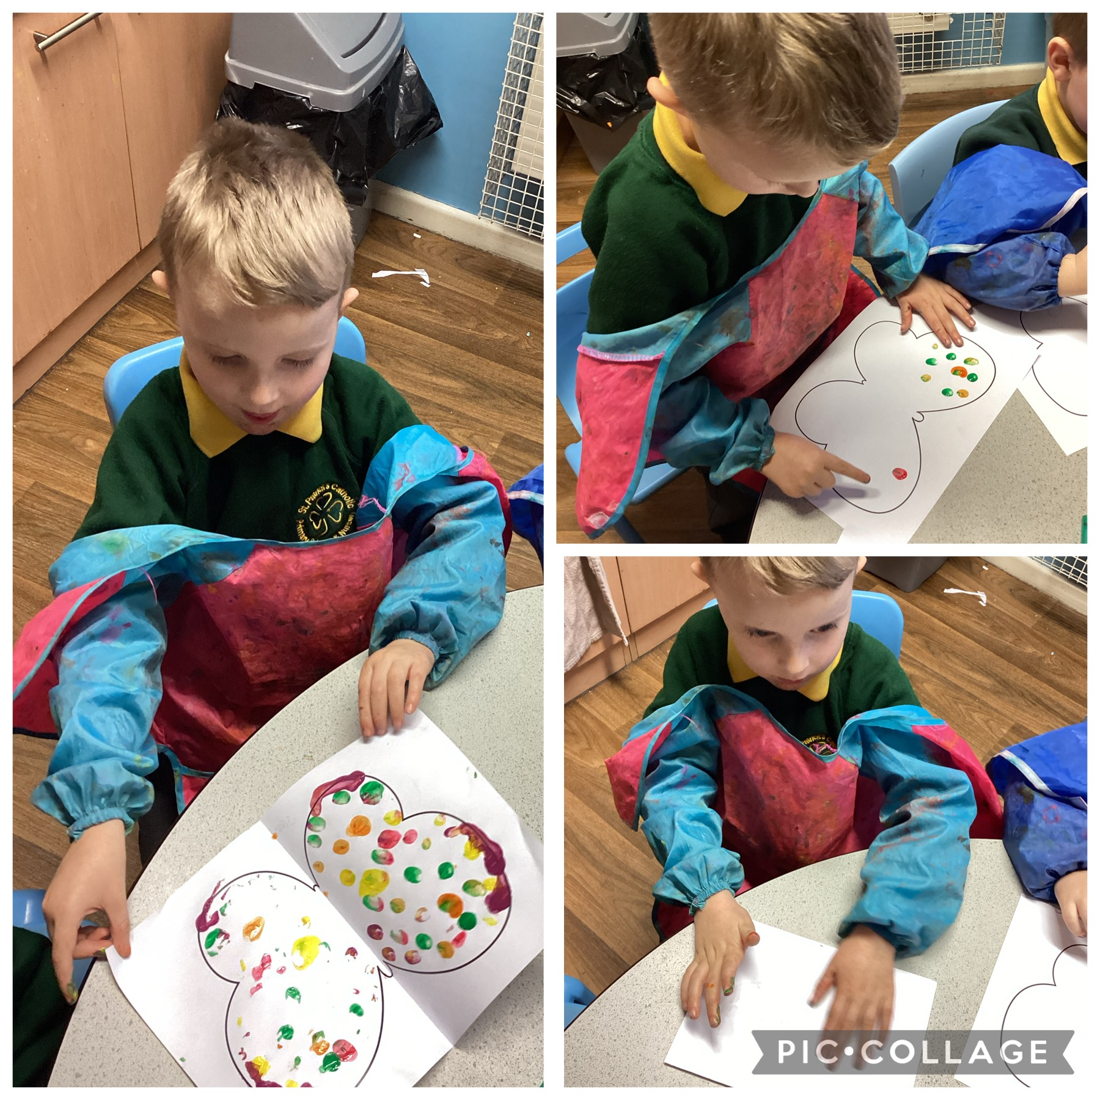
This week, the children have been talking about the life cycle of a butterfly. They have learned about how their wings are symmetrical and used their fingers to create a pattern, which they then printed on the other side.

the children have been learning to group ‘living’ and ‘non-living things. They were able to recognise the difference between the two. They now know that a living thing can move, grow and change, breathe, needs food and drink to stay alive and can also reproduce.

In Class This Week - Reception

- 14.2.2024 – 1:15pm School Ash Wednesday Service in Church (the start of Lent) – all welcome.

KS2 Class Masses
(Thursday 9:15am in Church) – All welcome.
25/1/24 – Year 6
1/2/24– Year 5
8/2/24 – Year 4
15/2/24 – Year 3

Stay and Pray – Spring 1 (Infant Hall - 9:05am)

St Patrick’s Night 2024
Whelley Legion – Friday 15th March

With music from Michael Coyne (Irish Singer) and DJ Paul. Traditional Irish Dancing from The Price Family, hot food and a raffle.

Tickets on sale next week, priced at £10, from Mr Marshall (Y5). All proceeds to Church Restoration Funds.

