


St. Patrick's
Catholic Primary School

‘We arise today to learn, love and grow through Jesus.’
Newsletter - Week Beginning 15.1.2024
Dates, times and events are correct at the time of publication of this newsletter
(though may be subject to some alterations or additions).
Top attended classes for the previous week 8.1.2024 |   Class | Attendance %
Gold | Y4B | 99.17%
Silver | RM | 99.00%
Bronze | Y6E | 98.18%
Whole school current academic year

91.4%


Star of the Week

Week Beginning
8.1.2024
Nursery | Lola Wilkieson | Reception | Sarah Ali
Nursery | Khalid Olayiwola | Reception | Eliora Aihimegbe
Year 1 | Isabelle Ward | Year 4 | Rehab Eissa
Year 1 | Martha May Lee-Mort | Year 4 | Poppy Booth
Year 2 | George Hughes | Year 5 | Erin Hopper
Year 2 | Amelia Davies | Year 5 | Elijah Habgood-Conlin
Year 3 | Kevinas Barcaitis | Year 6 | Madison Holmes
Year 3 | Isla-Mae Kenny | Year 6 | Ava O’Hara

A

Welcome, Father Hugh!
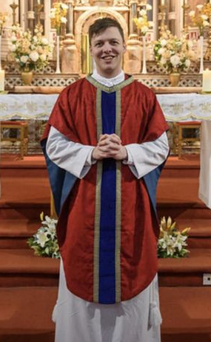
We offer a warm St Patrick’s welcome to Father Hugh Donleavy, who begins his appointment as Fr O’Shea’s Curate from this weekend. Fr Hugh will be a frequent and welcome visitor into school, alongside Fr O’Shea, and we look forward to his first visit. We feel blessed to have two priests in our Parish. Please do introduce yourself to Fr Hugh when you get chance.

Achievements
ACHIEVEMENTS

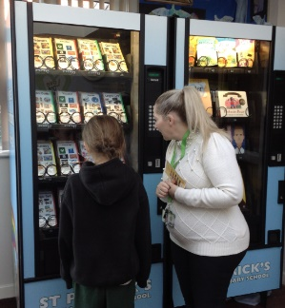
Well done to Penelope, Y4 for filling her ‘Going for Gold’ card for going above and beyond across the curriculum.
Penelope selected a craft set from the vending machines.
Well done, Penelope!

St Patrick’s Church

Events
We 16th June 2018

Y4 Children who have taken part in this year’s Sacramental Preparation Programme will make their First Holy Communion in a special Mass. The Mass starts at 10am in St Patrick’s Church.
This will be a wonderful celebration for school and parish.
e processing into church from school at 1:45. Mass will start at 2pm. We his being a great parish and school celebration of our patron saint’s day.

In the Mud Kitchen, we have been creating different food and drinks to help keep us warm. We have been making hot chocolate and different types of soups.

the children have been learning to group ‘living’ and ‘non-living things. They were able to recognise the difference between the two. They now know that a living thing can move, grow and change, breathe, needs food and drink to stay alive and can also reproduce.

In Class This Week - Nursery

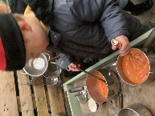
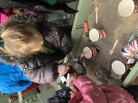
- 21.1.2024 – Arrival of Fr Hugh Donleavy as Assistant Priest. All are welcome to meet him at the 9:15am Mass that day.

- 14.2.2024 – 1:15pm School Ash Wednesday Service in Church (the start of Lent) – all welcome.

Stay and Pray – Spring 1 (Infant Hall - 9:05am)

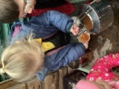

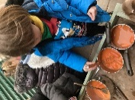
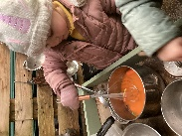
Join us this Sunday, 21st January, at the 9:15am Mass to welcome Father Hugh Donleavy. After Mass, there will be a Celebratory Coffee Morning in the Lappin Room, and a chance for everyone in our St Patrick’s Community to introduce themselves and say hello.

All welcome.

