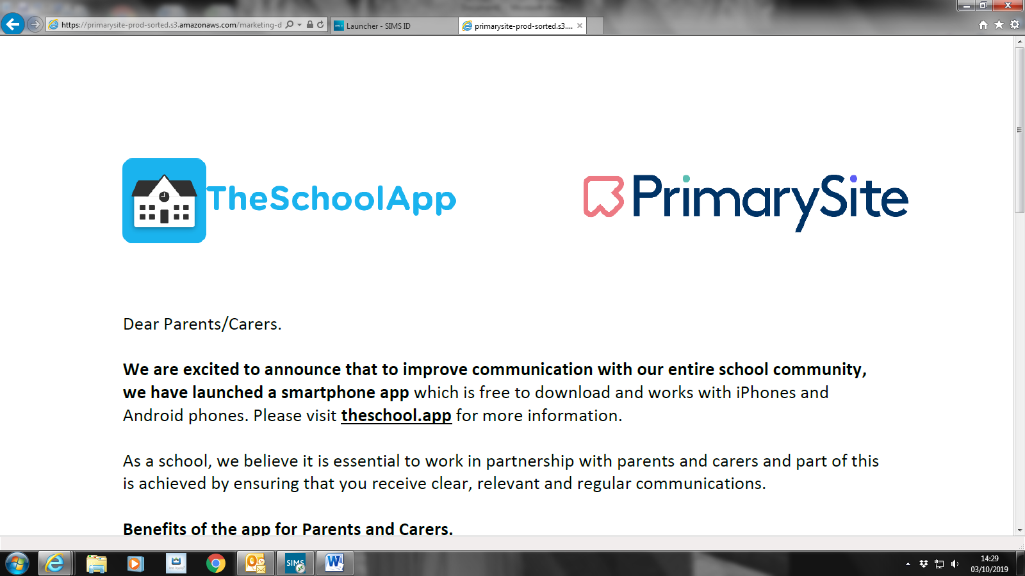

Dear Parents/Carers,

We are excited to announce that to improve communication with our entire school community; we have launched a smartphone app which is free to download and works with iPhones and Android phones. Please visit theschool.app for more information.

As a school, we believe it is essential to work in partnership with parents and carers and part of this is achieved by ensuring that you receive clear, relevant and regular communications.

Benefits of the app for Parents and Carers

• The app is secure; you set up a PIN/ Touch ID to access on your phone
• The app is powered by our school website which means that when you download it, you will have a single place to receive and access important messages along with calendar events, newsletters, latest news and all information pages within the school website.
• You no longer need to go searching for letters at the bottom of school bags
• Messages appear in your inbox in the condition that they left school; you will receive secure individual and group messages as well as whole school notices
• We can be certain that you have received the message

To set up the App

• Please complete the attached permissions slip and return ASAP
so we can send you an invitation to download the app.

To keep you fully updated, it is important that we have the most up-to-date parent/carer contact details and emergency contacts for your child. If any information changes throughout the school year, please notify us immediately.

Yours faithfully,
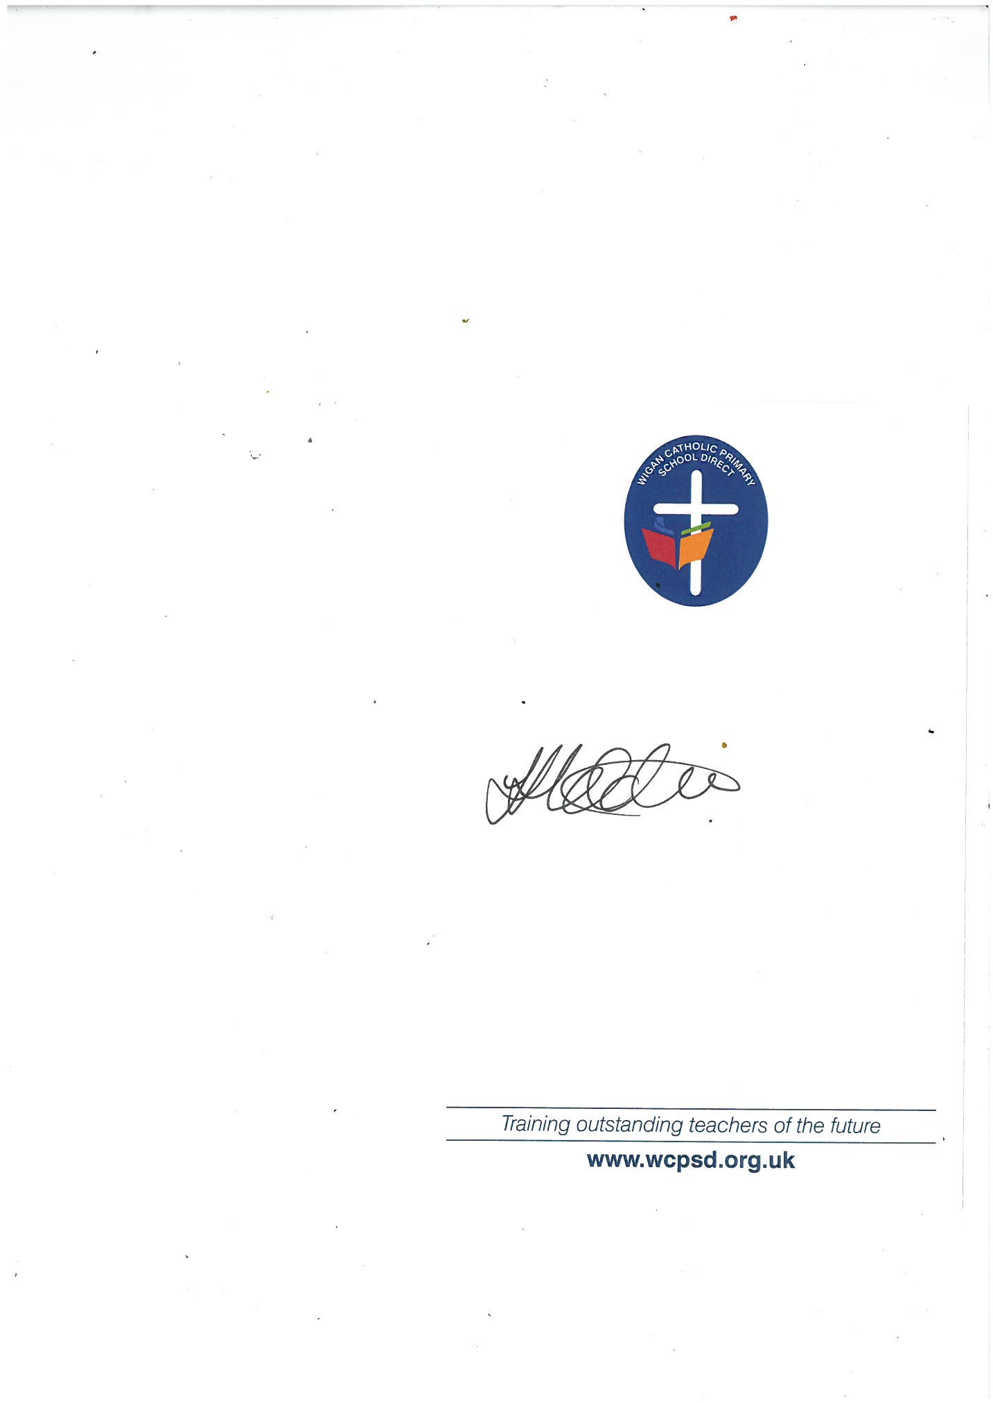

Mrs Hobden
Headteacher

PLEASE COMPLETE THIS FORM AND RETURN TO SCHOOL

PUPIL NAME
YEAR GROUP/CLASS NAME

CONTACT 1 | CONTACT 2
Relationship to pupil | Relationship to pupil
Title | Title
First name | First name
Surname | Surname
Mobile Number | Mobile Number
Email Address | Email Address

** By completing this form, I understand I am giving permission for the above contacts to receive direct messages via TheSchoolApp regarding the above child**

Name:

Signature:

Date:

