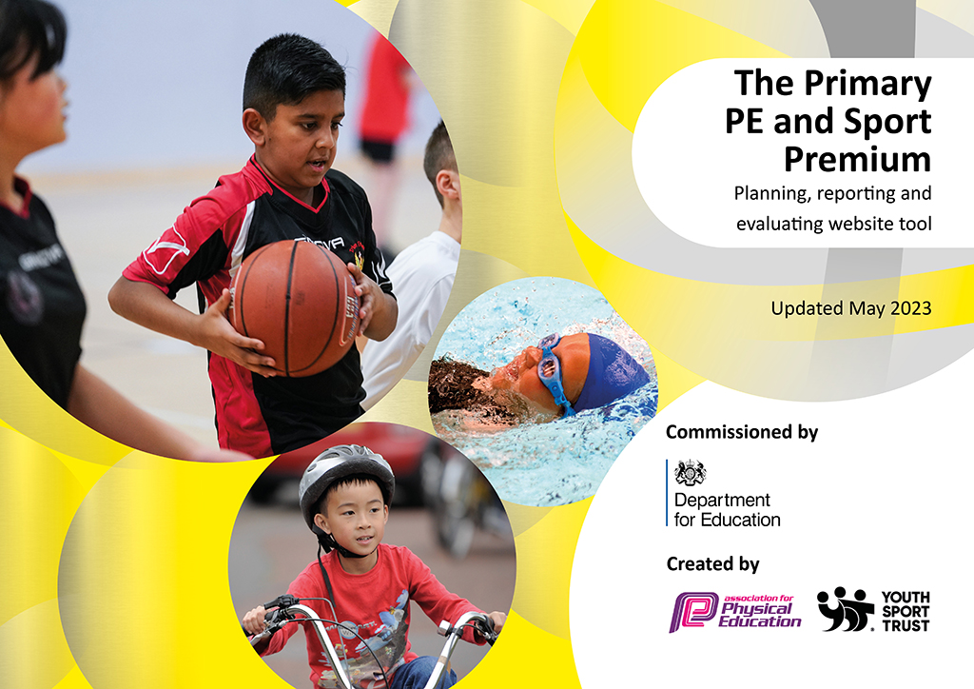

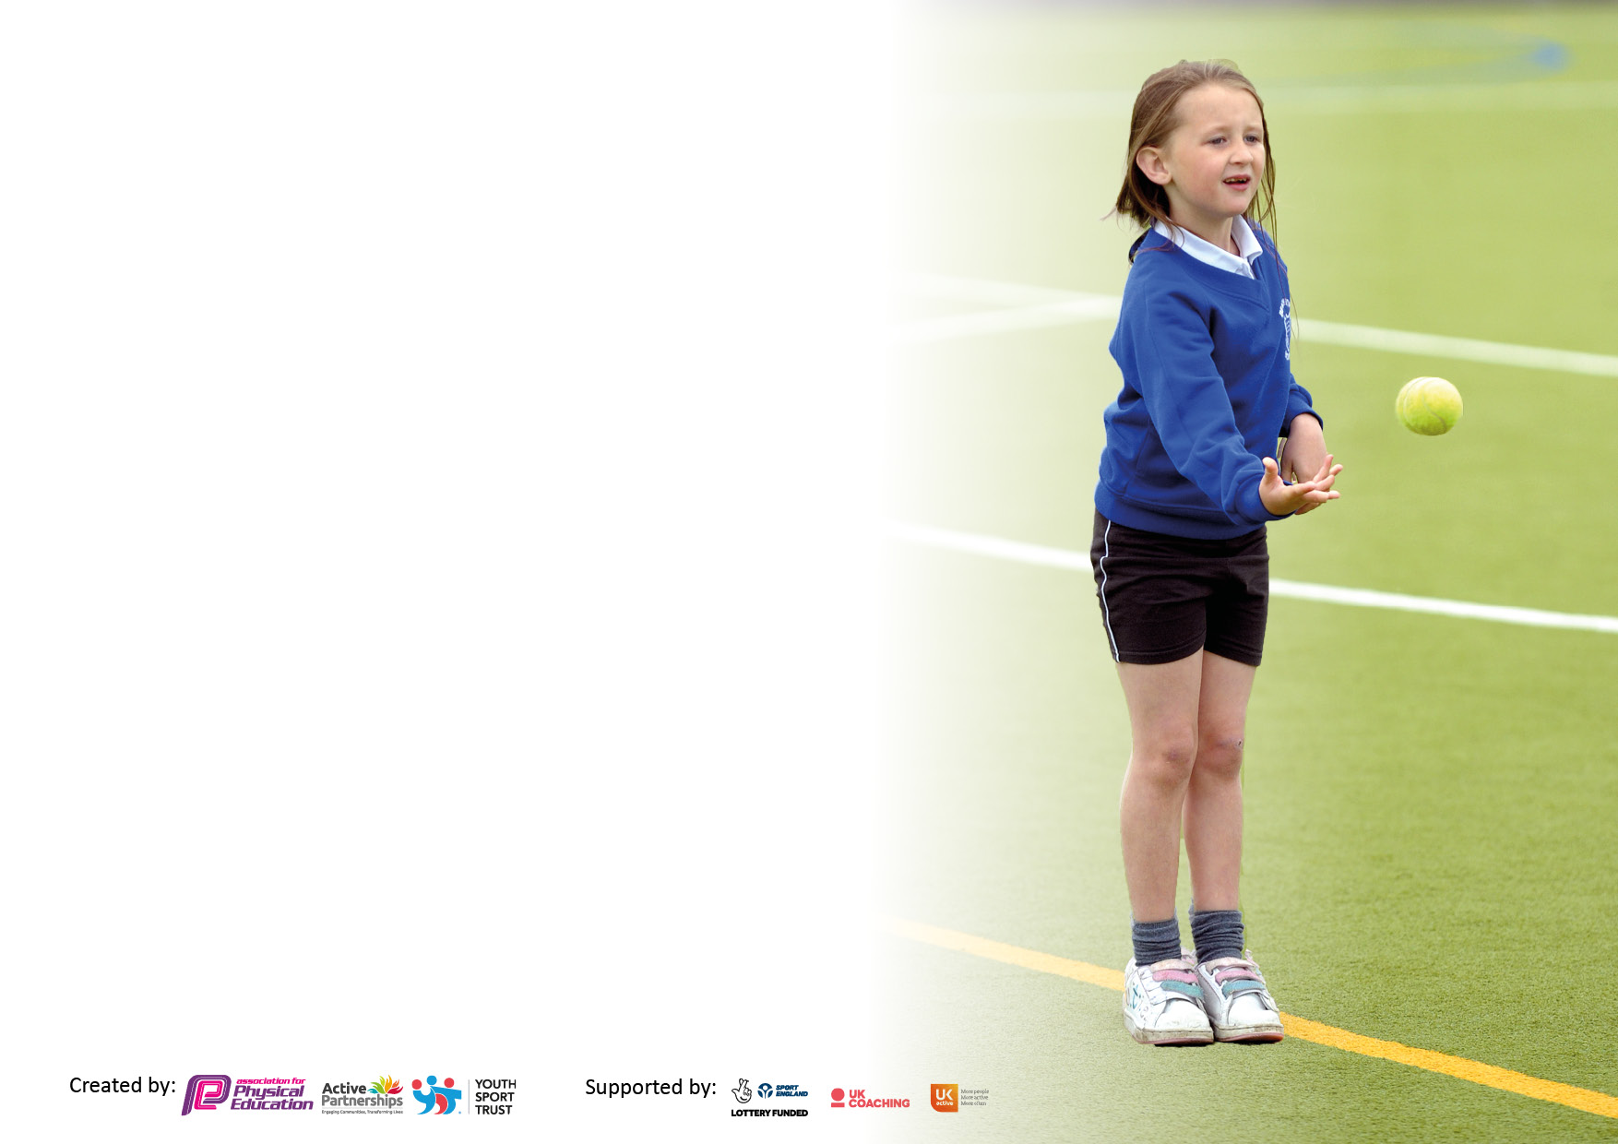
It is important that your grant is used effectively and based on school need. The Education Inspection Framework makes clear there will be a focus on ‘whether leaders and those responsible for governors all understand their respective roles and perform these in a way that enhances the effectiveness of the school’.

Under the Quality of Education Ofsted inspectors consider:
Intent - Curriculum design, coverage and appropriateness
Implementation - Curriculum delivery, Teaching (pedagogy) and Assessment
Impact - Attainment and progress

To assist schools with common transferable language this template has been developed to utilise the same three headings which should make your plans easily transferable between working documents.

Schools must use the funding to make additional and sustainable improvements to the quality of Physical Education, School Sport and Physical Activity (PESSPA) they offer. This means that you should use the Primary PE and sport premium to:

- Develop or add to the PESSPA activities that your school already offer
- Build capacity and capability within the school to ensure that improvements made now will benefit pupils joining the school in future years
- The Primary PE and sport premium should not be used to fund capital spend projects; the school’s budget should fund these.

Pleasevisitgov.ukfortherevisedDfEguidanceincludingthe5keyindicatorsacrosswhichschoolsshoulddemonstrate animprovement.Thisdocumentwillhelpyoutoreviewyourprovisionandtoreportyourspend.DfEencouragesschools to use this template as an effective way of meeting the reporting requirements of the Primary PE and Sport Premium.

We recommend you start by reflecting on the impact of current provision and reviewing the previous spend.

Schools are required to publish details of how they spend this funding, including any under-spend from 2021/2022, as well as on the impact it has on pupils’ PE and sport participation and attainment. All funding must be spent by 31st July 2023.

We recommend regularly updating the table and publishing it on your website throughout the year. This evidences your ongoing self-evaluation of how you are using the funding to secure maximum, sustainable impact. Final copy must be posted on your website by the end of the academic year and no later than the 31st July 2023. To see an example of how to complete the table please click HERE.

Details with regard to funding
Please complete the table below.

Total amount carried over from 2021/22 | £0
Total amount allocated for 2021/22 | £18,590
How much (if any) do you intend to carry over from this total fund into 2022/23? | £0
Total amount allocated for 2022/23 | £18,610
Total amount of funding for 2023/23. To be spent and reported on by 31st July 2023. | £18,610
Swimming Data
Please report on your Swimming Data below.

Meeting national curriculum requirements for swimming and water safety.  N.B. Complete this section to your best ability. For example you might have practised safe self-rescue techniques on dry land which you can then transfer to the pool when school swimming restarts.  Due to exceptional circumstances priority should be given to ensuring that pupils can perform safe self rescue even if they do not fully meet the first two requirements of the NC programme of study | During the swimming session the children practised self rescue techniques both out of the pool and in the pool.  Children have discussed water safety in class with their teacher.
What percentage of your current Year 6 cohort swim competently, confidently and proficiently over a distance of at least 25 metres?  N.B. Even though your pupils may swim in another year please report on their attainment on leaving primary school at the end of the summer term 2022.  Please see note above | 27%
What percentage of your current Year 6 cohort use a range of strokes effectively [for example, front crawl, backstroke and breaststroke]?  Please see note above | 43%
What percentage of your current Year 6 cohort perform safe self-rescue in different water-based situations? | 27%
Schools can choose to use the Primary PE and sport premium to provide additional provision for swimming but this must be for activity over and above the national curriculum requirements. Have you used it in this way? | Yes/No
Action Plan and Budget Tracking
Capture your intended annual spend against the 5 key indicators. Clarify the success criteria and evidence of impact that you intend to measure to evaluate for pupils today and for the future.

Academic Year: 2022/23 | Total fund allocated: | Date Updated:
Key indicator 1: The engagement of all pupils in regular physical activity – Chief Medical Officers guidelines recommend that primary school pupils undertake at least 30 minutes of physical activity a day in school |  |  |  | Percentage of total allocation:
 |  |  |  | 82%
Intent | Implementation |  | Impact
Your school focus should be clear what you want the pupils to know and be able to do and about  what they need to learn and to  consolidate through practice: | Make sure your actions to achieve are linked to your intentions: | Funding allocated: | Evidence of impact: what do pupils now know and what can they now do? What has changed?: | Sustainability and suggested next steps:
All pupils now engage in a daily wellbeing walk.  To appoint children and reinstate the school sports council. The school sport councillors will give the children of school a voice and give them ownership of the extra-curricular club plans to add to children’s daily active total.  All pupils to receive a minimum of 2 hour taught PE.  Sports Leaders  To provide a range of activities. | All staff and children complete a daily wellbeing walk along a designated route.  Children will be selected by their peers. Children to collate information from their peers about extra-curricular clubs. They will plan a list of wants and any resources that are required.  Delivery of 1, 1-hour high quality PE lesson (Get Set 4 PE curriculum) per week during curriculum time with the specialist sports coach working alongside class teachers. All pupils will also participate in 30 minutes of planned, progressive outdoor games per day. Each year group has timetabled slots to ensure the minimum requirement of physical activity for children is met daily.  Children who are already trained as sports leaders will continue to deliver at lunchtime  Children in year 4 and 5 will apply for the role as a sports leader and begin to assist adults and Year 6 children with leading activities. By the summer term, these children will begin to lead activities.  Replenish and buy new equipment to provide a variety of activities. | Free  Free  £14,149  Free  £1,200 | KS2 children to complete the wellbeing walk during the school day. The walk consists of a route around the school grounds to allow the children to talk and walk.  The selected children (applied for the position and voted by peers) for the sports council have been discussing with their peers their wants for sports within school. As a result, extra-curricular activities have been planned with these in mind. This has also resulted in school buying resources required to carry out such activities.  Pupils have accessed high quality PE lessons weekly that have been delivered by the specialist sports coach and class teachers. Both who have worked collaboratively to develop staff knowledge around P.E. Pupils have then been able to access further daily sports challenges and intra school competitions providing more active time. The impact has been that children are working towards their daily active minutes and have further competitive opportunities within school.  Children have applied and been selected for the Sports Leader role. They have been supported in becoming a leader by school staff and current Sports Leaders.  The impact has been the confidence the children have developed to then lead with confidence, setting up the games  Children will access a variety of activities and therefore engage in further active minutes. | To continue daily wellbeing walk.  Gather feedback to see if there are more suitable times during the school day for a wellbeing walk to take place.  To continue with the sports council and ask for new members to apply as the older children have left school. There will be new appointments in lower key stage 2.  To further upskill teachers who have areas of P.E. they wish to develop. To work with any new members of staff who are unfamiliar with the planning, delivery and assessment of P.E. within school.  The current sports leaders will help to train up the new leaders when they have applied and been appointed. The children will show the new leaders what is expected and then work alongside the new leaders, supporting them in their role.  To develop this further we will enquire about external training the Sports Leaders could be provided with.  Children will then develop an interest in different activities, resulting in more active minutes.
Key indicator 2: The profile of PESSPA being raised across the school as a tool for whole school improvement |  |  |  | Percentage of total allocation:
 |  |  |  | 0%
Intent | Implementation |  | Impact
Your school focus should be clear what you want the pupils to know and be able to do and about  what they need to learn and to  consolidate through practice: | Make sure your actions to achieve are linked to your intentions: | Funding allocated: | Evidence of impact: what do pupils now know and what can they now do? What has changed?: | Sustainability and suggested next steps:
Monitor timetables, planning and assessment sheets to ensure children are receiving 2 hours of PE per week, progression of skills are being used and seen across school  To obtain a School Games Award with a minimum of a Bronze award.  Year 3 will attend swimming for half a year. Y6 will attend for the remainder of the year with those who have not reached 25m targeted in a smaller group setting. | Collect assessments and look for progression across school. Use the assessment sheets to identify those who may need further support.  Autumn look at the areas that would need to be met in order to achieve the award.  Spring – Continue to monitor achievements and areas that need to be developed.  Summer - Collect evidence for Kite mark.  Year 3 will attend swimming for half a year. The children will be assessed throughout. Year 6 will then attend and any children who have not met the national curriculum requirements will be targeted in a smaller group setting. | Time  Time | Timetables are monitored. All classes are receiving 2 hours of PE per week. Hall is timetabled so each class have access.  Apply for the School Games Award. The impact will be that children’s engagement and achievements will be recognised with a whole school award.  Year 3 attended swimming lessons for half a year and assessed throughout. Year 6 will then attend swimming lessons and any children who haven’t met the national curriculum standard will be targeted in a smaller group in order to try and obtain the standard. | Keep the LTP in place and continue to monitor. Monitor assessments for areas that children require further support.  Continue to collect evidence for the School Games Award for when we reapply.  Monitor the progress of the year 3 children attending swimming. Discuss if another class would benefit from a period of time spent swimming in order to meet the national curriculum standards by Year 6.

Key indicator 3: Increased confidence, knowledge and skills of all staff in teaching PE and sport |  |  |  | Percentage of total allocation:
 |  |  |  | Already accounted for in KI1
Intent | Implementation |  | Impact
Your school focus should be clear | Make sure your actions to | Funding | Evidence of impact: what do | Sustainability and suggested
what you want the pupils to know | achieve are linked to your | allocated: | pupils now know and what | next steps:
and be able to do and support | intentions: |  | can they now do? What has
what they need to learn and to |  |  | changed?:
consolidate through practice:
To ensure all staff teaching PE have access to quality CPD and latest developments and expectations.  Lessons to be team taught with both class teacher and schools sports coach as a form of CPD. | Autumn – as teachers have moved classes discuss with them their needs in order to support this.  Work with School Games Organiser about CPD opportunities which are available  School sports coach to be present in each lesson from Nursery to Y6. In order to team teach along with giving staff the opportunities to teach lessons. | Free  £14,149 | Supported teachers with the planning for PE (using MTP) Support teachers with assessments in order to inform their planning.  Pupils access high quality P.E. delivered by specialist sports coach along with class teacher. Areas of development for staff have been identified and improved using a collaborative approach. | MTP discussed and planned for a range of activities within different year groups and challenging a range of skillsets. Monitor assessments to check progression.  Allow teachers to lead with P.E. lessons and continue to receive support from specialist sports coach. Be aware of any teacher changes to different year groups or new to school and identify their CPD requirements.
Key indicator 4: Broader experience of a range of sports and activities offered to all pupils |  |  |  | Percentage of total allocation:
 |  |  |  | 11%
Intent | Implementation |  | Impact
Your school focus should be clear | Make sure your actions to | Funding | Evidence of impact: what do | Sustainability and suggested
what you want the pupils to know | achieve are linked to your | allocated: | pupils now know and what | next steps:
and be able to do and about | intentions: |  | can they now do? What has
what they need to learn and to |  |  | changed?:
consolidate through practice:
Additional achievements:  Long term plan highlights variety of sports, gymnastics and dance during curriculum time. This will impact the children and they will have the opportunity to improve skills and performance in different ways.  Each term there will be a range of afterschool clubs for the children to attend. The afterschool clubs will provide the children with a range of sporting opportunities  Raise pupil awareness of the various sporting opportunities available to them | Long term plan Ensure a mixture of games, dance and gymnastics. Variety of sports.  Monitor OAA across the year as it is taught  Variety of sports. Each year group will have access to 1 sports club each week. The sports will change on a termly basis. Track the children who attend, highlight pupil premium and SEND  Invite agencies into school to make children aware of what is on offer outside of school. Further investment in additional resources to facilitate the provision for outdoor education and alternative ranges of sporting activities for all year round  Introduce the GT children to opportunities outside of school. | Time  £2,000  Time | LTP in place  Impact show a range of skills and knowledge being taught  Range of clubs throughout the year include, dance, archery, rugby, football, multi skills, netball, athletics, cheerleading, handball and rounders.  Pupils become aware of further opportunities outside of school. The impact will be them taking part in clubs out of school. | Continue with the LTP in place. Continue to show progress in the children’s vocabulary through the use of the questionnaires.  To focus on KS2 to see why there is a dip in not as many children attending clubs. Sports Council clubs they would like to see on offer.  Introduce ?? and specialist sports coach to delivering clubs next year.  Continue to make links with clubs to help children to further progress their talents after the success of athletics and the number of children who now attend.

Key indicator 5: Increased participation in competitive sport |  |  |  | Percentage of total allocation:
 |  |  |  | 7%
Intent | Implementation |  | Impact
Your school focus should be clear | Make sure your actions to | Funding | Evidence of impact: what do | Sustainability and suggested
what you want the pupils to know | achieve are linked to your | allocated: | pupils now know and what | next steps:
and be able to do and about | intentions: |  | can they now do? What has
what they need to learn and to |  |  | changed?:
consolidate through practice:
To arrange inter and intra school competitions so that children still have the opportunity to compete on a competitive level.  Provide opportunities for children to develop a wide range of sporting skills and qualities such as being a good leader and fair play  Lead and compete in Wigan Town Sports. | Work with Cathy Robinson and enter events on different levels to allow an inclusive approach. Ensure that children at any level have the opportunity to compete. Work with the sports council to set up intra school competitions,  Attend the just join in sessions so that SEND children have the opportunity to represent the school  Lunchtime clubs with Sports leaders helping to officiate extra games.  Deliver an extra-curricular club for Athletics aimed at Key Stage 2.  Deliver lunch time Athletics activities for those children selected. | £1000  £210  £50 | Children have entered events on different levels during autumn – more children have had the opportunity to represent the school  Inclusion  Developmental  Participation  Competitive  The tracking shows that more children have represented the school this year on the different levels  Play leader training  Town sports entered and planning for June/ July | To continue to enter a range of competitions on the different levels so that more children get the opportunity to represent the school.  Plan for additional attendance at competitions that may have had smaller representation.  School staff to work with sports leaders and any older children who have previously been a sports leader to assist them initially.  Continue with the running of town sports

Signed off by
Head Teacher:
Date:
Subject Leader:
Date:
Governor:
Date:

