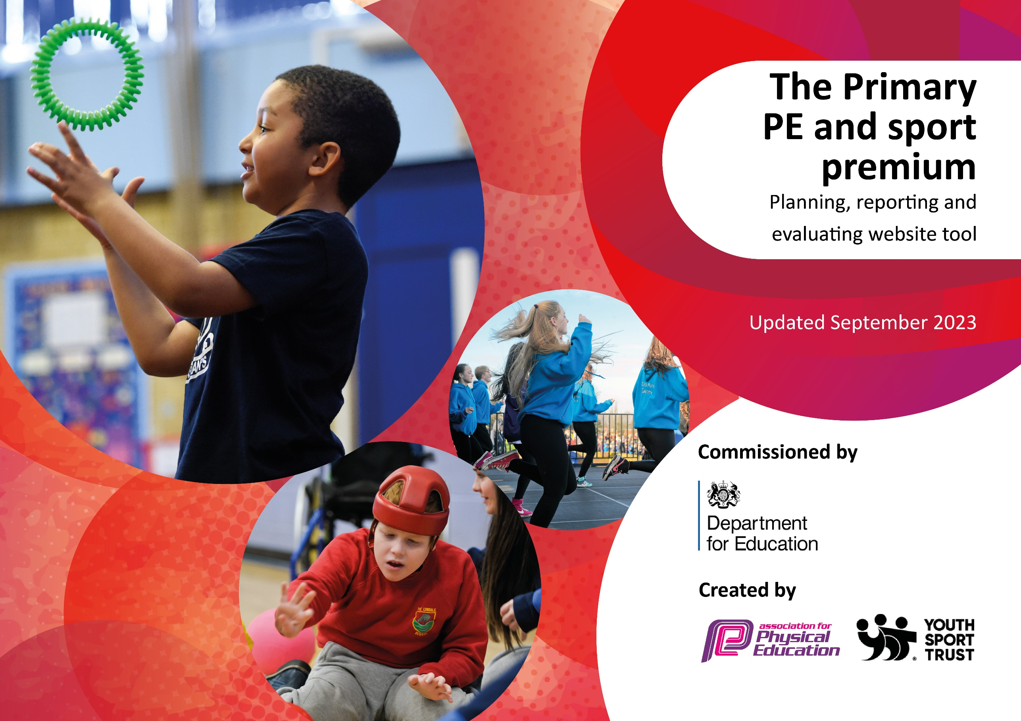

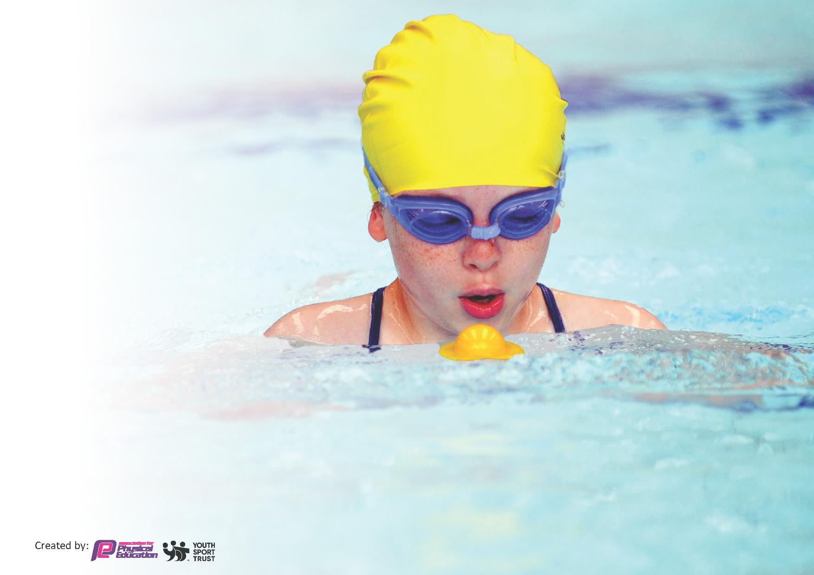
This template can be used for multiple purposes:
by:
- It enables schools to effectively plan their use of the Primary PE and sport premium
- It helps schools to meet the requirements (as set out in guidance) to publish information on their Primary PE and sport premium
- It will be an effective document to support Ofsted inspections enabling schools to evidence progress in Physical Education (PE) and evidence swimming attainment, which forms part of the PE National Curriculum. We would recommend schools consider
the Intent, Implementation and Impact of any spend, as examined within the Education Inspection Framework.

It is important that your grant is used effectively and based on school need.

Schools must use the funding to make additional and sustainable
improvements to the quality of the PE, School Sport and Physical Activity (PESSPA)
they offer. This means that you should use the Primary PE and sport premium to:

- Build capacity and capability within the school to ensure that improvements made now will benefit pupils joining the school in future years
- Develop or add to the PESSPA activities that your school already offers.

The Primary PE and sport premium should not be used to fund capital spend projects; the school’s core budget should fund these. Further detail on capital expenditure can be found in the updated Primary PE and sport premium guidance.

The Primary PE and sport premium guidance, outlines 5 key priorities that funding should be used towards. It is not

necessary that spending has to meet all the key priorities, you should select the priorities that you aim to use any funding towards.

Although completing this template is not a requirement for schools, schools are required to publish details of how they spend this funding. Schools must also outline what the impact this funding has had on pupils’ PE and sport participation and attainment and how any spending will be sustainable in the future. All funding must be spent by 31st July 2024.

The Department for Education has worked closely with the Association for Physical Education (afPE) and the Youth Sport Trust (YST) to develop this template and encourages schools to use it. This template is an effective way of meeting the reporting requirements of the Primary PE and sport premium.
Review of last year’s spend and key achievements (2022/2023)

We recommend you start by reflecting on the impact of current provision and reviewing your previous spend.

Activity/Action | Impact | Comments
Children being trained as play leaders and delivering clubs to the children at lunch times.  To give the children the opportunity to compete for the school at different levels.  To ensure PE has a high profile across school | More children had the opportunity to become physically active. All children were more involved as the clubs were during the school day.  More children got the opportunity to represent the school at their level. We ensured we entered a range of competitions at a competitive, participation, developmental or inclusive level.  All pupils to receive a minimum of 2 hour taught PE and have access to a range of after school clubs. | The play leaders who are already trained will hand over to the new play leaders to help a smooth transition. The children will apply for the role.  A range of children had the opportunity to represent the school rather than just the gifted children. The children were entered at level matching their ability and were able to represent the school, competing against other local schools.  Children have more opportunities to access a range of activities and sports each half term, in addition to the P.E. lessons throughout each week.

Key priorities and Planning
This planning template will allow schools to accurately plan their spending.

Action – what are you planning to do | Who does this action impact? | Key indicator to meet | Impacts and how sustainability will be achieved? | Cost linked to the action
Promote and develop the wellbeing walk across school.  Appoint a leadership team to support physical education and school sport, developing and leading clubs.  Children to become a play leader. They will work with the younger children in school to deliver activities during lunchtime clubs  Monitor timetables, planning and assessment sheets to ensure children are receiving an offer of 2 hours of physical activity per week progression of skills are being used and seen across school  Identify the bottom 20 % from assessments. Timetable these children to work with Sports Coach for intervention.  To Maintain School games Award Gold. This will impact the children as this will raise sports across school providing the children with opportunities to become involved. All year groups will work with  Year 3 will attend swimming during autumn and spring followed by Y6 in the spring and summer.  Provide staff with the opportunity to ask questions regarding PE and school sport and support with teaching and implementation. This will be supported by the school’s sports coach when teaching with members of staff.  Provide a range of extra-curricular activities for the children to attend each half term  To arrange inter and intra school competitions so that children still have the opportunity to compete on a competitive, developmental, participation or inclusive level.  Competitive sports for all children across school to compete in | Teachers and teaching assistants as they need to lead the activity.  pupils – as they will take part.  Children as they will develop sense of responsibility and independence. Also, children around school have the opportunity to be heard.  Staff who will train the play leaders to lead activities.  The children as they will be involved with the training and delivering the clubs.  Teachers as they will be planning, delivering and assessing PE  Children as they will be taking part in PE and extra-curricular clubs.  J.Birchall to deliver interventions.  Teachers as they will identify the children  Children as they will be taking part.  C.Baxter – applying for the accreditation and leading  Teachers – supplying the evidence  Y3 & 6 teachers and teaching assistants – taking the children to swimming  Wigan life swim teachers- teaching the children  C.Baxter - monitoring the data  Children – taking part.  J.Birchall – supporting the staff  Teachers – implementing the planning  J.Birchall, Skillwise Sports, teachers and Sports Cool – delivering the clubs  Children – attending the clubs  Cathy Robinson (SGO) – arranging the competitions  C.Baxter & J.Birchall – Arranging and entering, selecting the children, tracking  Children – taking part.  PE team – planning  Teachers – supporting  Children taking part | Key indicator 2 -The engagement of all pupils in regular physical activity – the Chief Medical Officer guidelines recommend that all children and young people aged 5 to 18 engage in at least 60 minutes of physical activity per day, of which 30 minutes should be in school.  Key indicator 2 -The engagement of all pupils in regular physical activity – the Chief Medical Officer guidelines recommend that all children and young people aged 5 to 18 engage in at least 60 minutes of physical activity per day, of which 30 minutes should be in school.  Key indicator 2 -The engagement of all pupils in regular physical activity – the Chief Medical Officer guidelines recommend that all children and young people aged 5 to 18 engage in at least 60 minutes of physical activity per day, of which 30 minutes should be in school.  Key indicator 3 – The profile of PE and school sport is raised across school as a tool for whole school improvement  Key indicator 3 – The profile of PE and school sport is raised across school as a tool for whole school improvement  Key indicator 3 – The profile of PE and school sport is raised across school as a tool for whole school improvement  Key indicator 1 – increased confidence, knowledge and skills of all staff in teaching pe and sport  Key indicator 4 – broader experience of a range of sports and activities offered to pupils.  Key indicator 5 – increased participation in competitive sports.  Key indicator 5 – increased participation in competitive sports.  Key indicator 2 -The engagement of all pupils in regular physical activity  Key indicator 1 – increased confidence, knowledge and skills of all staff in teaching pe and sport | More pupils meeting their daily physical activity goal.  Children are leading the campaign to allow pupil to becomes physically active. Resources ordered to be used in the lunch time activities.  The children will be trained as leaders, developing their own leaderships skills. They will then have the skills to deliver lunch time clubs to the younger children in school  PE curriculum will be taught across all classes ensuring a high profile and each year group will be offered additional extra-curricular clubs throughout the year.  Children taking part will have the opportunity to close the gap with peers. They will work as a small group on targeted objectives to support them.  The profile across school will ensure PE remains high and will be encouraged.  Children will be working towards the national curriculum requirement of 25 m  Staff will be confident in teaching PE  The children will be able to develop their skills in a range of extra-curricular activity, whilst being physically active.  More children will have the opportunity to represent the school at their level in competitive sports.  All children will compete in sports day.  All children will take part in a Euro 24 competition.  All children will take part in competitions that are set each half term. | Free  ?  £16,460 coaches’ salary  £300 resources  £16,460 coaches salary  £440

Key achievements 2023-2024
This template will be completed at the end of the academic year and will showcase the key achievements schools have made with their Primary PE and sport premium spending.

Activity/Action | Impact | Comments
We have successfully maintained the ‘Gold’ School Games Award.  Playleaders have been appointed to enrich organised games and activities at break times and lunch times.  The school sports coach continues to provide ongoing support to school staff in planning, delivery and assessment. Collaborative teaching, planning and assessment on a weekly basis ensures the teachers deliver high quality PE lessons, with progressive skill-based learning taught. Staff are able to ask questions and consolidate their understanding in order to teach a broad range of sports and activities.  Children across all year groups have had a range of opportunities to attend out of school sports events; either on an inclusive, participation, developmental or competitive drive. | The sports, PE and activity profile within school remains raised, which has enabled children of all ages and abilities to become involved in in and out of school sports.  A group of children have been trained to organise activities for others children on the playground, they encourage children to join in games, promote inclusion and establish positive interactions and friendships.  High quality PE lessons are delivered developing children’s physical literacy with an aim to encourage a lifelong participation. Pupils access increased opportunities in school and the wider community. Teachers are upskilled by working alongside the coach improving their knowledge around the development of core skills. Teachers feel that the high school sports profile raises achievement across the curriculum as children develop in their confidence and self-esteem through sports.  Children feel capable and confident in their abilities to be physically active in competition. These external competitions have shown to inspire our children to do their best whilst becoming more inquisitive about their sporting activity. Children accessing these competitions at the right level for them has ensured that more of our children are motivated to take part. | We will continue to strive for excellence and aim to maintain our gold standard award in the next academic year.  Reintroducing play leaders has been a positive step here at Saint Patrick’s. Children are confident in their role and help other children, model respecting equipment, follow the schools’ values and virtues and are honest, reliable and trustworthy. Their efforts are celebrated in assemblies.  Work in collaboration with the sports coach enables teachers to feel confident and assured in their delivery. Having a sports coach in school who is passionate about physical activity and sports themselves provide children with a positive role model, motivating them to have more involvement within various activities linked to PE and sport.  Children at Saint Patrick’s are excited to represent school in competition, work as a team and strive to win. However, they recognise that partaking in competitions is not always about winning and those who have participated seem to grow in their resilience and we see that they learn about themselves in challenging situations.

Swimming Data
Meeting National Curriculum requirements for swimming and water safety.
Priority should always be given to ensuring that pupils can perform safe self-rescue even if they do not fully meet the first two requirements of the National Curriculum programme of study

Question | Stats: | Further context  Relative to local challenges
What percentage of your current Year 6 cohort can swim competently, confidently and proficiently over a distance of at least 25 metres? | 25% | We consider that the data reflects that the pupils accessing swimming in Y6, having not had the opportunity to swim since Y3 with school, has impacted the competence, confidence and proficiency of the cohorts swimming ability. Due to this, we are adapting the swimming block time table from next year so that years 4 – 6 access swimming lessons for a term each year to build on their skills progressively. Additionally, 10 children of the cohort joined us in years 4 through to 6 – therefore not accessing Y3 swimming at Saint Patrick’s. 3 children in the cohort also had EHCP’s.
What percentage of your current Year 6 cohort can use a range of strokes effectively [for example, front crawl, backstroke, and breaststroke]? | 50% | Due to the unattendance of regular swimming lessons (Y4/Y5), most children have not had the opportunity to develop their stroke skills and therefore cannot use a range of strokes effectively. Again, we are adapting the swimming block time table from next year so that years 4 – 6 access swimming lessons for a term each year to build on their skills progressively. Additionally, 10 children of the cohort joined us in years 4 through to 6 – therefore not accessing Y3 swimming at Saint Patrick’s. 3 children in the cohort also had EHCP’s.

What percentage of your current Year 6 cohort are able to perform safe self-rescue in different water-based situations? | 25% | Due to the cohort’s lack of proficiency to swim, most children do not have the skills to perform safe self-rescue in different water-based situations. Moving forward, we hope that timetable adjustments will allow the children to gain these life skills from regular swimming lessons. Additionally, 10 children of the cohort joined us in years 4 through to 6 – therefore not accessing Y3 swimming at Saint Patrick’s. 3 children in the cohort also had EHCP’s.
If your schools swimming data is below national expectation, you can choose to use the Primary PE and sport premium to provide additional top-up sessions for those pupils that did not meet National Curriculum  requirements after the completion of core lessons. Have you done this? | Yes/No | We have decided not to buy in additional top up sessions due to availability and timetable constraints. However, we are exploring the way we deliver swimming to year groups and will be changing this next year so that children will go for a block of time each year from year 4-6 to build up skills.
Have you provided CPD to improve the knowledge and confidence of staff to be able to teach swimming and water safety? | Yes/No | Swimming tuition is delivered by the local swimming baths and trained instructors. Staff support poolside and under the direction of the swimming instructor.

Signed off by:

Head Teacher: | Lisa Hobden
Subject Leader or the individual responsible for the Primary PE and sport premium: | Erin Hutson, Hannah Docherty, Devon Meakin
Governor: | Elaine Smith
Date: | 5.11.24

