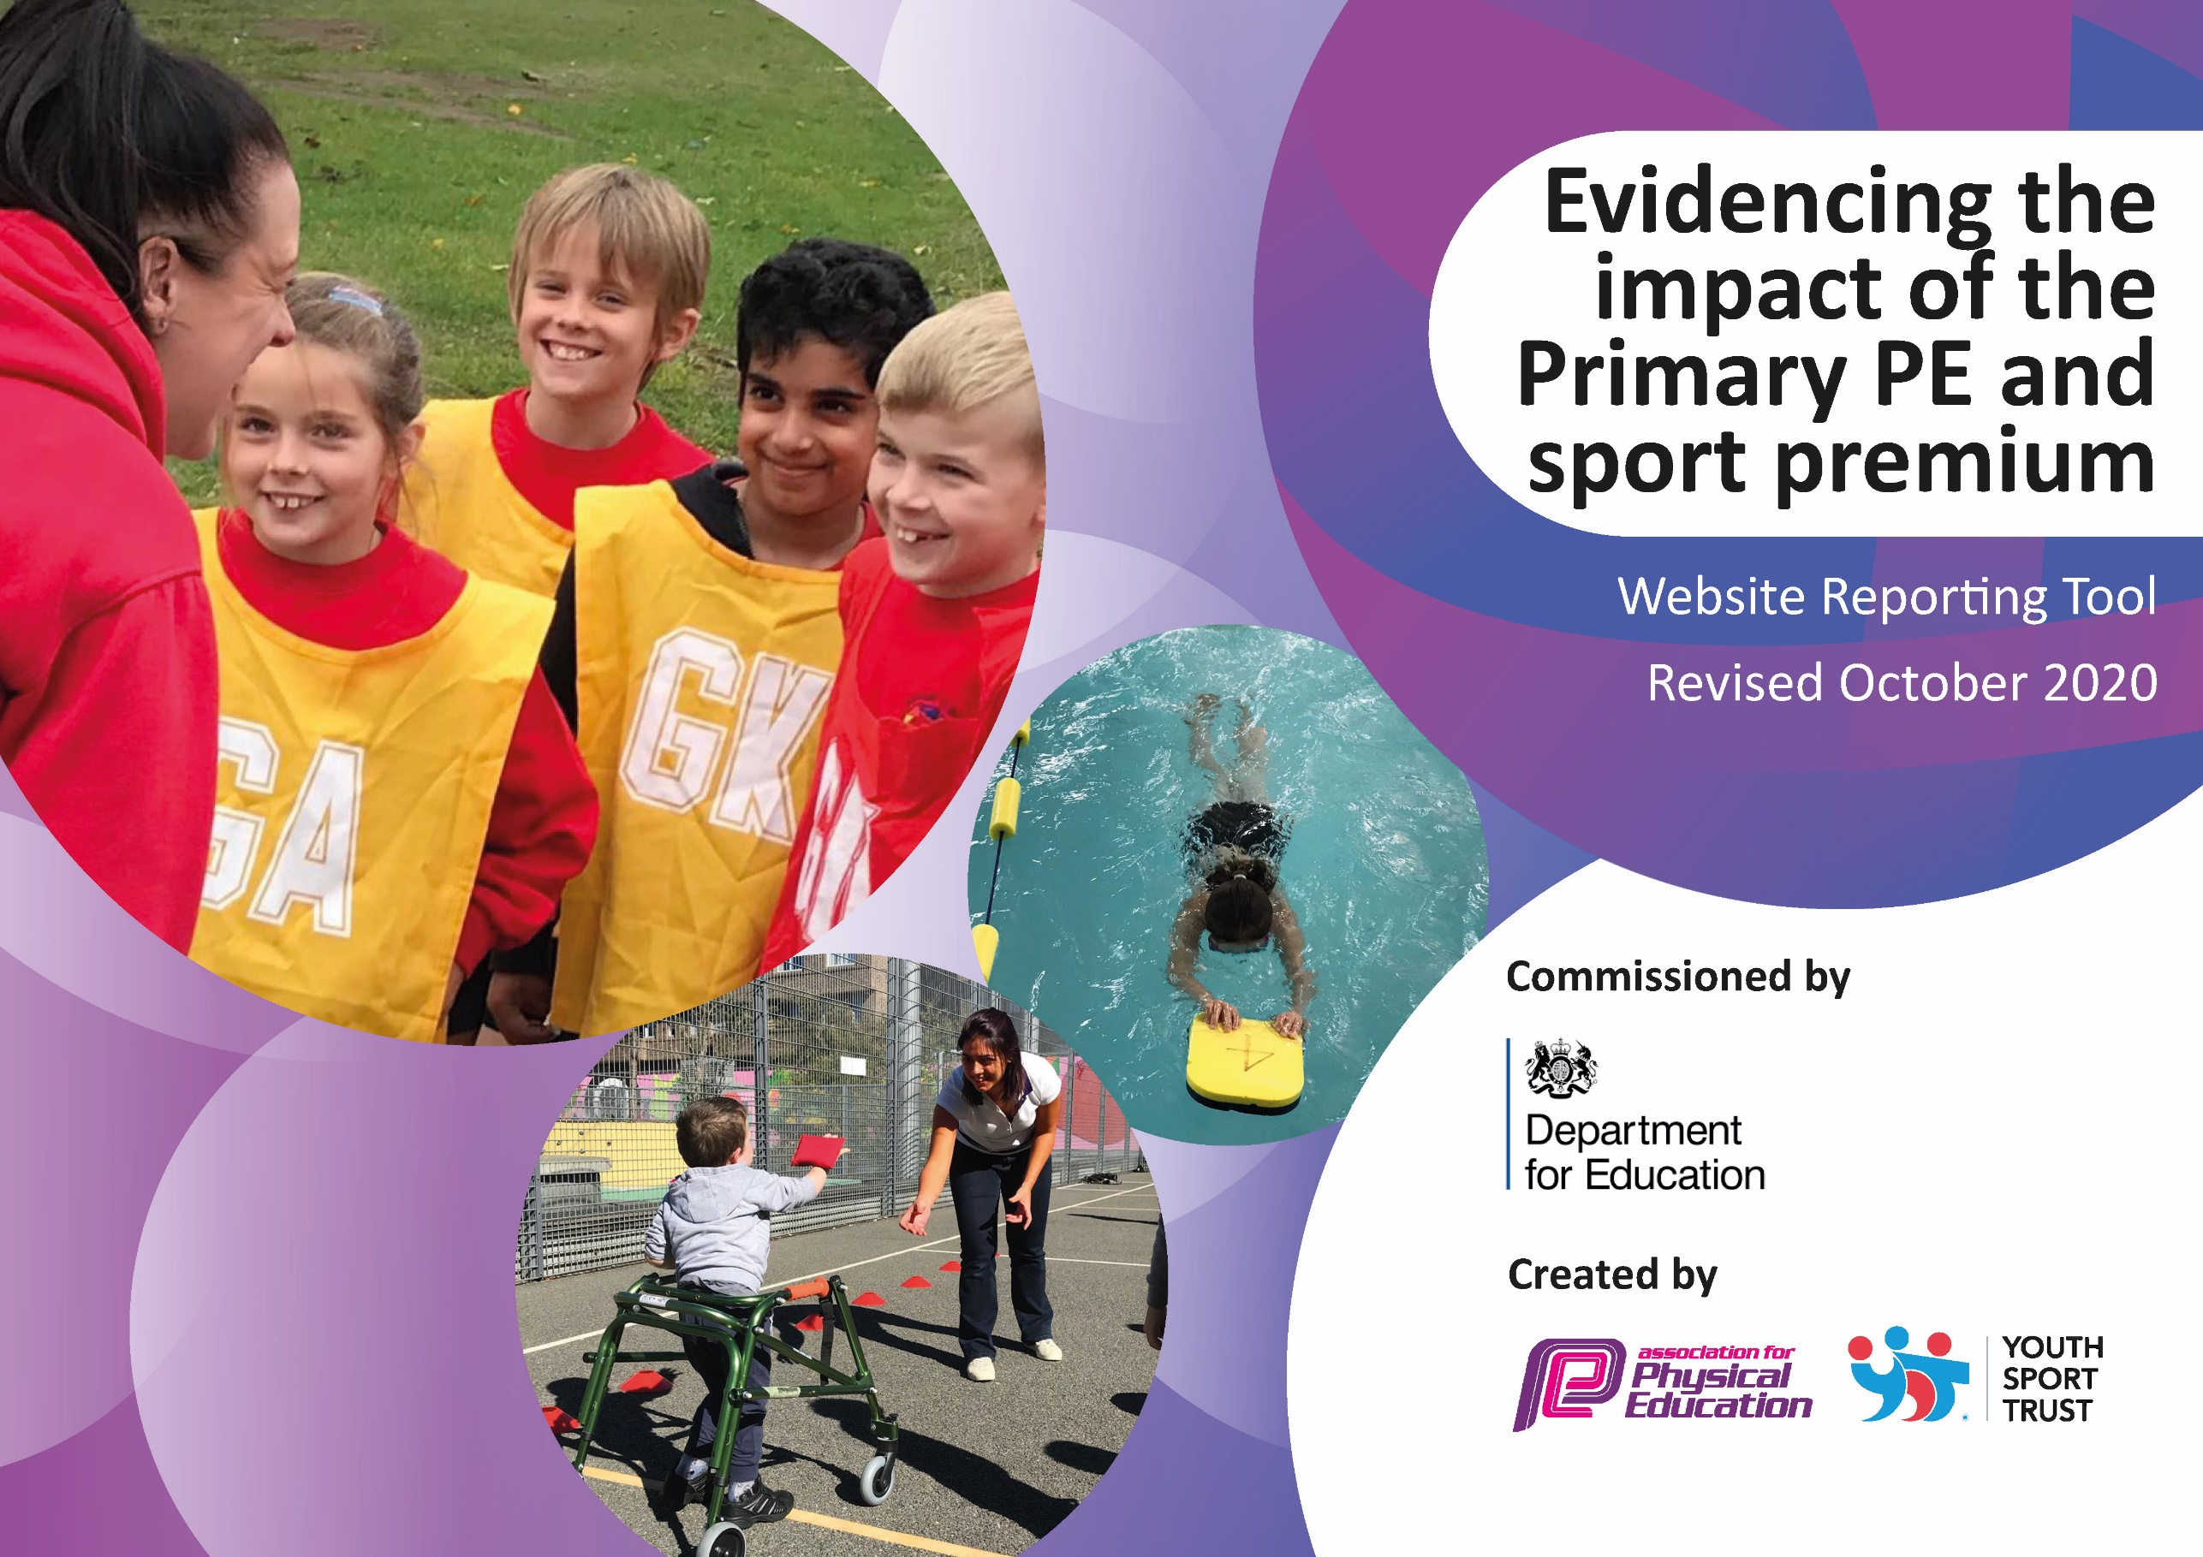
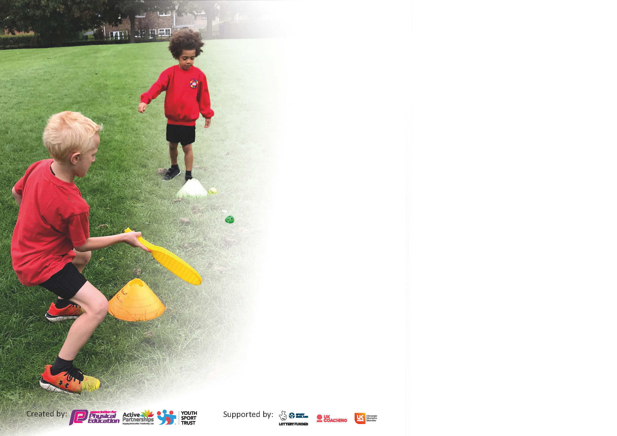

It is important that your grant is used effectively and based on school need. The Education Inspection Framework (Ofsted 2019 p64) makes clear there will be a focus on ‘whether leaders and those responsible for governors all understand their respective roles and perform these in a way that enhances the effectiveness of the school’.

Under the Quality of Education criteria (p41) inspectors consider the extent to which schools can articulate their curriculum (INTENT), construct their curriculum (IMPLEMENTATION) and demonstrate the outcomes which result (IMPACT).

To assist schools with common transferable language this template has been developed to utilise the same three headings which should make your plans easily transferable between working documents.

Schools must use the funding to make additional and sustainable improvements to the quality of Physical Education, School Sport and Physical Activity (PESSPA) they offer. This means that you should use
the Primary PE and sport premium to:

- Develop or add to the PESSPA activities that your school already offer
- Build capacity and capability within the school to ensure that improvements made now will benefit pupils joining the school in future years

Please visit gov.uk for the revised DfE guidance including the 5 key indicators across which schools should demonstrate an improvement. This document will help you to review your
provision and to report your spend. DfE encourages schools to use this template as an effective way of meeting the reporting requirements of the Primary PE and sport premium.

We recommend you start by reflecting on the impact of current provision and reviewing the previous spend.

Schools are required to publish details of how they spend this funding as well as on the impact it has on pupils’ PE and sport participation and attainment by the end of the summer term or by 31st July 2021 at the latest.

** In the case of any under-spend from 2019/20 which has been carried over this must be used and published by 31st March 2021.

We recommend regularly updating the table and publishing it on your website throughout the year. This evidences your ongoing self-evaluation of how you are using the funding to secure maximum, sustainable impact. Final copy must
be posted on your website by the end of the academic year and no later than the 31st July 2021. To see an example of how to complete the table please click HERE.
Created by: Supported by:

Please note: Although there has been considerable disruption in 2020 it is important that you publish details on your website of how you spend the funding - this is a legal requirement.
Support for review and reflection - considering the 5 key indicators from DfE, what development needs are a priority for your setting and your pupils now and why? Use the space below to reflect on previous spend and key achievements and areas for development.

N.B. In this section you should refer to any adjustments you might have made due to Covid-19 and how these will influence further improvement.
Key achievements to date until July 2020: | Areas for further improvement and baseline evidence of need:
- Implementation of IPEP – planning.  - The use of WOW tracker – a daily tracker which children input into how they have got to school each morning.  - Children were more active throughout the school day engaging in outdoor games during lunchtimes.  - Introduction of the Wellbeing Walk for all year groups from Nursery – Y6.  - Introduction of Intra school competitions.  - Achieving the ongoing commitment and achievement in the schools games programme award.  - Achieving the virtual schools programme ongoing support, commitment and engagement award. | - To attend every PE cluster meeting to ensure effective communication and understanding of yearly objectives shared by West Wigan Schools SGO.  - To ensure identified staff access CPD opportunities through team teaching with the school’s sports coach.  - To implement a PE and Sport Council.  - To host an annual sports day during National School Sports Week.  - To continue to work towards achieving external recognition awards.

Did you carry forward an underspend from 2019-20 academic year into the current academic year? YES/NO * Delete as applicable

If YES you must complete the following section
If NO, the following section is not applicable to you

If any funding from the academic year 2019/20 has been carried over you MUST complete the following section. Any carried over funding MUST be spent by 31 March 2021.
Academic Year: September 2020 to March 2021 | Total fund carried over: £ | Date Updated:
What Key indicator(s) are you going to focus on? |  |  |  | Total Carry Over Funding:
 |  |  |  | £
Intent | Implementation |  | Impact
Your school focus should be clear how you want to impact on your pupils. | Make sure your actions to achieve are linked to your intentions: | Carry over funding allocated: | Evidence of impact: How can you measure the impact on your pupils; you may have focussed on the difference that PE, SS & PA have made to pupils re-engagement with school. What has changed?: | Sustainability and suggested next steps and how does this link with the key indicators on which you are focussing this academic year?:

Meeting national curriculum requirements for swimming and water safety.  N.B Complete this section to your best ability. For example you might have practised safe self-rescue techniques on dry land. | 18%
What percentage of your current Year 6 cohort swim competently, confidently and proficiently over a distance of at least 25 metres?  N.B. Even though your pupils may swim in another year please report on their attainment on leaving primary school at the end of the summer term 2020. | 38%
What percentage of your current Year 6 cohort use a range of strokes effectively [for example, front crawl, backstroke and breaststroke]? | 38%
What percentage of your current Year 6 cohort perform safe self-rescue in different water-based situations? | 18%
Schools can choose to use the Primary PE and sport premium to provide additional provision for swimming but this must be for activity over and above the national curriculum requirements. Have you used it in this way? | Yes/No  Although school had planned to use funding in this way, due to COVID restrictions and school closures, this was not possible during this academic year.

Action Plan and Budget Tracking
Capture your intended annual spend against the 5 key indicators. Clarify the success criteria and evidence of impact that you intend to measure to evaluate for pupils today and for the future.

Academic Year: 2020/21 | Total fund allocated: £18,650 | Date Updated: 14/7/21
Key indicator 1: The engagement of all pupils in regular physical activity – Chief Medical Officers guidelines recommend that primary school pupils undertake at least 30 minutes of physical activity a day in school |  |  |  | Percentage of total allocation:
 |  |  |  | %
Intent | Implementation |  | Impact
Your school focus should be clear what you want the pupils to know and be able to do and about  what they need to learn and to  consolidate through practice: | Make sure your actions to achieve are linked to your intentions: | Funding allocated: | Evidence of impact: what do pupils now know and what can they now do? What has changed?: | Sustainability and suggested next steps:
All pupils to receive a minimum of 2 hour taught PE. | Delivery of 1, 1 hour high quality PE lesson (iPEP curriculum) per week during curriculum time with the specialist sports coach working alongside class teachers. All pupils will also participate in 30 minutes of planned, progressive outdoor games per day. Each year group has timetabled slots to ensure the minimum requirement of physical activity for children is met daily. | £17,289 | Pupils have a deeper understanding of the foundations of physical activity. They understand the benefits of sustained physical activity and can ascertain whether they are physically fitter. Children are more physically competent in the skill-based sports that they have accessed. Access to curriculum coverage has been widely reduced due to Covid-19. Despite school closures, daily activity was still promoted on our home learning platform. | Continue to provide the children with the opportunity to access a minimum of 2 hours of physical activity a week. Continue to adapt iPEP planning and delivery to follow Covid-19 guidelines and meet the needs of the children.
All pupils now engage in a daily wellbeing walk. | All staff and children complete a daily wellbeing walk along a designated route. | - | Children now engage in a further daily activity which promotes physical and emotional wellbeing. | Continue to timetable and monitor this daily activity for all year groups to access.
Active travel to and from school is promoted to all children via the Wow Travel Tracker scheme. | Promote the use of WOW Tracker throughout the school in preparation for next year. | - | Due to Covid-19 restrictions, year groups have accessed the scheme from Summer 1. The number of children travelling to school actively has increased. | Continue to promote active travel with families to increase the number of pupils walking, scooting and cycling.
Key indicator 2: The profile of PESSPA being raised across the school as a tool for whole school improvement |  |  |  | Percentage of total allocation:
 |  |  |  | %
Intent | Implementation |  | Impact
Your school focus should be clear what you want the pupils to know and be able to do and about  what they need to learn and to  consolidate through practice: | Make sure your actions to achieve are linked to your intentions: | Funding allocated: | Evidence of impact: what do pupils now know and what can they now do? What has changed?: | Sustainability and suggested next steps:
All children will be invited to engage in a weekly yoga session via the Wigan Warriors Community Trust Foundation. | Staff and children will engage in weekly yoga sessions. | Free | Children now know a variety of yoga poses and can use a yoga to reduce day to day anxieties. Daily yoga bursts have also been introduced as brain breaks. | Allow children to access opportunities to engage in Yoga activities.
Host an annual sports day involving all children within National Schools Sports Week. | Children will access different activity stations throughout the day including of a range of sports activities linked to the Olympics. Activities will be differentiated and inclusive with a focus on having fun and participation from all. Participation will be celebrated in a virtual end of week assembly. | (£30) | Children have enjoyed the opportunity of engaging in different activities which are not necessarily delivered as part of the iPEP programme. The Sports Council enjoyed voting in the specific events linked to the Olympics. | Continue to host an annual sports day with the hope of inviting parents as spectators next year during National Schools Sports Week.
To create a PE and Sports Council to introduce pupil voice to influence future after school clubs / activities. | Sports councillors were elected by their peers in each class from Y2-Y6 during year group elections. | Free. | Children were included in the decision making processes across the year groups. | For the PE and Sports Council to meet in person (when guidelines will allow) and to become more high profile across school. To continue to share the pupil voice of their peers. Re-elect new representatives.
To continue to advertise and celebrate PE and school sports achievements i.e. Sports Star of the Week. To also celebrate external sporting achievements through social media. | The use of St. Patrick’s sports twitter account alongside Instagram class pages. | Free. | Children’s achievements are celebrated regularly. Children are proud of their achievements. Regular notifications and re-tweets demonstrate the wider community is aware of our provision and achievements.  Awarded the ongoing commitment and achievement award for Autumn and Spring term.  Recognised for our support, commitment and engagement with the Virtual Programme. | Ensure all staff who will be in use of the sports specific Twitter account are trained to use social media appropriately and continue sharing the schools success through this media.  Strive to achieve further awards.

Key indicator 3: Increased confidence, knowledge and skills of all staff in teaching PE and sport |  |  |  | Percentage of total allocation:
 |  |  |  | %
Intent | Implementation |  | Impact
Your school focus should be clear | Make sure your actions to | Funding | Evidence of impact: what do | Sustainability and suggested
what you want the pupils to know | achieve are linked to your | allocated: | pupils now know and what | next steps:
and be able to do and about | intentions: |  | can they now do? What has
what they need to learn and to |  |  | changed?:
consolidate through practice:
Lessons to be team taught with both class teacher and schools sports coach as a form of CPD. | School sports coach to be present in each lesson from Nursery to Y6. | £17,289 | Increased skills and knowledge of staff leads to more engaging lessons and increased staff confidence in the delivery of PE lessons. | Staff continue to team teach PE alongside school sports coach. Staff to share new developments within inset meetings.
Staff to undertake training in order to keep up to date with local developments and therefore raise the attainment and progress levels of pupils through good or better teaching. | PE leads to attend cluster meetings virtually.  Send identified staff on CPD opportunities that may arise throughout the year. | Free | Skill-based training for staff leads to the delivery of improved PE teaching. | Termly learning walks to develop whole school sports and PE and write up via MME systems – analysing data.  Ensuring attendance of West Wigan cluster meetings.  Sharing new developments.
Key indicator 4: Broader experience of a range of sports and activities offered to all pupils |  |  |  | Percentage of total allocation:
 |  |  |  | %
Intent | Implementation |  | Impact
Your school focus should be clear | Make sure your actions to | Funding | Evidence of impact: what do | Sustainability and suggested
what you want the pupils to know | achieve are linked to your | allocated: | pupils now know and what | next steps:
and be able to do and about | intentions: |  | can they now do? What has
what they need to learn and to |  |  | changed?:
consolidate through practice:
To identify equipment needs. | Inventory of sporting equipment to gain an understanding of emerging/current needs. | £1350 | Purchase of equipment. Increased access to a variety of PE equipment. | Yearly inventory tasks to check stock levels.  Stock disseminated to storage facilities in line with iPEP planning delivery and planned.
Continue to offer a wide range of sports and activity within and outside of the curriculum in order to maximise participation. | Deliver National Curriculum requirements during curriculum time ensuring children have access to a range of skill-based sports.  Conduct a pupil voice survey to ascertain pupil preferences re. lunch and after school clubs. | Free | Children access a variety of physical activities and sports based games.  Children were included in the decision making processes across the year groups to inform staff of new activities of which they would like to engage within in school. | As Covid-19 restrictions lift, a wider range of sports and activity after school clubs will be on offer for all year groups throughout the year.
Targeted support is offered to identified Early Years children to support their physical development by the school’s sports coach. | The sports coach will work with these children on a weekly basis either 1-1 or in a small group dependent on the needs of the children. Activities will be based on the development of both gross and fine motor skills. | £17,289 | The identified children’s physical development has been tracked and progress has been made despite Covid-19 restrictions. | Continue to timetable the sports coach to work with identified children.
Set a variety of differentiated activities as online tasks via social media for children to engage with at home. | Upload weekly challenges. | Free | Children enjoy sharing their achievements via the online platforms with the support of their parents. | Continue to celebrate their achievements.
Subsidise Y6 booster swimming allocation. | Book Y6 onto swimming booster May/June.  Buy spare swimwear/towels etc. | £2085 | COVID restrictions have had an impact on school swimming lessons during this academic year. Unfortunately, Y6 booster sessions were not able to take place. | Continue to annually booster children’s swimming abilities in the Summer term of Y6.

Key indicator 5: Increased participation in competitive sport |  |  |  | Percentage of total allocation:
 |  |  |  | %
Intent | Implementation |  | Impact
Your school focus should be clear | Make sure your actions to | Funding | Evidence of impact: what do | Sustainability and suggested
what you want the pupils to know | achieve are linked to your | allocated: | pupils now know and what | next steps:
and be able to do and about | intentions: |  | can they now do? What has
what they need to learn and to |  |  | changed?:
consolidate through practice:
To increase the participation of competitive sport for all pupils (considering sporting abilities/SEN status/ year groups/ gender and pupil premium). | Entry forms and transport arrangements to Wigan West school games, sporting events and multi-skills festivals to be completed/arranged if on.  Organise teams, transport and kit before each event.  Include SEND pupils in next experiences through Just Join In sessions.  Liaise with school sports organiser regularly and track achievements. | Free. | Due to Covid-19 restrictions, events were all cancelled this year. Instead, children engaged intra school challenges. | Continue to host intra school events where possible until Covid-19 restrictions are lifted.

Signed off by
Head Teacher:
Date:
Subject Leader: | L Tracey, C Baxter, E Hutson, K Leonard
Date: | 14.7.21
Governor:
Date:

