SAINT PATRICK’S CATHOLIC PRIMARY SCHOOL
Dear Parent/Carer,
To celebrate World Book Day this year, we will be hosting a World Book Week in school. Our theme for the week is ‘Let’s go to the Circus’. During reading and writing lessons, the children will be exploring a class book based on the circus and their activities will run alongside this.

We are also holding a ‘Book in a Box’ competition, children are invited to take their favourite story and create a mashup where the characters from their story are placed in a circus. An example of this might be ‘Charlie and the Chocolate Circus’ instead of Charlie and the Chocolate Factory. You will need a box, which can be a cereal box, shoe box or equivalent. You can decorate your box inside and out to represent the characters in the circus setting. All competition entries must be in school by Friday 4th March 2022, examples of the ‘Book in a Box’ can be seen below. This might make a nice half term project for the children to be working on.

To end the week, we invite all children to dress up on Friday 4th March 2022. Instead of choosing a favourite book or character, we ask that the children dress as though they are taking part in a circus, this might be: clowns, acrobats, ring masters or even animals - their teachers will be following the same theme too. The reason for this is that we have invited a circus workshop into school on Friday to celebrate the end of our World Book Week celebrations. Emptiness

Yours sincerely,
Miss Preston and Miss Calderbank

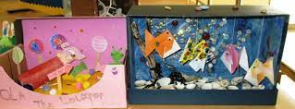
Book in a box examples:
