
Saint Patrick’s Catholic Primary School


HARDYBUTTS Telephone: 01942 244361
WIGAN, WN1 3RZ email: enquiries@admin.saintpatricks.wigan.sch.uk

Headteacher: Mrs L Hobden
3rd September 2024
Dear Parents/Carers,

As we return from the summer holidays, I would like to take this opportunity to welcome everyone who are either returning to school, or who are new to our school.
Following changes to statutory guidance from the Department for Education linked to attendance and due to the release of the Working together to improve school attendance (applies from 19 August 2024) (publishing.service.gov.uk) I would like to remind everyone how crucial regular attendance and arriving on time is to all children.
St Patrick’s staff are committed to ensuring all children achieve, however this can only be achieved if they attend school and are on time.
A letter was shared with all parents/carers prior to the summer holidays from the Local Authority detailing the changes to Education Penalty Notices. These changes are now in effect (from the 19th August 2024) and therefore any non-attendance or poor punctuality may result in an education penalty notice from the Local Authority. A copy of the letter can be found in the attendance section of schools website.
What are the changes?
1. There will be a new national threshold of 10 unauthorised sessions for any reason (equivalent to 5 school days) within a rolling 10 school week period for when a penalty notice must be considered.
2. The new rules mean you will no longer be able to take your child out of school for one week’s holiday without a penalty notice being issued.
3. There will be an increase in the penalty fine from £60 to £80 if paid in 21 days. If the fine is not paid by the first 21 days, it will rise to £160 if paid within 28 days of being issued.
4. If a second penalty fine is issued to the same parent for the same child within a 3-year rolling period, the fine will automatically rise to £160 with no option to pay the lower rate of £80.
5. If a parent then commits a third offence in a 3-year rolling period, the local authority will consider other enforcement options available to them.
As stated in point 1, the unauthorised absences can be for any reason (not just for holidays in term time). Any persistent unauthorised absences will be considered for an education penalty notice (as directed by the Department for Education). This would include children who are persistently absence due to illness (unless this can be corroborated with evidence, ie Drs appointment card, letter from hospital etc). If the local authority and school identify patterns in sickness reporting (ie children are regularly off sick for one or two days a week, week on week), this may be considered as a persistent unauthorised absence and therefore meet criteria for an education penalty notice.

What should I do if my child is going to be absent from school?
If your child will be absent from school, regardless of reason, please ensure this is reported to the school office on 01942 244361. A call should be made prior to the start of the school day. If your child is absent for a number of consecutive days, a call must be made to the school office each day of the absence.
Punctuality
School doors open at 08:45 with Registers taken at 09:00. Any child who is not present for the register will be marked as absent. If a child arrives late, ie after 09:00 but before 09:30, the absent mark will be altered to a late mark. As directed by the DfE, for any child who arrives after 09:30, this will be classed as an absence as they will have already missed a significant portion of the morning session. Therefore, for children who are persistently late, this may accrue as absences and lead to an education penalty notice from the local authority.
Working together to improve attendance
At St Patrick’s, we are committed to ensure all children have an equal chance of success. This can only be achieved through regular attendance and arriving on time.
We appreciate that this is not always possible and that there can be many factors that hinder regular attendance or punctuality (arriving on time). To support with attendance, school has an attendance champion (Mr McConnell- Deputy Headteacher) who works closely with a Local Authority Attendance Officer (Mrs Ruth Cooper).
Mrs Cooper and Mr McConnell are here to support families with attendance. Sometimes this support may informal through telephone conversations, informal meetings, letters and if necessary, families can be supported more formerly through earliest help or early help.
Any meetings with Mrs Cooper and Mr McConnell, formal or informal are to support families with attendance and punctuality. Sometimes small changes can make a big difference to punctuality and attendance and these can be explored with Mrs Cooper and Mr McConnell. If you would like to discuss your child’s attendance or punctuality please feel free to contact school’s main office on 01942 244361 and a meeting will be arranged.
Further details about attendance and punctuality (including relevant policies) can be found in the attendance section of school’s website: https://www.saintpatricks.wigan.sch.uk

By working together, we will give all children the best chance of success both for now and in their future working life. Thank you for your continued support and commitment to our school community.

Yours faithfully,
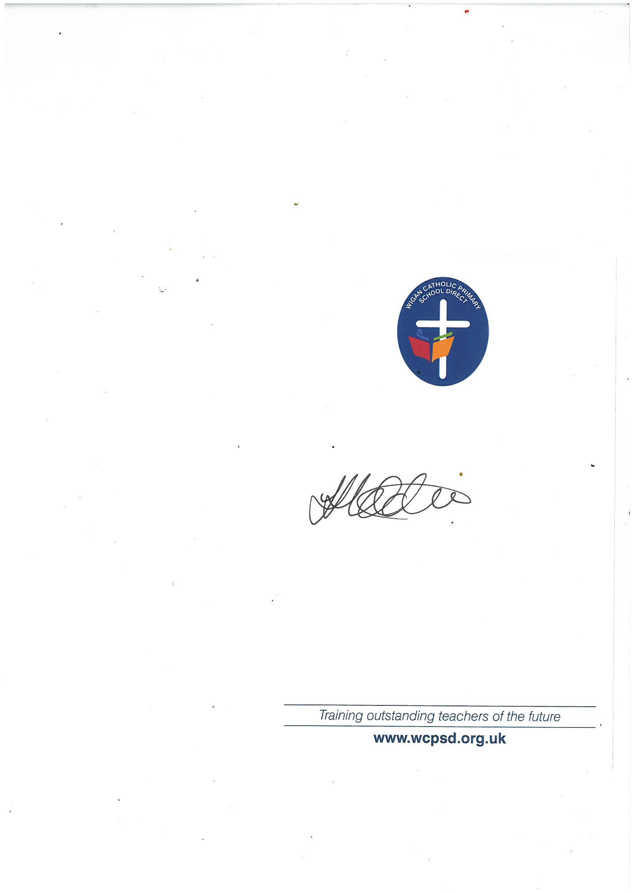

Mrs Hobden
Headteacher







