

HARDYBUTTS, WIGAN WN1 3RZ Telephone: 01942 244361 email: enquiries@admin.saintpatricks.wigan.sch.uk

Headteacher: Mrs L Hobden
Dear Parent/Carer,
Collective Worship is a central and daily part of our timetable here at St Patrick’s Catholic Primary School. To that end, I am delighted to inform you that we are now able to re-instate our weekly ‘Stay and Pray’ Prayer and Worship for every Year Group in School. Each Friday, from 9:05-9:15am in the Junior Hall, a different Year Group will lead a Collective Worship that we invite you and your families to join.

On the day of your child’s Stay and Pray, please drop them off as normal in to school and then make your way to the Fire Exit Door of the Junior Hall to take your place. The weekly newsletter at St Patrick’s Church will also inform and invite parishioners of the Stay and Pray dates and times. Praying together is a beautiful way to start our morning and helps to strengthen the strong links that already exist here between home, school and church.

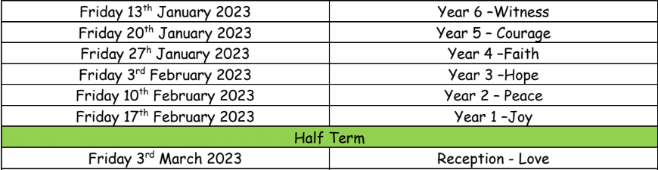
I attach a list of dates for every Year Group’s upcoming Stay and Pray if you would like to make arrangements, in advance, to attend your child’s date:
If you have any questions about ‘Stay and Pray’, please speak to your child’s class teacher, Mr Marshall or Miss Tracey.

We look forward to welcoming you in to school to join us in prayer.

Yours faithfully,

Mrs Hobden
Head Teacher

