
Saint Patrick’s Catholic Primary School


Dear parent/carer,

I write to inform you that from September 1st 2020 we will no longer be using Dolce to provide our school meals.

At Saint Patrick’s, we have decided that from September 2020 we will supply our own school lunchtime catering. Should your child require a hot or cold meal at lunch time, we will be able to provide this.

Our school meals are cooked on the premises by our own catering team, led by our Catering Manager, Ms Paula Dalgleish. Our menu is designed to provide a varied and healthy choice which means that your child can enjoy a tasty, healthy meal at a very fair cost and without the fuss of making packed lunches, should you wish. We also cater for alternative dietary needs including vegetarian and gluten free.
At Saint Patrick’s we believe that school meals give your child a real appetite for learning and help them to achieve their full potential. In addition to eating a nutritious meal, your child learns the essential skills of using cutlery and eating as part of a family group.
All children in Years R, 1 and 2 are entitled to a Free School Meal as part of the government's Universal Free School Meal initiative.

Other children may be eligible to receive Free School Meals through entitlement because of benefits that the parent/carer is receiving. Please check with the office if you are unsure - by claiming Free School Meals you are not only ensuring your child gets the meal they are entitled to but also helping the school get the maximum amount of funding to help with your child's learning.

You may decide to swap between providing a lunch for your child and paying for a school meal. Both choices are fine and school lunches can be ordered on a daily basis rather than a full week.

Parent Pay
In an attempt to support parents and carers in paying for school meals and school events, we have purchased and implemented an e-payment method to order and pay for all school dinners from September 2020. This can be done online using a very secure website called Parent Pay. If you already have a ParentPay account with another school, you can simply login to that account and add your other children via the ADD A CHILD tab on your home page. School will send a unique activation username and password for parents to activate their account. Once you have activated your account you can make online payments straight away. Currently school meals cost £2.30 per day £11.50 per week.
It will take the first two weeks on the Autumn term to set up Parent pay and our online ordering system for meals. Please can I ask that if possible could you order your child/children’s meals for the first two weeks using the menu and slip below and then either hand into school or email to the kitchen below.
kitchen@saintpatricks.wigan.sch.uk

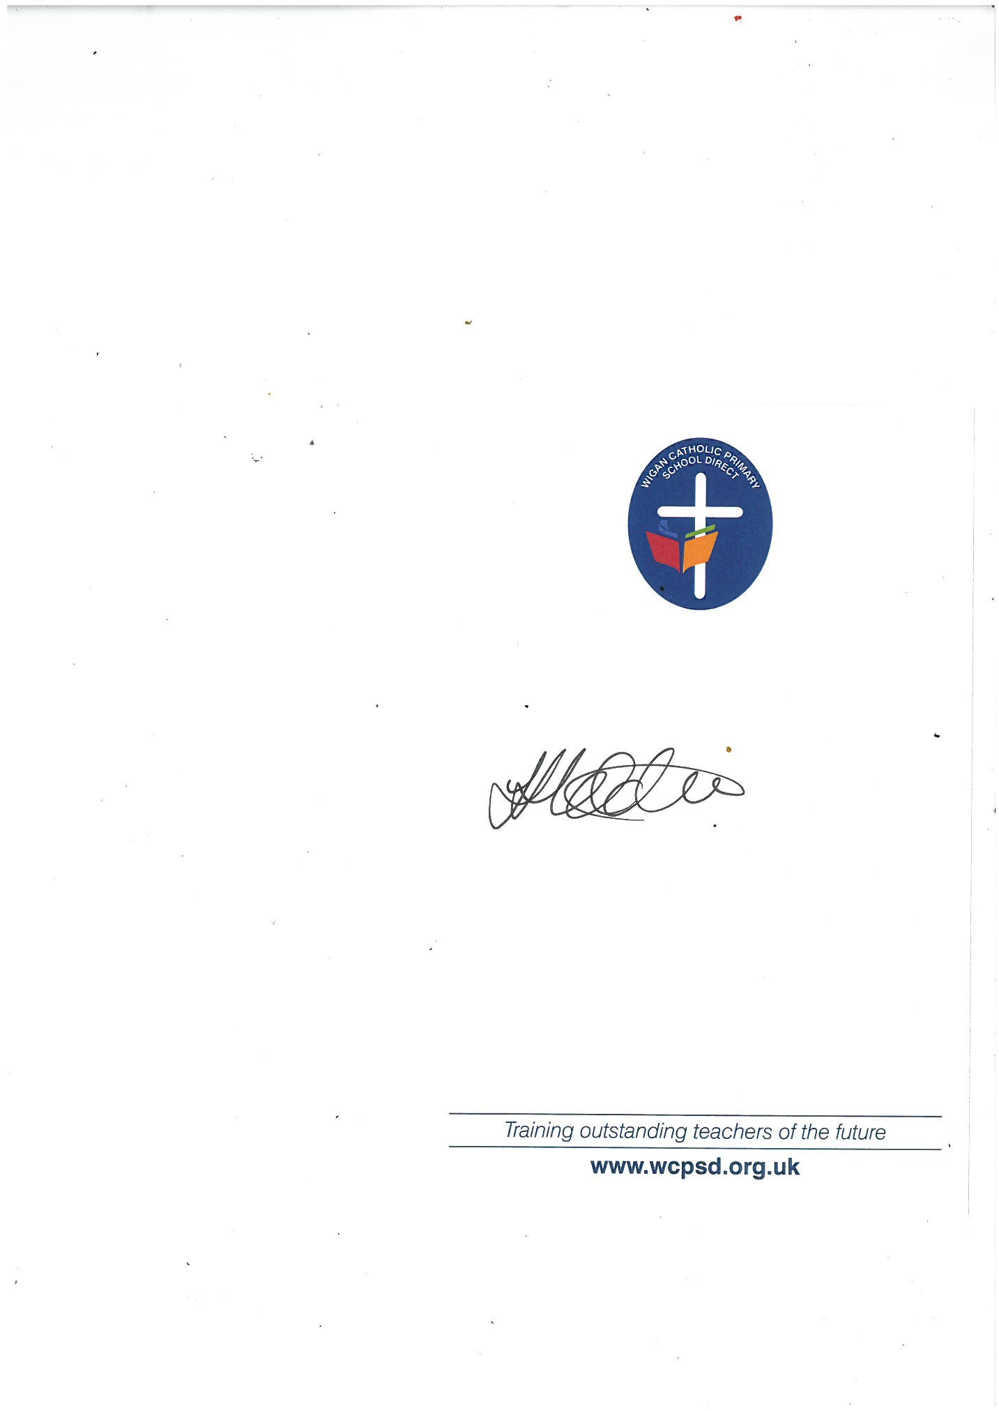
Yours sincerely,

Mrs Hobden
Headteacher

Menu for first two weeks in September
Week Beginning | Monday | Tuesday | Wednesday | Thursday | Friday
31.8.2020 |  | Fresh pork sausage/veg sausage, mashed potato, veg and gravy | Flavoured chicken wrap*, rice, veg/salad | Meat pie*/veg pie herb dice potatoes, veg and gravy | Omega 3 fish fingers, chips, baked beans, tomato ketchup
31.8.2020 |  | Sandwich selection & chopped salad ham, cheese, tuna mayo or egg mayo. | Sandwich selection & chopped salad ham, cheese, tuna mayo or egg mayo. | Sandwich selection & chopped salad ham, cheese, tuna mayo or egg mayo. | Sandwich selection & chopped salad ham, cheese, tuna mayo or egg mayo.
31.8.2020 |  | Jelly* & Ice cream  Yoghurt  Fresh Fruit | Choc orange muffin  Yoghurt  Fresh Fruit | Carrot cake  Yoghurt  Fresh Fruit | Cornflake crispie  Yoghurt  Fresh Fruit
7.8.2020 | Pasta Bolognaise* & garlic bread, veg | Sausage roll/veg sausage roll, creamed potatoes, baked beans | Roast chicken* dinner, roast potatoes, veg, gravy | Cheese and tomato wholegrain pizza potato wedges veg/salad | Turkey dinosaurs/Quorn nuggets, potato waffles, spaghetti hoops
7.8.2020 | Sandwich selection & chopped salad ham, cheese, tuna mayo or egg mayo. | Sandwich selection & chopped salad ham, cheese, tuna mayo or egg mayo. | Sandwich selection & chopped salad ham, cheese, tuna mayo or egg mayo. | Sandwich selection & chopped salad ham, cheese, tuna mayo or egg mayo. | Sandwich selection & chopped salad ham, cheese, tuna mayo or egg mayo.
7.8.2020 | Vanilla muffin  Yoghurt  Fresh Fruit | Choc brownie  Yoghurt  Fresh Fruit | Gingerbread man  Yoghurt  Fresh Fruit | Strawberry mouse  Yoghurt  Fresh Fruit | Arctic roll  Yoghurt  Fresh Fruit
Some of the items on the menu may contain ALLERGENS in the ingredients. We understand the dangers to individuals with allergies or food intolerances. If this applies to your child, please speak with a member of staff.

*Halal option available
Sandwich bread type selection will be different daily: Tortilla wraps; sandwiches; bread rolls or baguettes.

---------------------------------------------------------------------------------------------------------------
School Meal Choices September 2020
Childs name__________________________ Class _____________________

Week beginning | Monday | Tuesday | Wednesday | Thursday | Friday
Tue 1.9.2020
7.9.2020

Please note any allergies

___________________________________________________________________________________________________________________________________________________________________________________________________________________________________________________________________________________________________________

