
Saint Patrick’s Catholic Primary School


HARDYBUTTS Telephone: 01942 244361
WIGAN, WN1 3RZ email: enquiries@admin.saintpatricks.wigan.sch.uk

Headteacher: Mrs L Hobden

Important Information Regarding Attendance & Punctuality

Penalty Notice Warning

Dear Parent/Carer,

We are fortunate at St. Patrick’s to have the support of the vast majority of our families in securing high rates of attendance at our school. We would like to take this opportunity to thank you for your continued support. As you will be aware, good attendance underpins everything that we are trying to achieve as a school for your child/children.

When attendance becomes a real problem we may have to, unfortunately, issue penalty notices and in order to be able to do this we have been asked by the Local Authority to issue a Penalty Notice Warning to ALL parents/carers whose child/children attend St. Patrick’s Catholic Primary School.

If you child is absent from school without authorisation you could receive a fine without further notification.

Please see attached penalty notice warning for non-school attendance.

I must also make you aware that registers will close at 9:00am therefore if your child arrives in school after this time they will be recorded as an unauthorised late.

Yours faithfully,
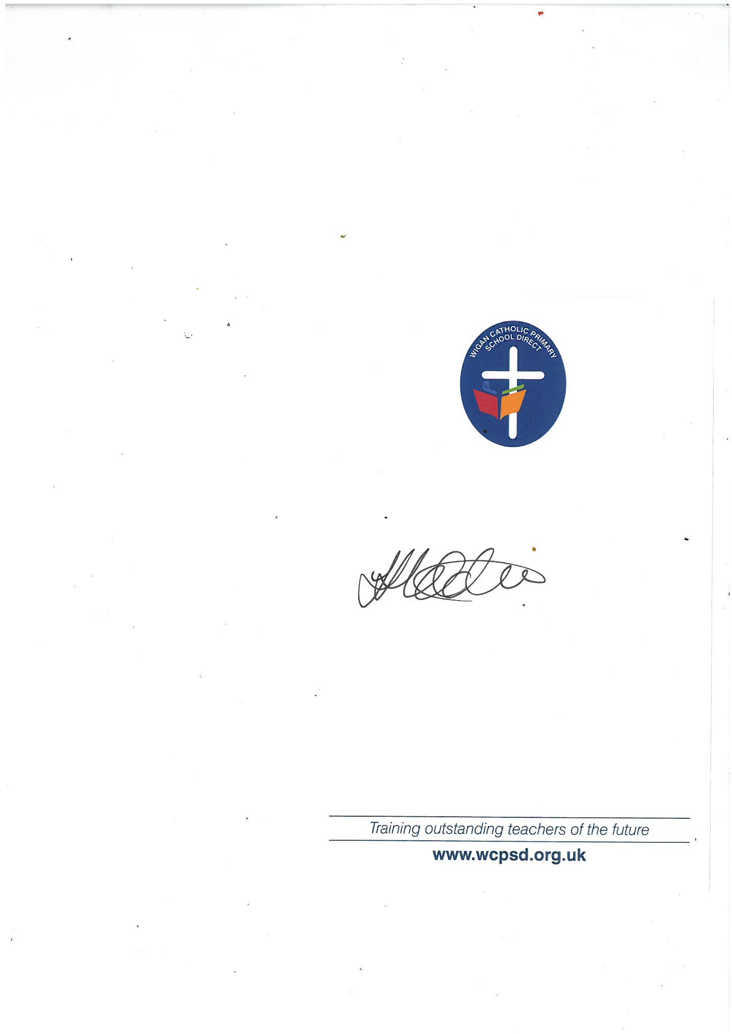

Mrs Hobden
Headteacher

