
Saint Patrick’s Catholic Primary School


HARDYBUTTS Telephone: 01942 244361
WIGAN, WN1 3RZ email: enquiries@admin.saintpatricks.wigan.sch.uk

Headteacher: Mrs L Hobden

Important Information Regarding Attendance

Education Penalty Notice Warning for Non-School Attendance

Under the Education Act 1996, parents and carers have a duty to make sure their children regularly attend school. If parents or carers fail to do this, they can be prosecuted.

Working with a code of conduct the Local Authority can issue a penalty notice to parents or carers if a child has missed a number of sessions without permission from the school.

If your child falls within one or more of these categories within a 12 week period;

- 10 sessions (5 days) of unauthorised absence with under 90% attendance
- 20 sessions (10 days) of unauthorised absence
- Persistently arrives late for school after the close of registration

You will receive a Penalty Notice of £60 which will increase to £120 if not paid within 21 days. The penalty notice will need to be paid in full before 28 days of the notice being served. Failure to pay a penalty notice may result in prosecution; (a separate penalty notice may be issued to each parent/career for each child).

In law, an offence is committed if a parent/carer fails to secure a child’s regular attendance at school. Wigan Council Attendance Service, in conjunction with schools, will use these powers as an early deterrent to prevent patterns of unauthorised absence developing.

You may also receive a penalty notice for the offence of failing to secure regular school attendance under the following circumstances:
- Your child is stopped on a truancy sweep
- You fail to ensure that your child is not in a public place during the first 5 days of a fixed term of permanent exclusion

The Local Authority and School are committed to providing the best possible future for your child. If you have any concerns about your child’s attendance at school, please do not hesitate to contact school for support and guidance.

Yours faithfully,
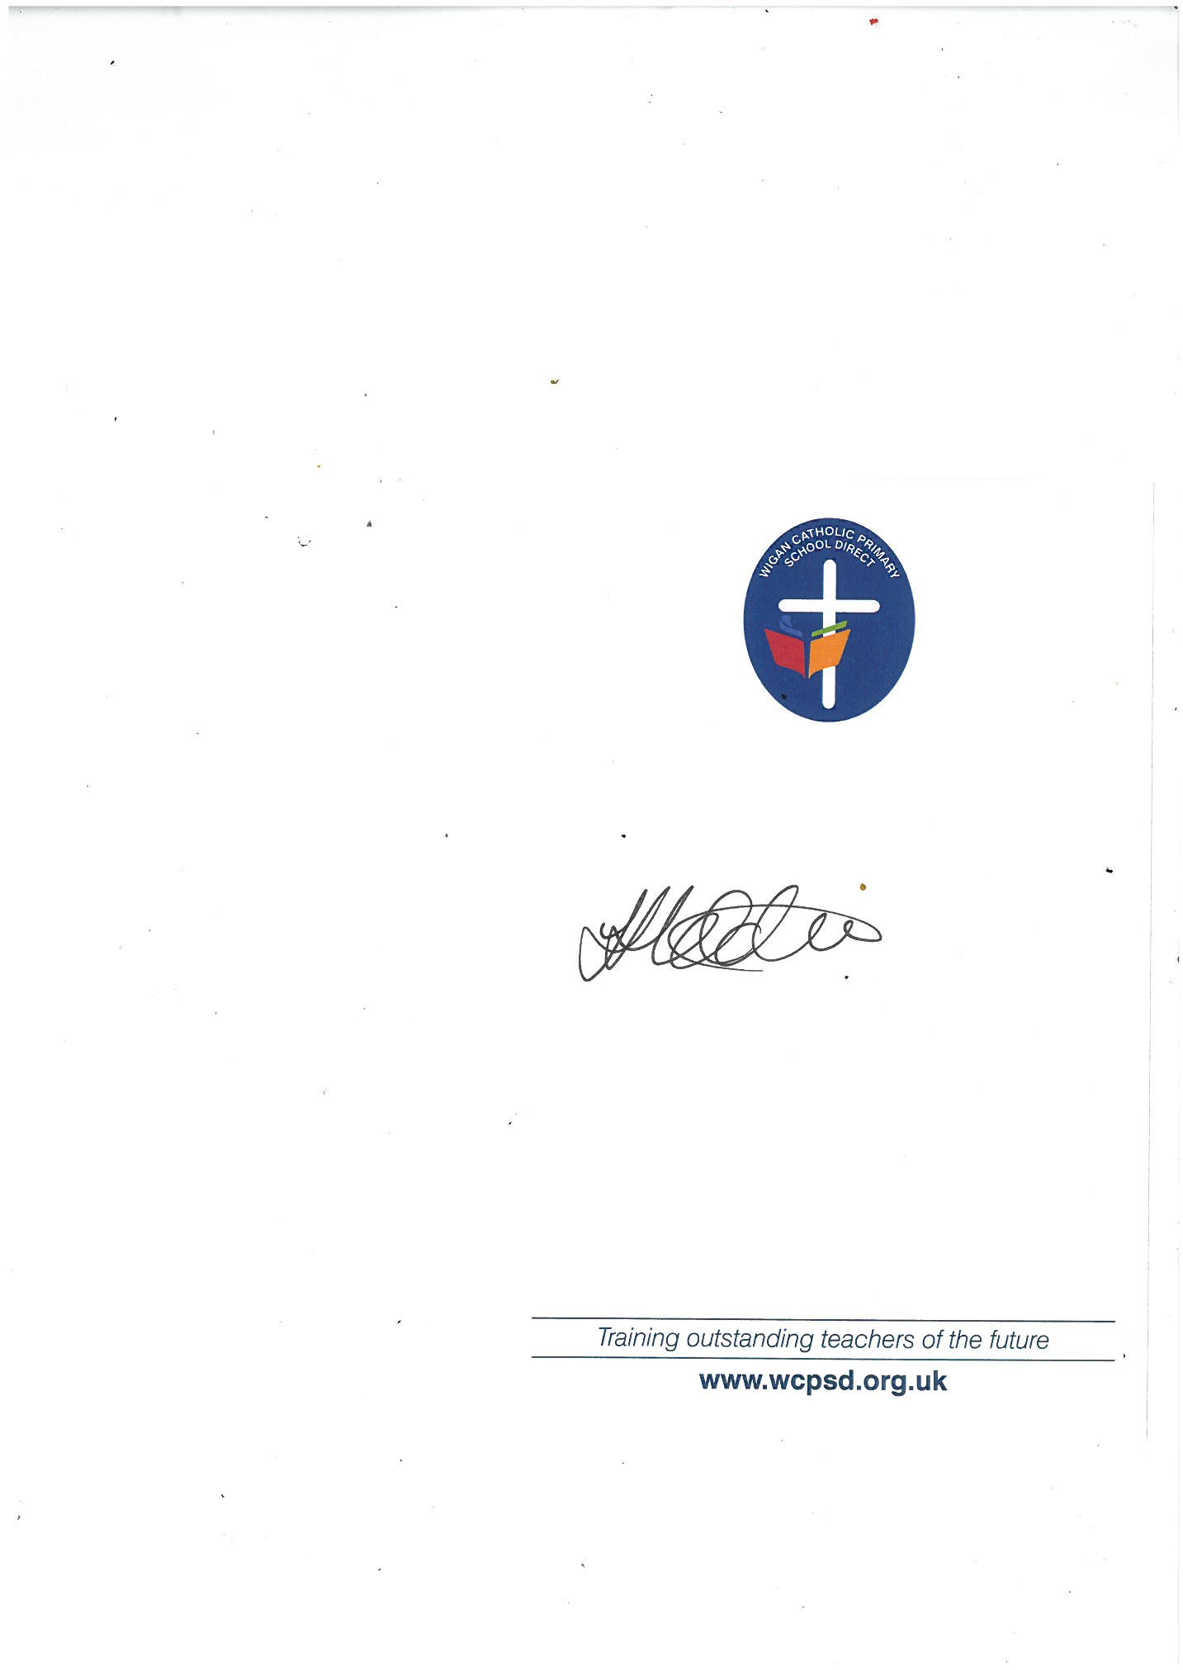

Mrs Hobden
Headteacher

