
Saint Patrick’s Catholic Primary School


‘We arise today to learn, love and grow through Jesus’.

HARDYBUTTS Telephone: 01942 244361
WIGAN, WN1 3RZ email: enquiries@admin.saintpatricks.wigan.sch.uk

Headteacher: Mrs L Hobden

Tuesday 15th October 2024
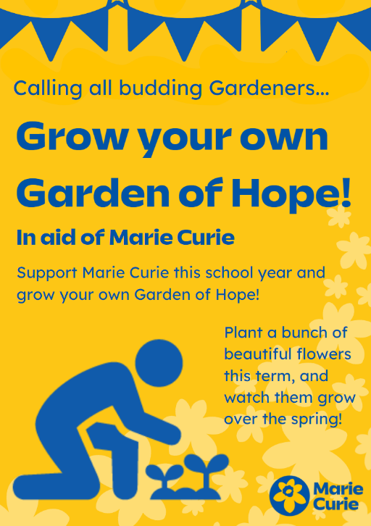
Dear Parents/Carers,
We are excited to announce our participation in the Garden of Hope Project, organised by the Marie Curie Cancer Support Charity.
We will be using our school grounds to grow our own Garden of Hope, in memory of loved ones and friends affected by cancer. If your child would like to participate in our Garden of Hope and plant a daffodil, please bring in £1 (alongside this reply slip) to cover the cost of the bulb by this Friday, 18th October.
We recognise this is short notice and we do apologise for this; however, the details have only been confirmed by the Charity in the last few days. If you have any questions about the Garden of Hope Project, please speak to Mr Marshall (Catholic Life Co-Ordinator).
Thank you, in advance, for your generosity and support.

Yours faithfully,

Mrs Hobden
Headteacher

Child’s Name: ________________________________ Year Group: _________

My child would like to participate in the Garden of Hope Project and I enclose a £1 donation towards the cost of the bulb.

Signed: _________________________________ Parent/Carer Date: ___________

